|  |
| --- |
| **Written By:**  **VenuYerra (**[venu.yerra@ideaentity.com](mailto:venu.yerra@ideaentity.com)**)** |
| **SUBMTTER REQUEST-USER MANUAL FOR SUBMITTER** |
| **Submitted To:** |
| **Submitted By:** |
| **Written By:**  **VenuYerra (**[venu.yerra@ideaentity.com](mailto:venu.yerra@ideaentity.com)**)** |



Table of Contents

INTRODUCTION 4

SETTINGS PAGE: 4

CONTENT MANAGEMENT SECTION 4

POINTS OF CONTACT 5

ADD NEW ITEM 5

EDIT THE ITEM 7

ARCHIVE THE ITEM 9

DELETE ITEM 10

KNOWLEDGE BASE 12

ADD NEW ITEM 12

EDIT THE ITEM 13

ARCHIVE THE ITEM 15

DELETE ITEM 17

Q&A SECTION 18

ADD NEW ITEM 18

EDIT THE ITEM 20

ARCHIVE THE ITEM 22

DELETE ITEM 24

QUICK LINKS 25

ADD NEW ITEM 25

EDIT THE ITEM 27

ARCHIVE THE ITEM 28

DELETE ITEM 30

CALENDAR 31

Events/ Trainings/ Meeting Calendar 31

ADD NEW ITEM 31

EDIT THE ITEM 33

DELETE ITEM 35

ANNOUNCEMENTS 37

ADD NEW ITEM 37

EDIT THE ITEM 39

DELETE ITEM 41

POLICY MEMOS & GUIDELINES 42

ADD FOLDER 43

DRAG/DROP FILES 47

EDIT THE DOCUMENT NAME 50

DELETE THE DOCUMENT 51

HELP DESK 52

EDIT THE ITEM 52

USER MANAGEMENT SECTION 54

ADD USERS TO USER GROUPS 55

REMOVE USERS FROM USER GROUPS 56

METADATA MANAGEMENT 57

ADD RANK 58

EDIT THE ITEM 59

ARCHIVE THE ITEM 60

ADD DIRECTORATE 62

EDIT THE ITEM 63

ARCHIVE THE ITEM 64

ADD EVENT TYPE 65

EDIT THE ITEM 66

ARCHIVE THE ITEM 67

ADD ITEMS LIST 68

EDIT THE ITEM 69

ARCHIVE THE ITEM 70

ADD FREQUENCY 72

EDIT THE ITEM 73

ARCHIVE THE ITEM 74

ADD CHECKLIST 75

EDIT THE ITEM 76

IS ARCHIVE THE ITEM 77

SITE FEEDBACK 78

# INTRODUCTION

SUBMITTER REQUEST is a pamphlet that provides guidance and history for excellence in protocol, decorum, customs and courtesies during Air Force ceremonies, conferences, and social events, in hosting distinguished visitors and in honours afforded at military funerals. Major Command, Direct Reporting Unit, and Field Operating Agency commanders and the Chief, National Guard Bureau, may issue additional guides specific to their protocol operations so long as it further supports the goals of the United States Air Force and specific military missions.

# SETTINGS PAGE:

**Protocol Support Request Owners** and/or the **Protocol Officer** can manage the Home Page content by using the Settings page.

1. In the menu bar, click on the **Settings** tab.

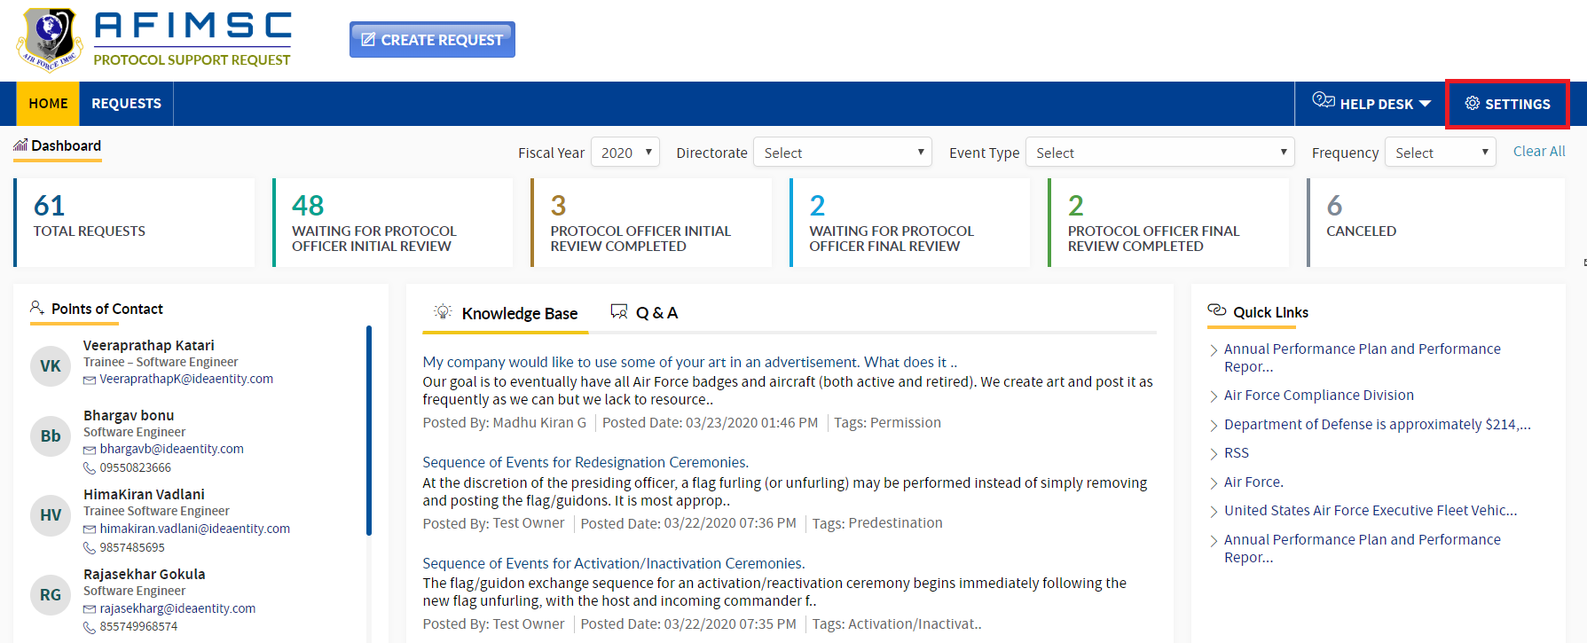

1. The page will then navigate to the **Settings** page, and the sections seen below will be displayed.

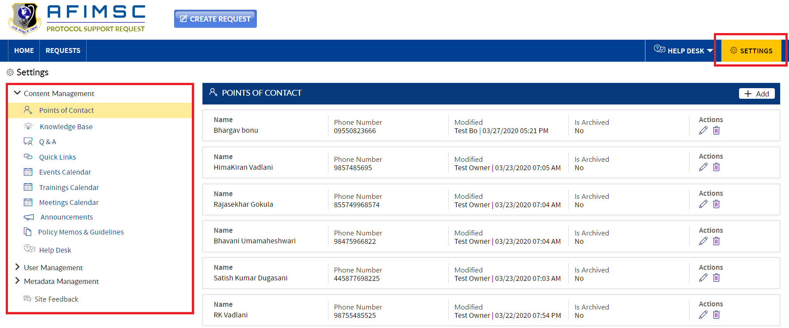

# CONTENT MANAGEMENT SECTION

In the **Content Management** section, lists/libraries will be visible to **Protocol Support Request Owners** and/or the **Protocol Officer** for management. The lists/libraries are as follows:

1. Points of Contact
2. Knowledge Base
3. Q&A
4. Quick links
5. Events Calendar
6. Trainings Calendar
7. Meetings Calendar
8. Announcements
9. Policy Memos & Guidelines
10. Help Desk

# POINTS OF CONTACT

**Protocol Support Request Owners** and/or the **Protocol Officer** can manage add/edit/archive/delete the items in the **Points of Contact** list.



### ADD NEW ITEM

To add a new **Point of Contact** in the list, follow the steps below:

1. By default, the **Points of Contact** list will highlight, and the related details will display on the right-hand side.
2. Click on the **Add** button in the right-side corner. From there, **Add People** will be displayed.

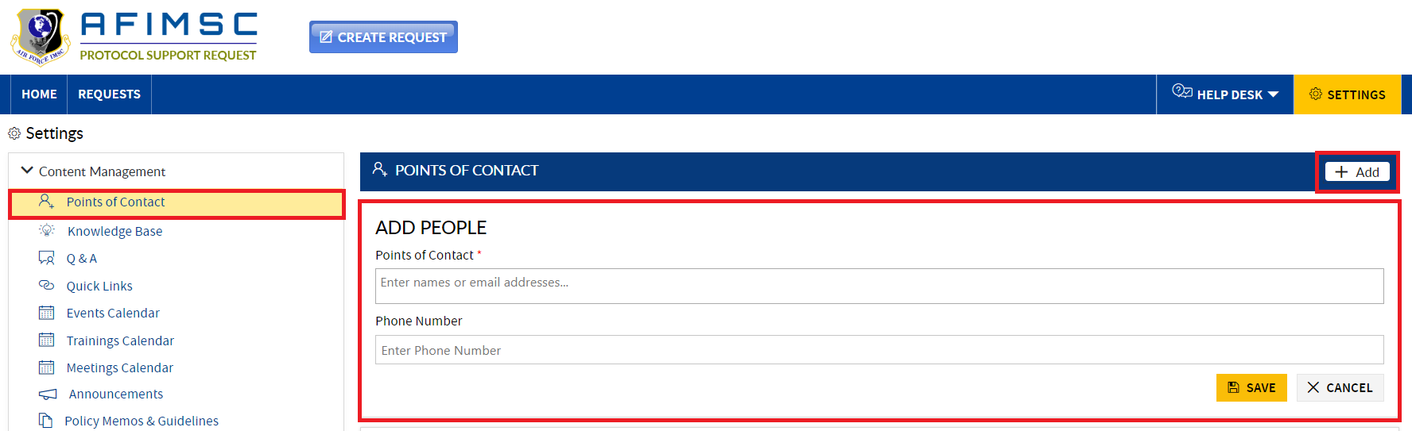

1. Enter the **Point of Contact** **Name** and Phone Number (Optional), and click the **Save** button.

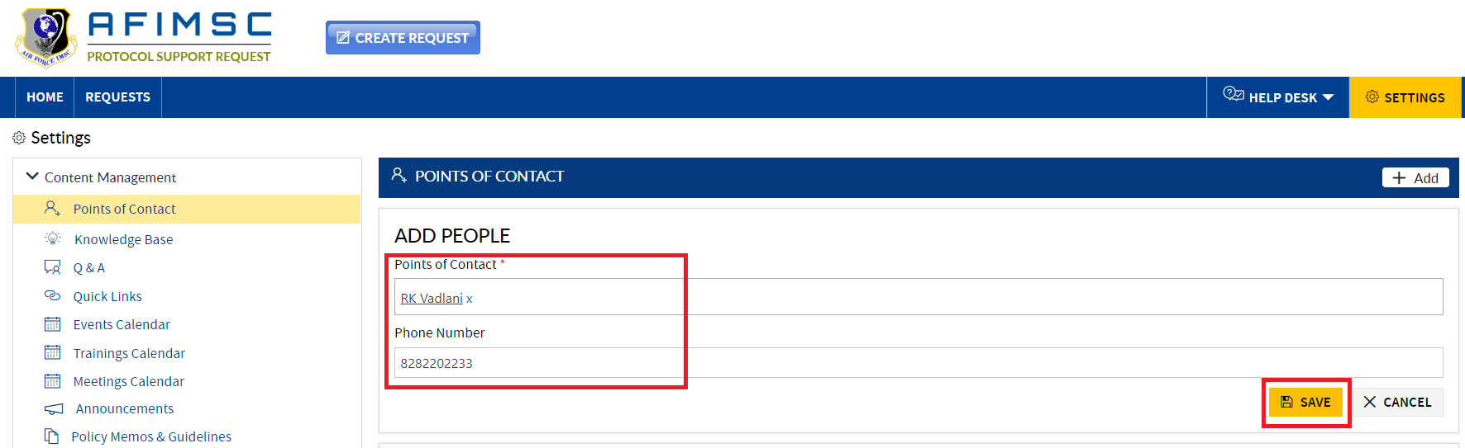

1. The new item will be added, and will display at the top of the **Points of Contact** section.

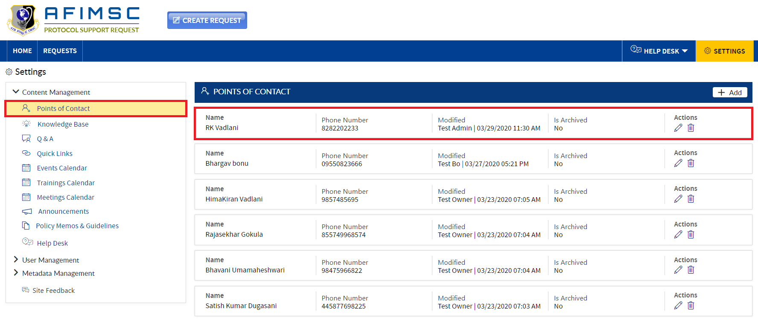

1. As seen below, the new **Point of Contact** will be displayed at the top of the **Points of Contact** section on the Home Page.

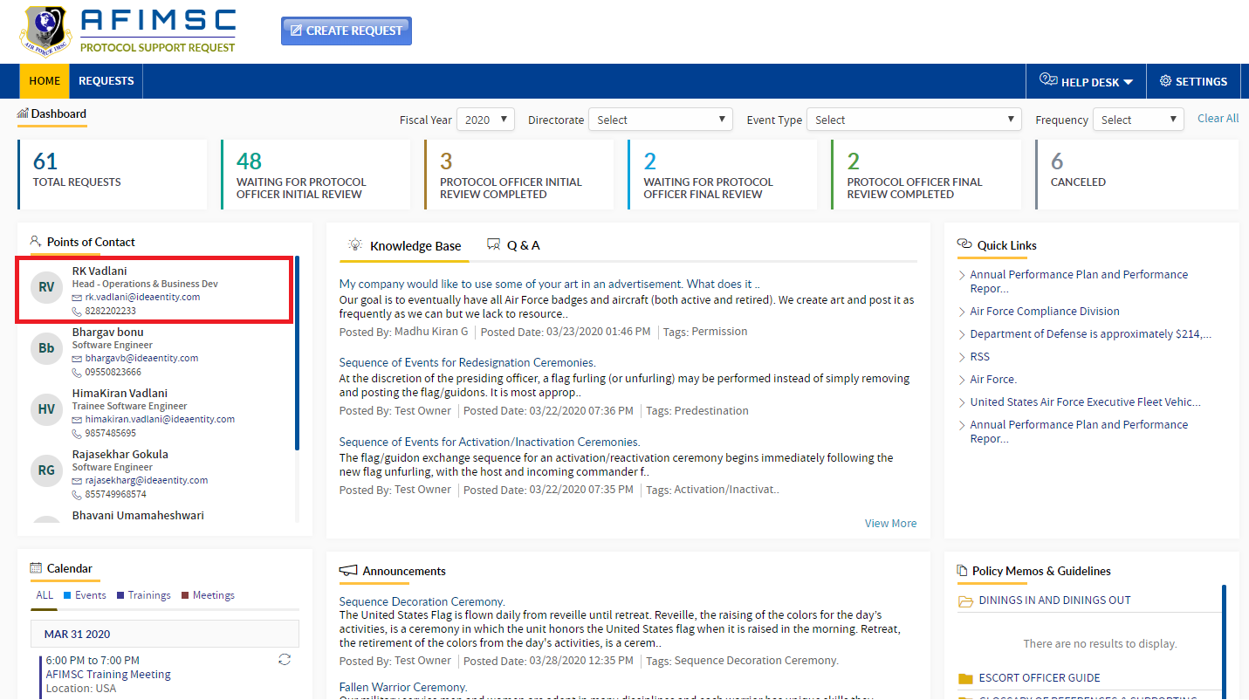

### EDIT THE ITEM

1. Choose the item, and click on the **Edit** icon.

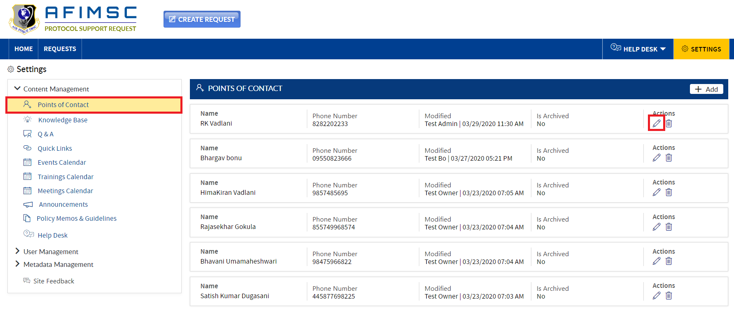

1. The **Edit** pop-up will be displayed with the **Is Archived** field and the **Update**/**Cancel** buttons.

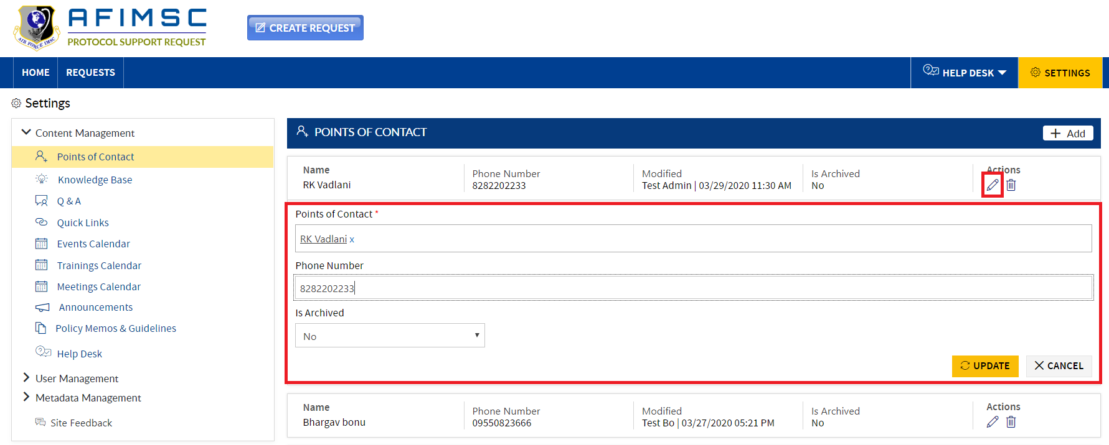

1. **Edit** the required field details and click the **Update** button.

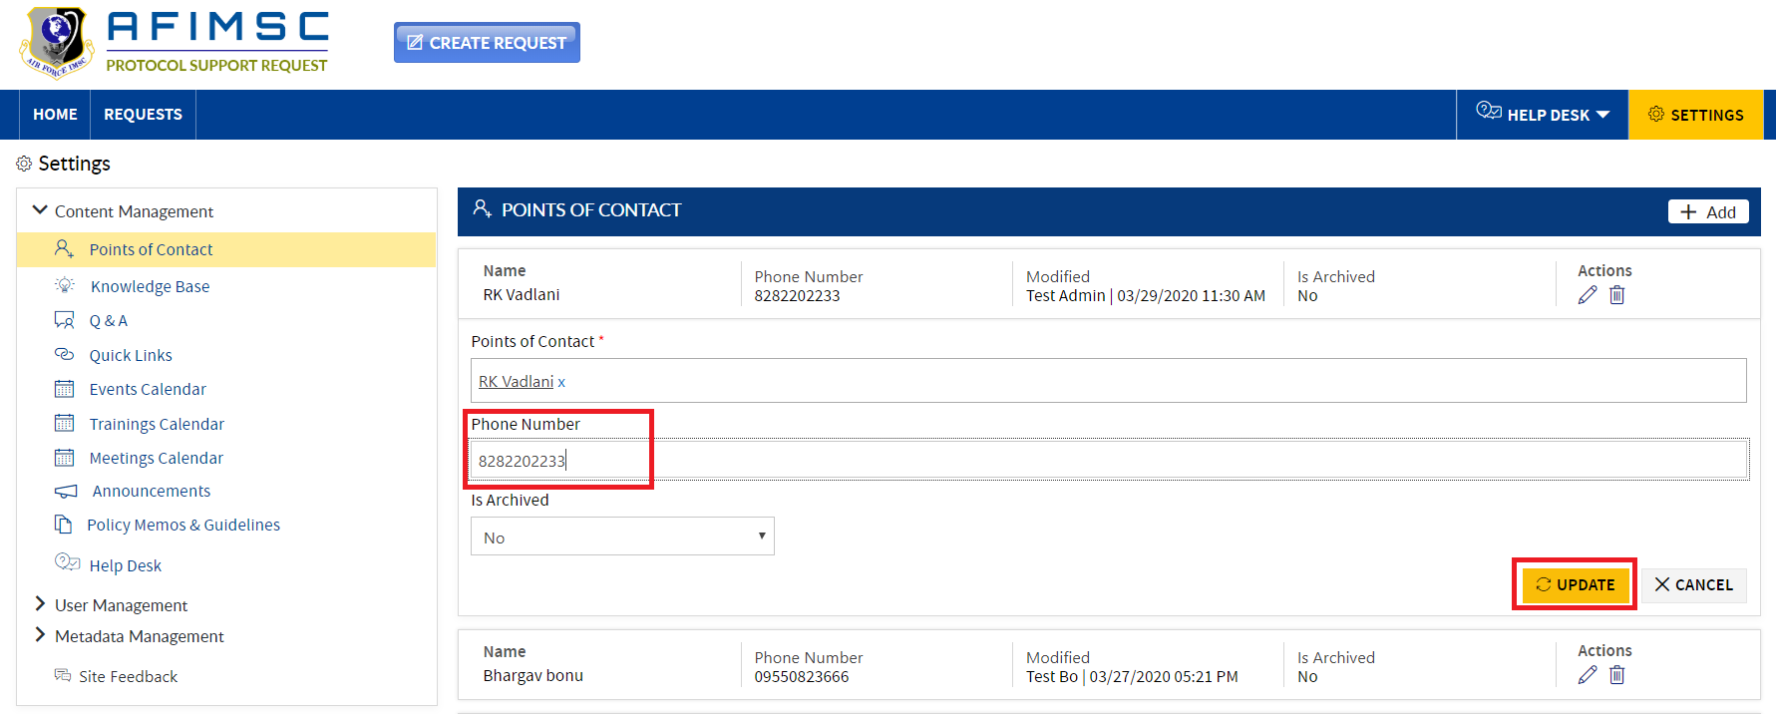

1. The item will be updated and visible on top in the **Settings** page under the **Points of Contact** section.



### ARCHIVE THE ITEM

To archive the item, follow the steps below:

1. Choose the item, and click the **Edit** icon.



1. The **Edit** pop-up will be displayed with the **Is Archived** field and the **Update**/**Cancel** buttons.



1. In the **Is Archived** field dropdown, select **Yes** and click the **Update** button.

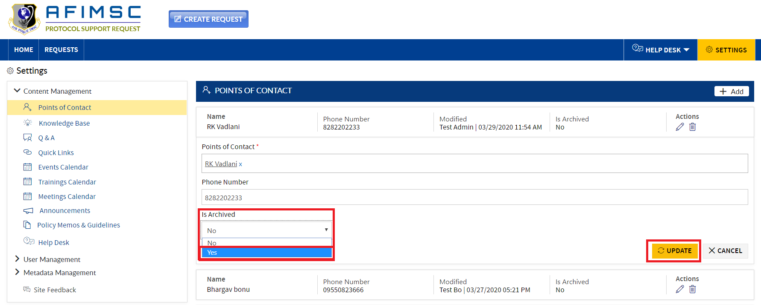

1. The item will now be archived.

Note: The archived item will not be visible in the Home Page under the **Points of Contact** section.

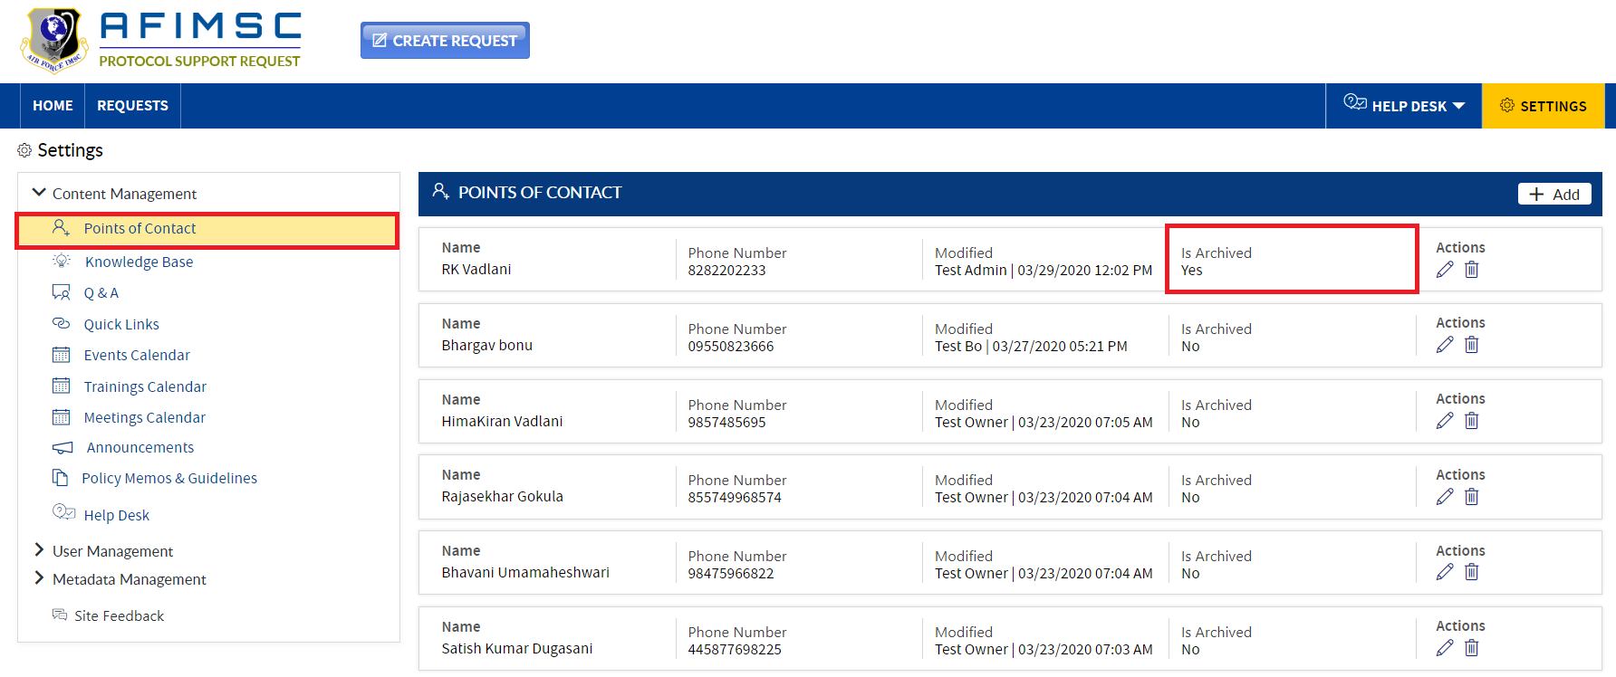

### DELETE ITEM

To **Delete** a **Points of Contact** item, follow the steps below:

1. Choose the item, then click on the **Delete** icon.

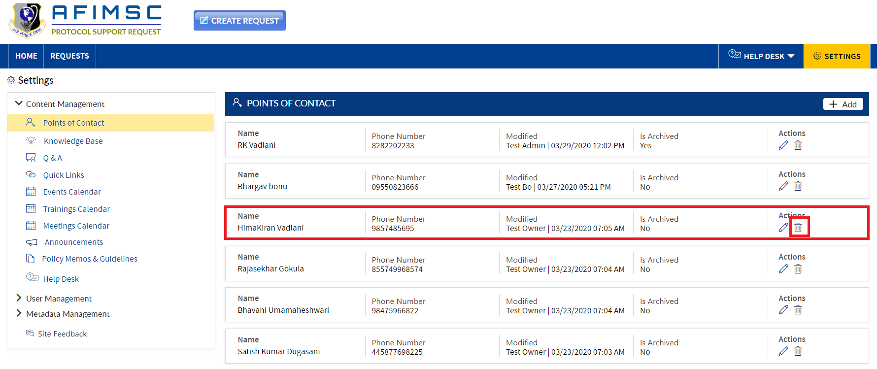

1. A confirmation pop-up will display, then click on the **OK** button.

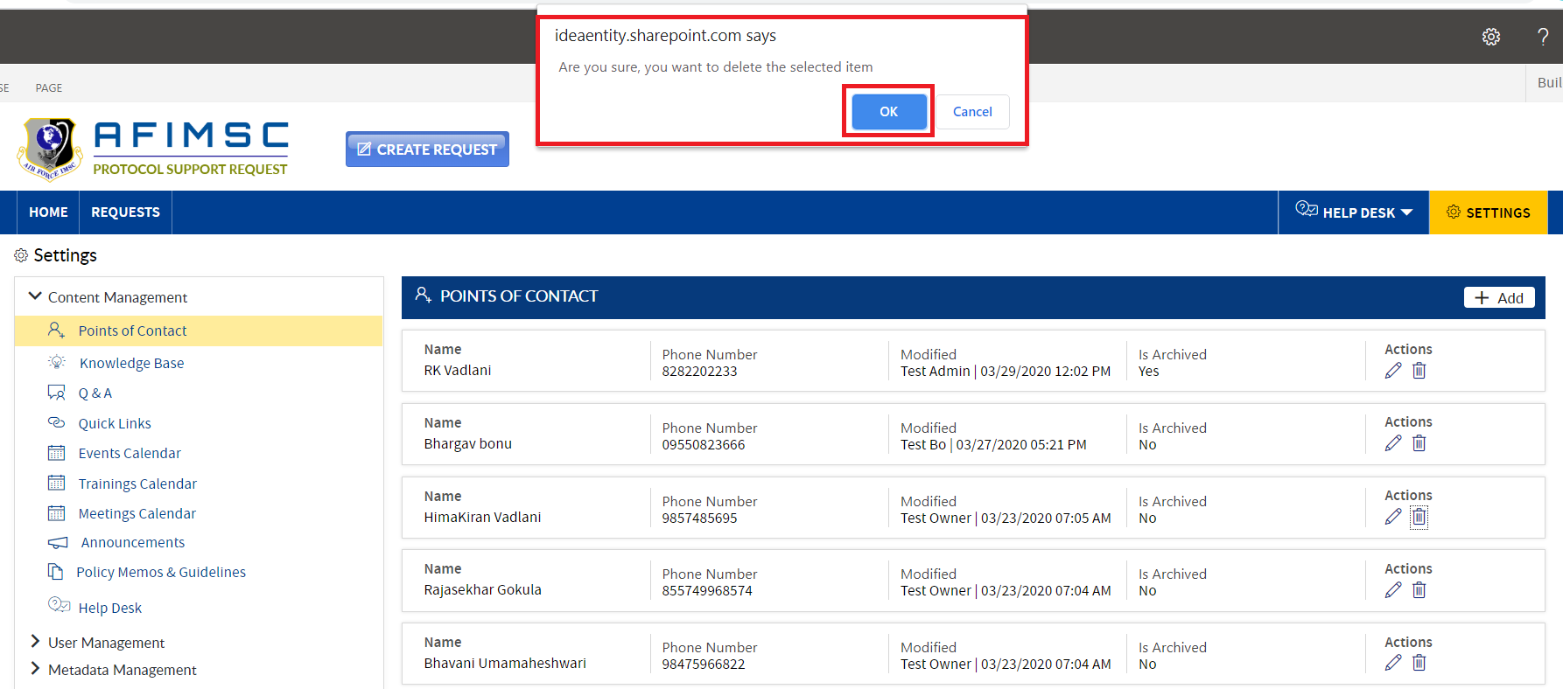

1. The item will be deleted from the list.

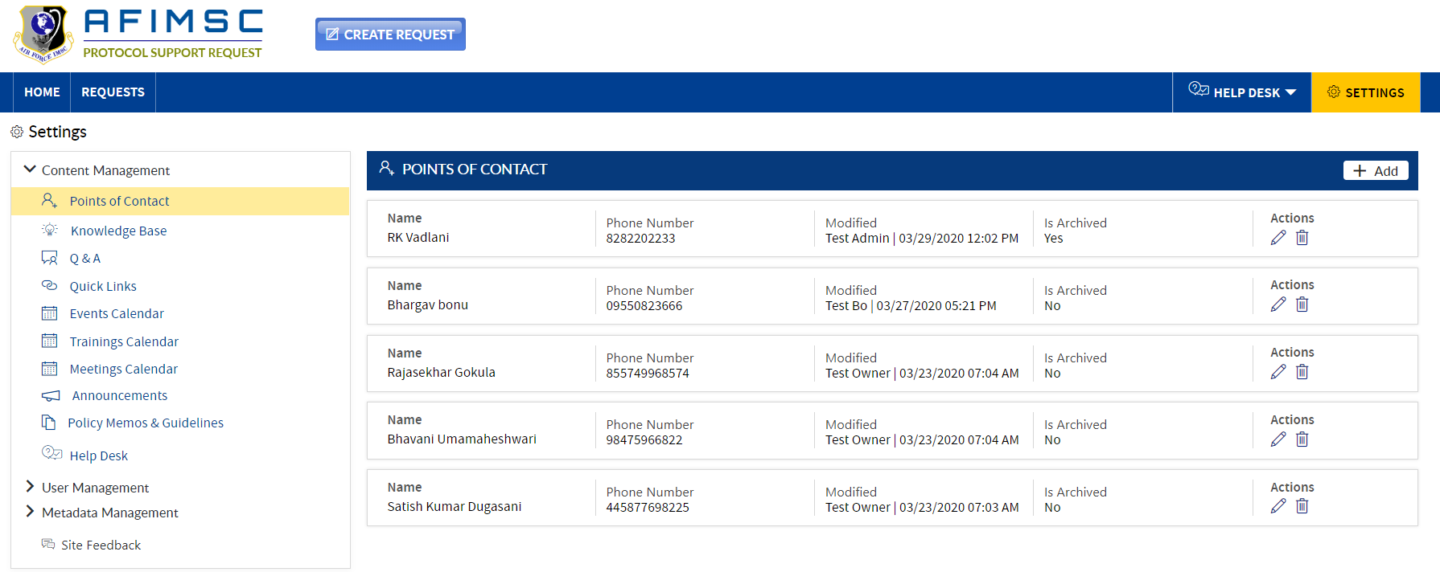

1. The deleted item will no longer be visible in the **Settings** page under the **Points of Contact** section.

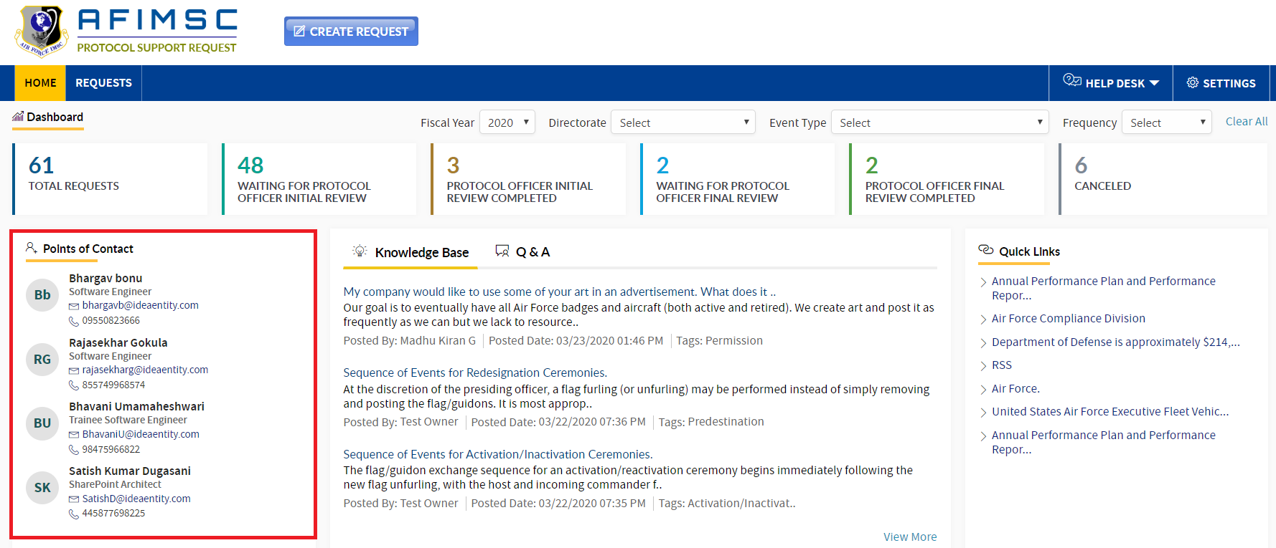

# KNOWLEDGE BASE

**Protocol Support Request Owners** and/or the **Protocol Officer** can manage add/edit/archive/delete the items in the list.

### ADD NEW ITEM

To add a new item in the list, follow the steps below:

1. In the **Content Management** section, click on the **Knowledge Base** link. Respective details will be visible on the right-hand side.
2. Click on the **Add** button in the right-side corner. The **Add** pop-up will be displayed.

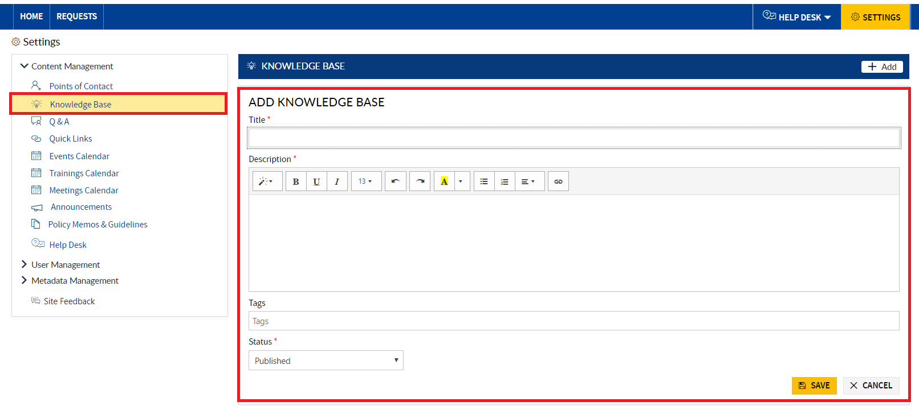

1. Enter the Title, Description, Tag and Status then click the **Save** button.

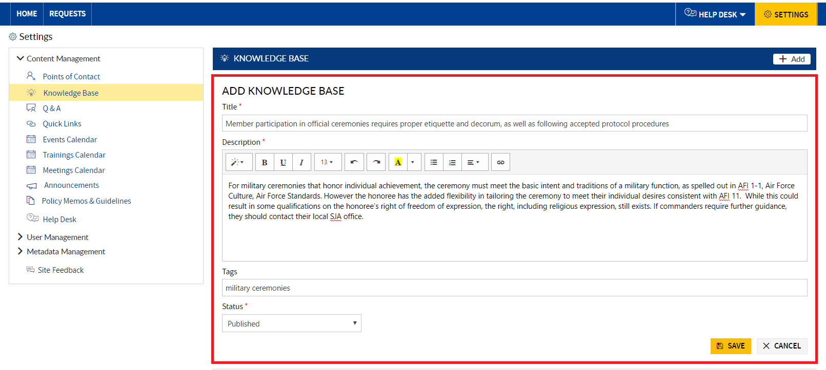

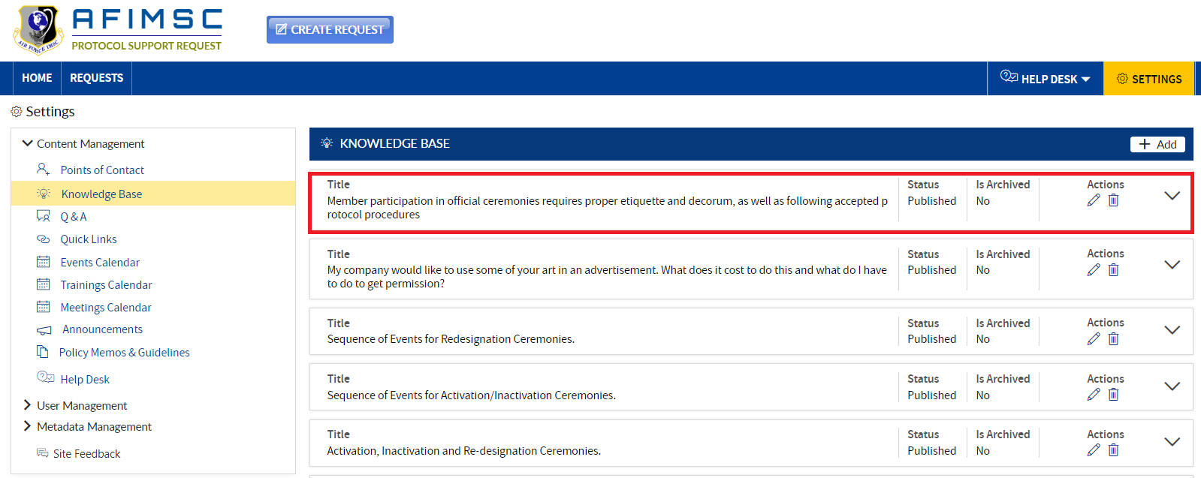

1. The added item will be displayed at the top of the **Knowledge Base** section on the Home Page.

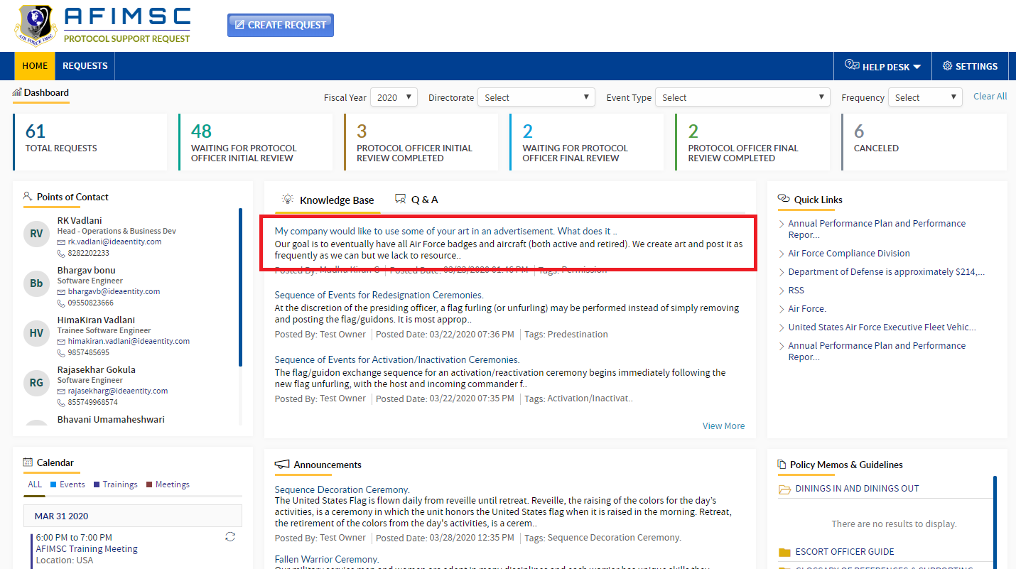

### EDIT THE ITEM

1. Choose the item to be changed, and click on the **Edit** icon.

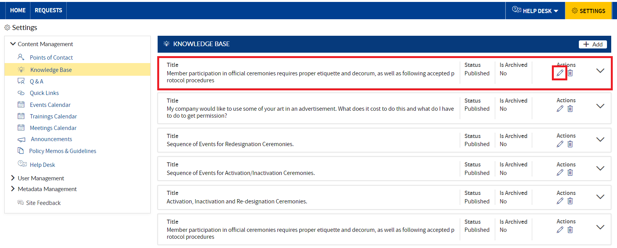

1. The **Edit** pop-up will be displayed with the **Is Archived** field and **Update**/**Cancel** buttons.

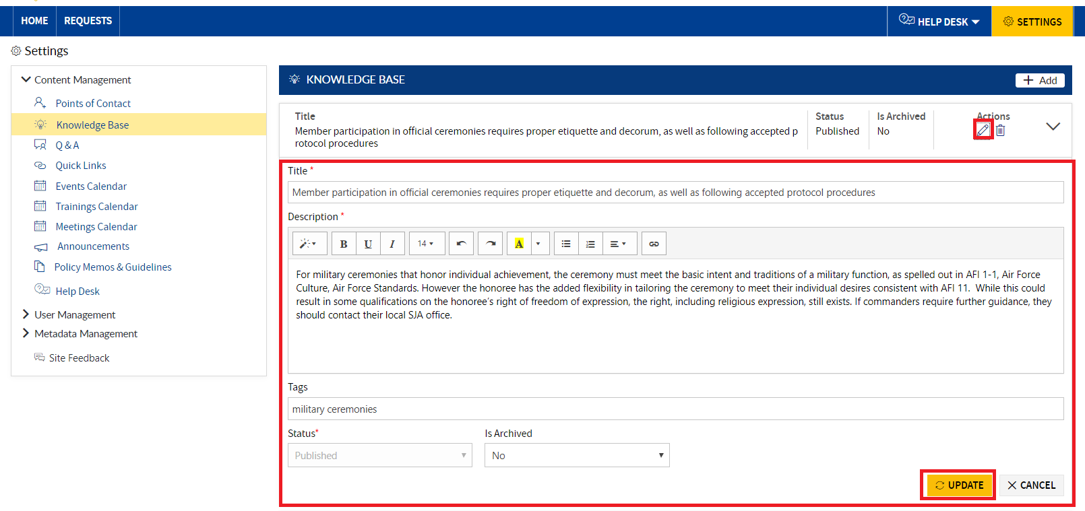

1. **Edit** the required field details and click the **Update** button.



1. The item will be updated and visible on top in the **Settings** Page under the **Knowledge Base** section.



### ARCHIVE THE ITEM

To archive the item, follow the steps below:

1. Choose the item, then click on the **Edit** icon.



1. The **Edit** pop-up will be displayed with the **Is Archived** field and the **Update**/**Cancel** buttons.



1. In the **Is Archived** field dropdown, select **Yes** and click the **Update** button.

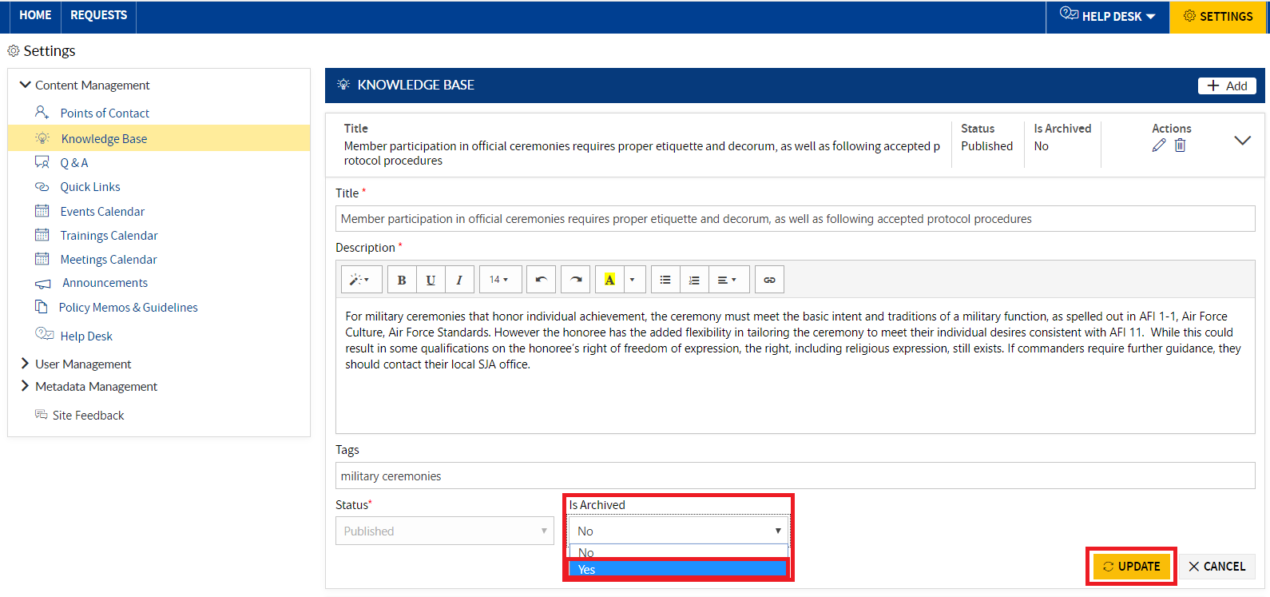

1. The item will now be archived.

Note: The archived item will not be visible on the Home Page under **Knowledge Base** section.

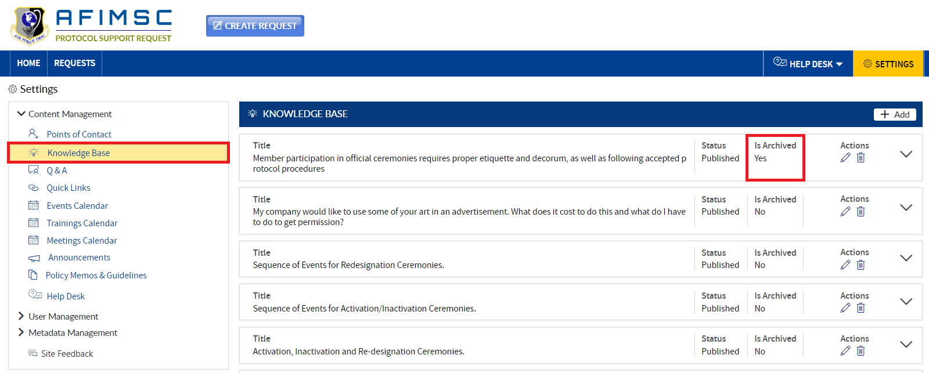

### DELETE ITEM

To **Delete** the **Knowledge Base** item, follow the below steps:

1. Choose the item, then click on the **Delete** icon.

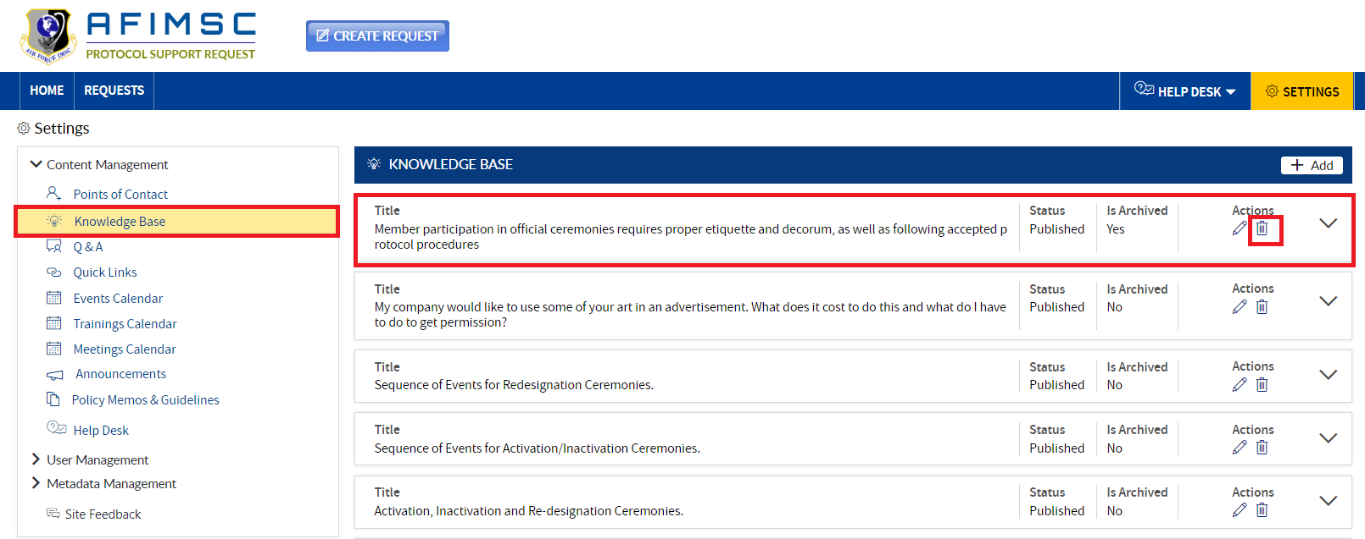

1. The confirmation pop-up will display. Click on the **OK** button.

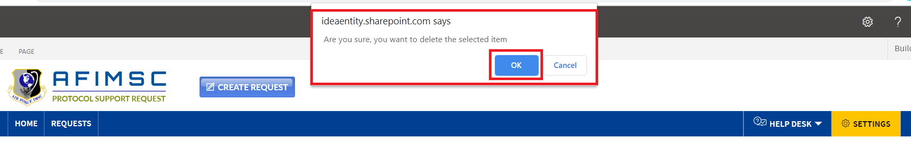

1. The item will be deleted from the list.

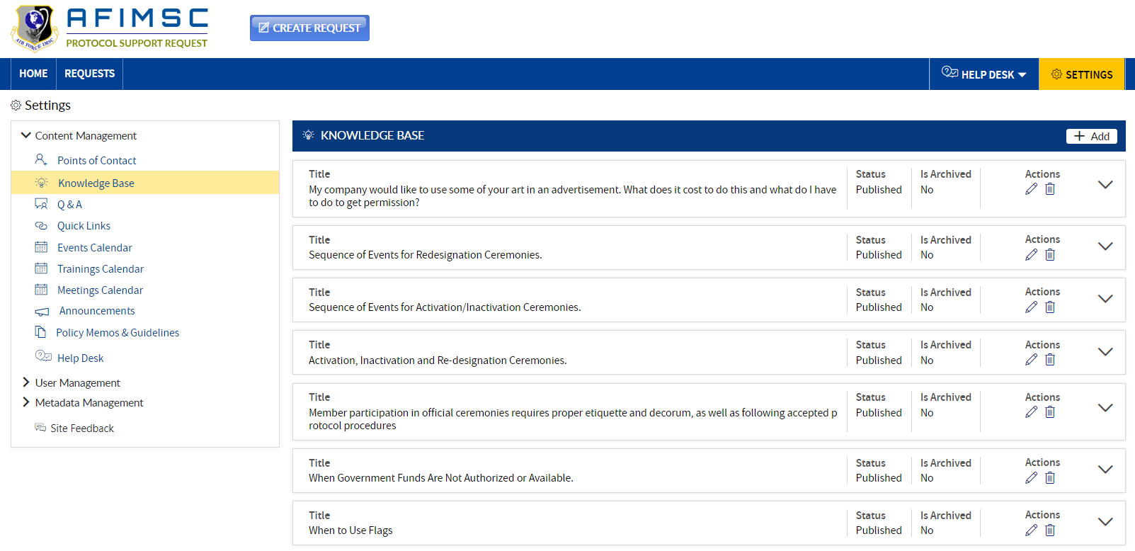

1. The deleted item will not visible on the Home Page under the **Knowledge Base** section.

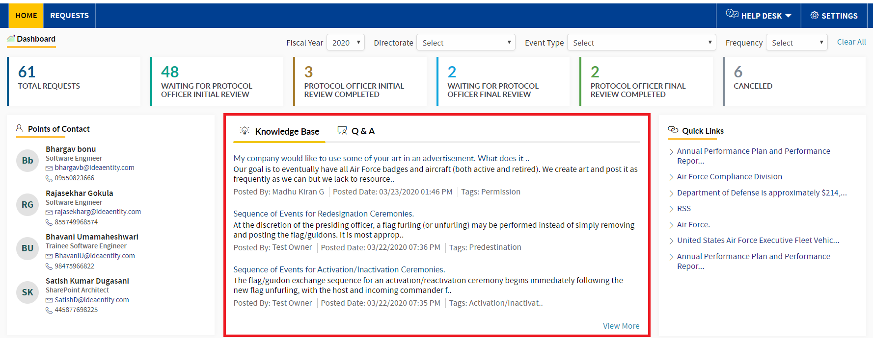

# Q&A SECTION

The user may ask questions related to the events and site. The user can view the all **Questions & Answers** for any queries. **Protocol Support Request Owners** and/or the **Protocol Officer** can add/edit/archive/delete the items in the list.

### ADD NEW ITEM

To add a new item in the list, follow the steps below:

1. In the **Content Management** section, click on the **Q&A** link. Respective details will be visible to the right.

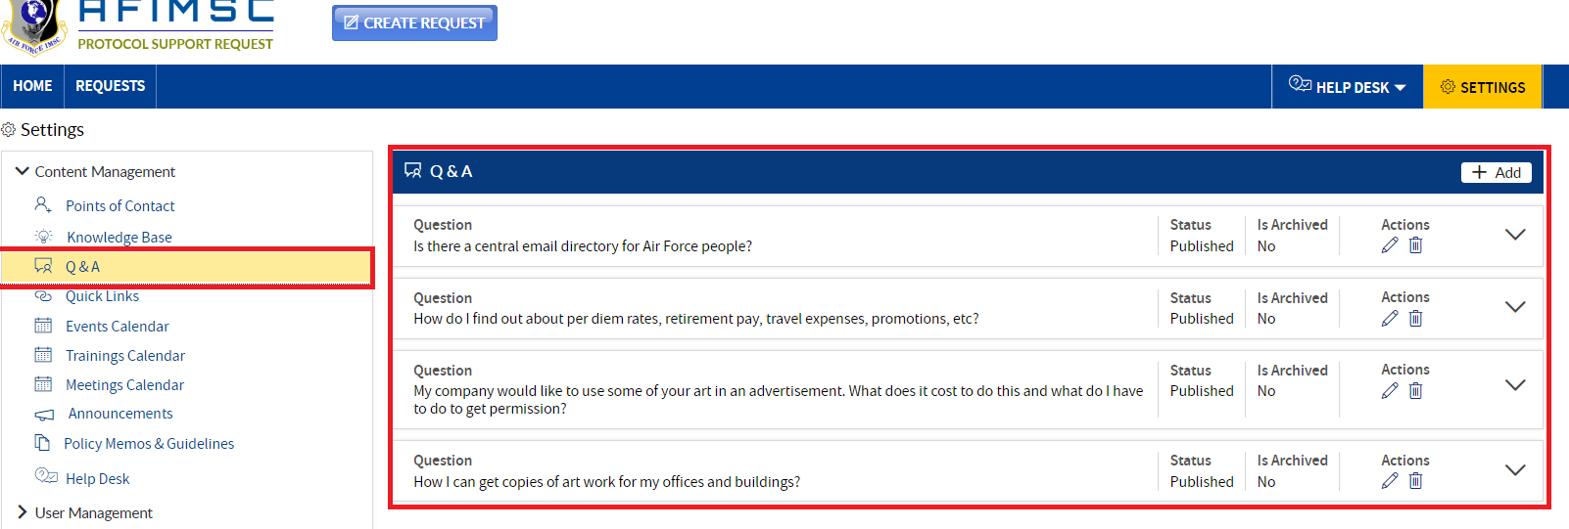

1. Click on the **Add** button in the right-side corner, and the **Add** pop-up will then be displayed.

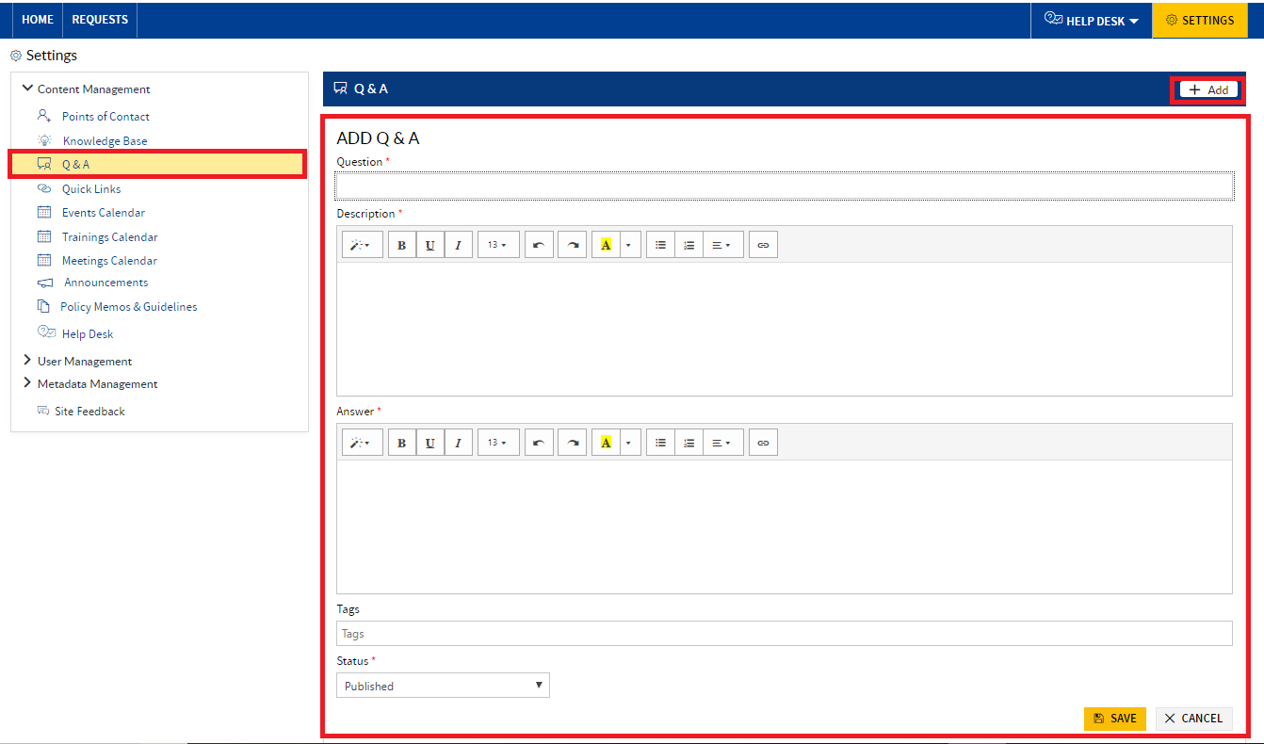

1. Enter all information in the required fields, and click on the **Save** button.

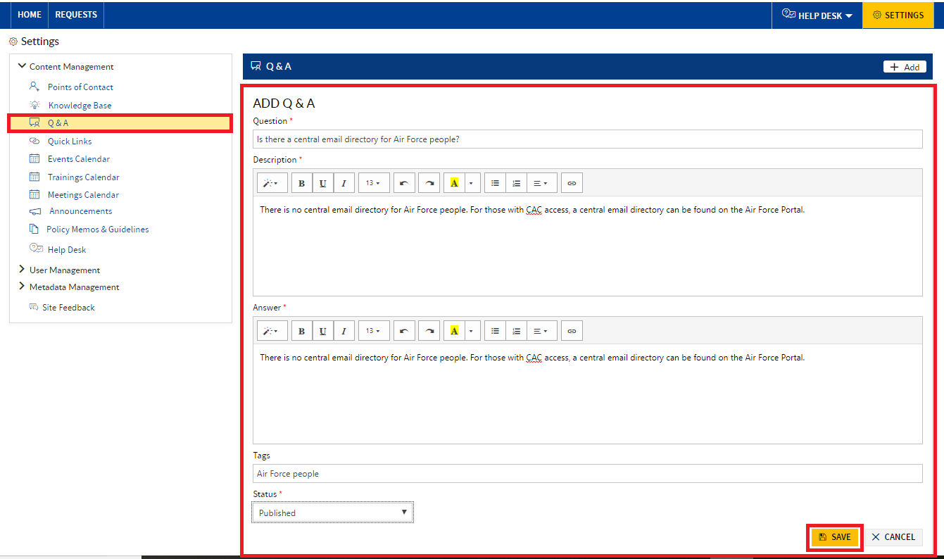

1. The item will be added, and will be displayed at the top of the list under the **Q&A** section.

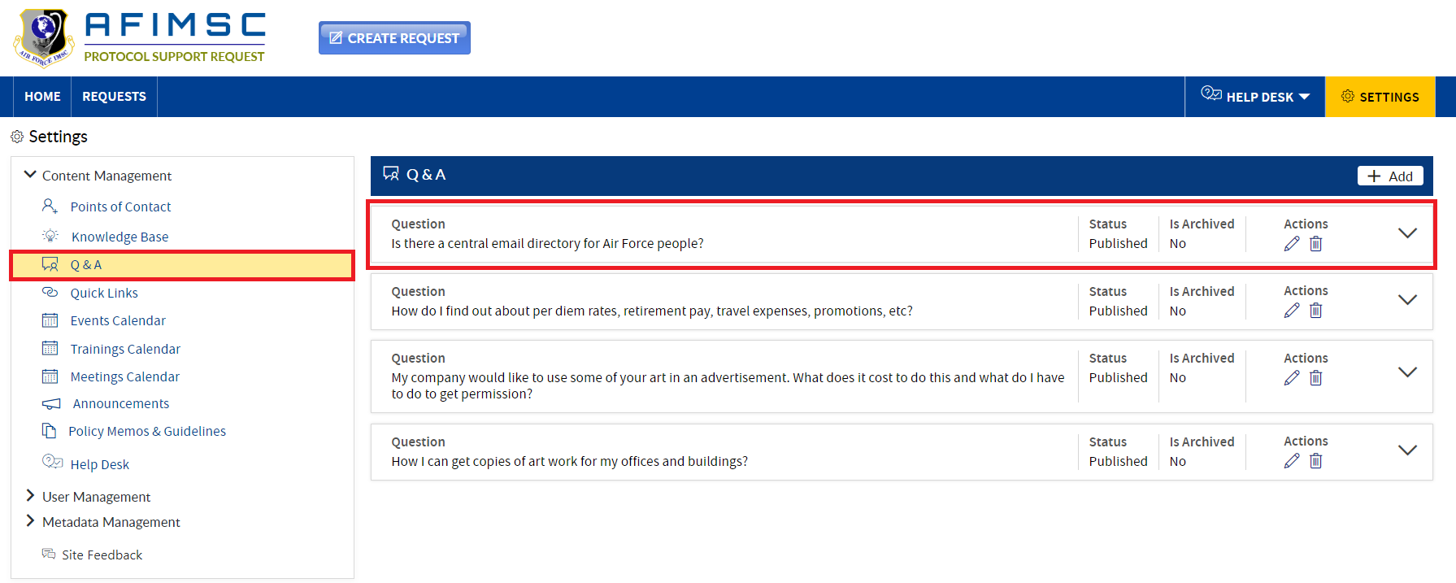

1. The added item will be displayed on top of the Home Page under the **Q&A** section.

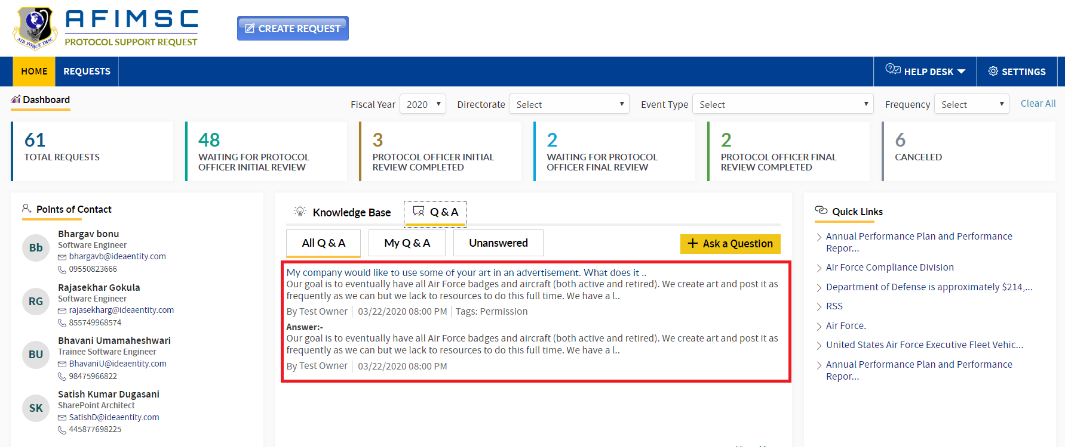

### EDIT THE ITEM

1. Choose the item and click on the **Edit** icon.

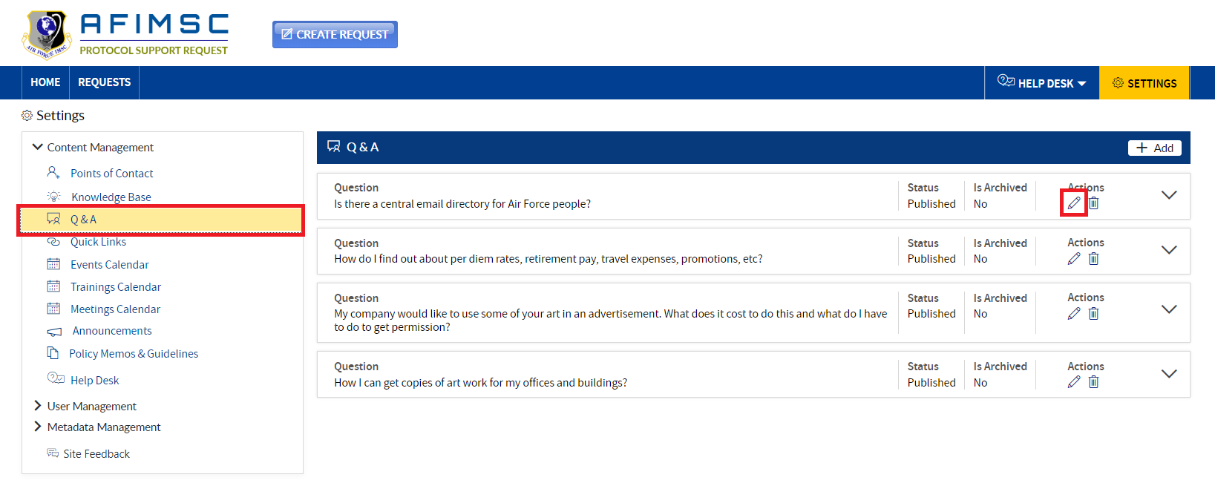

1. The **Edit** pop-up will be displayed with the **Is Archived** field and the **Update/Cancel** buttons.

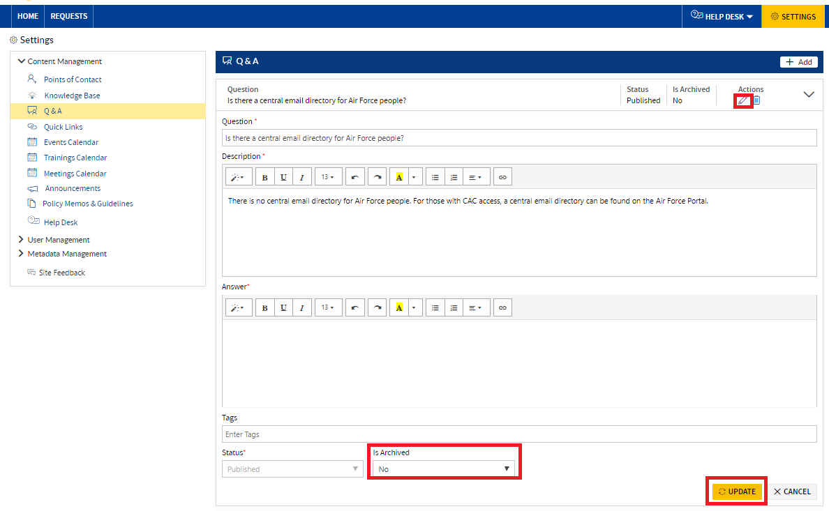

1. **Edit** the required field details and then click on the **Update** button.

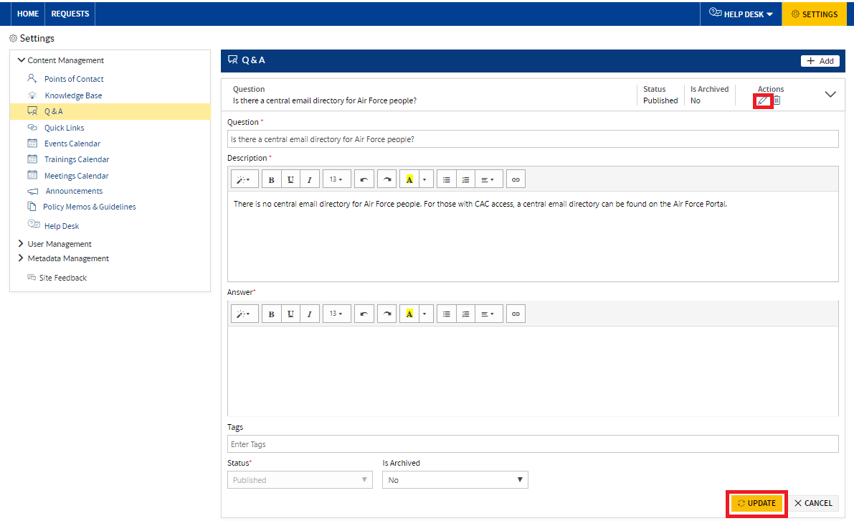

1. The item will be updated and visible on the **Settings** Page at the top of the **Q&A** section.



### ARCHIVE THE ITEM

To archive the item, follow the steps below:

1. Choose the item, then click on the **Edit** icon.



1. The **Edit** pop-up will be displayed with the **Is Archived** field and the **Update**/**Cancel** buttons.



1. In the **Is Archived** field dropdown, select **Yes,** and then click on the **Update** button.

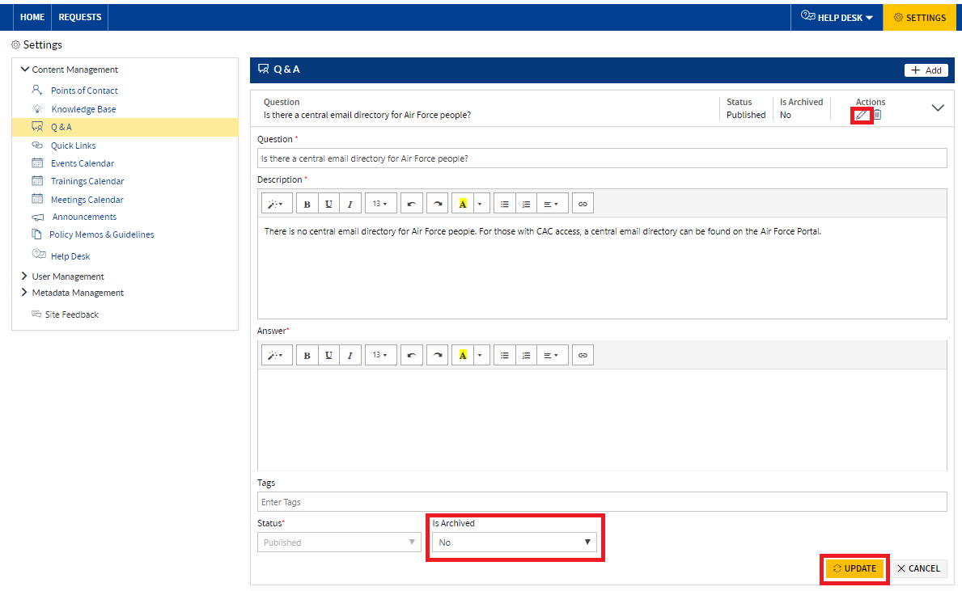

1. The item will now be archived.

Note: The archived item will not be visible in the Home Page under the **Q&A** section.

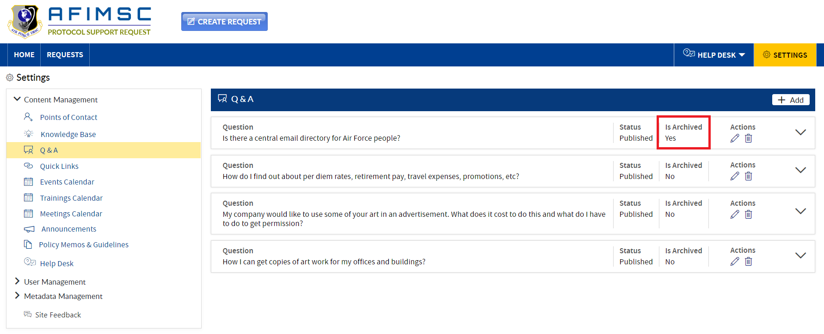

### DELETE ITEM

To delete the **Q&A**, follow the steps below:

1. Choose the item, then click on the **Delete** icon.

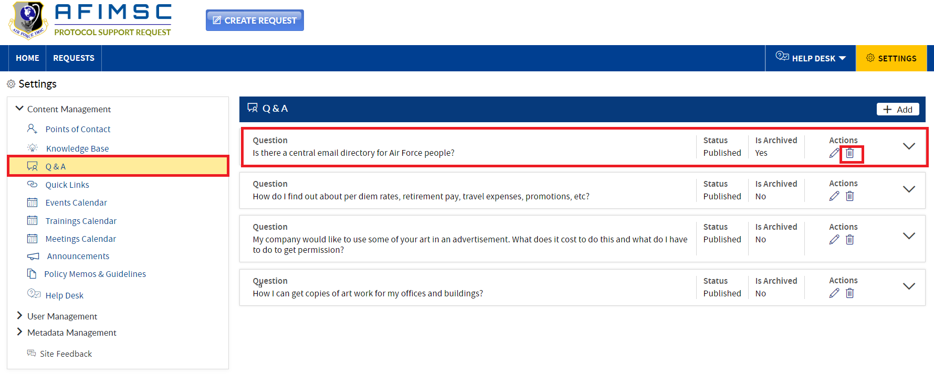

1. A confirmation pop-up will display. From there, click on the **OK** button.



1. The item will now be deleted from the list.

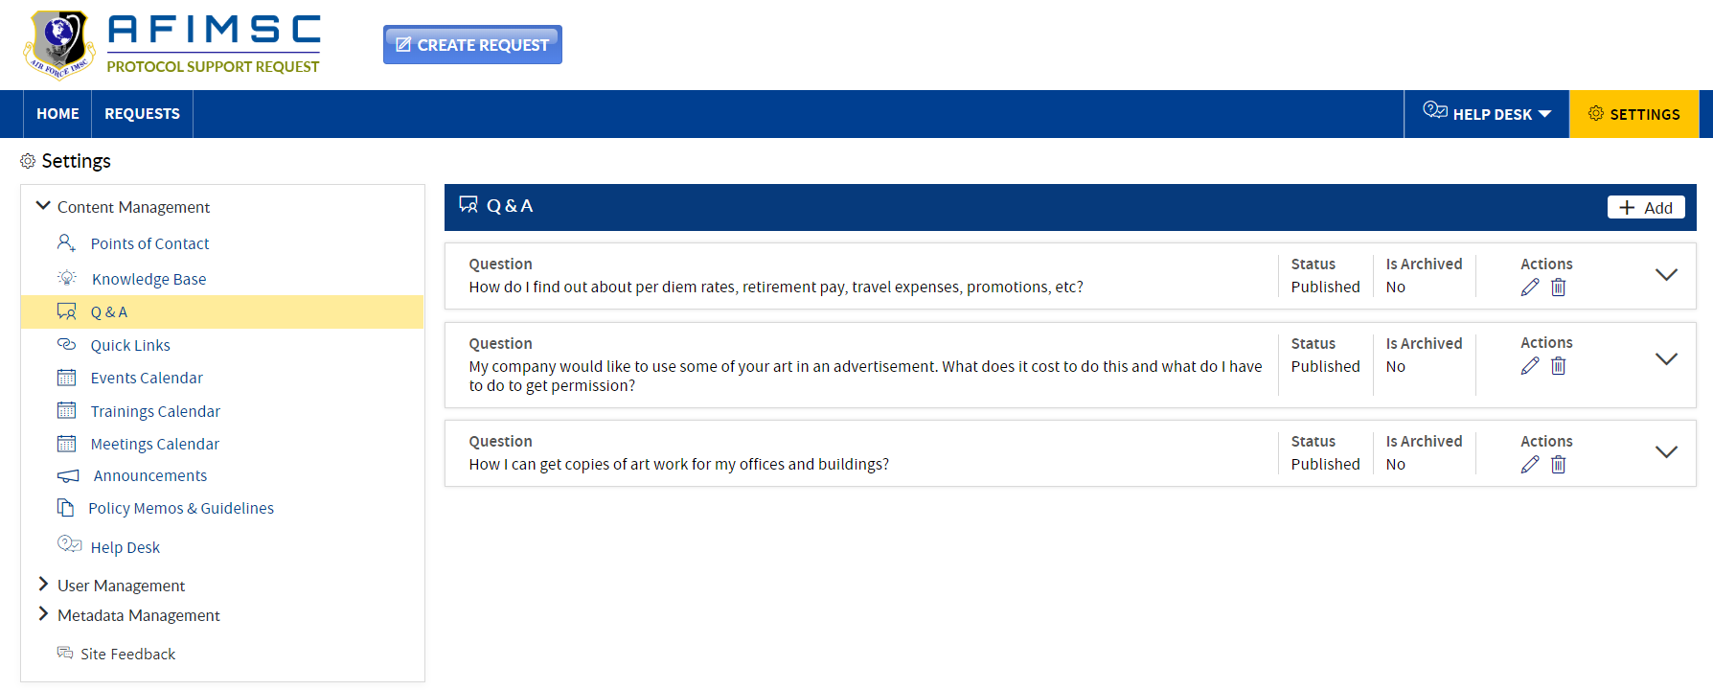

1. The deleted item will not be visible in the Home Page under the **Q&A** section.

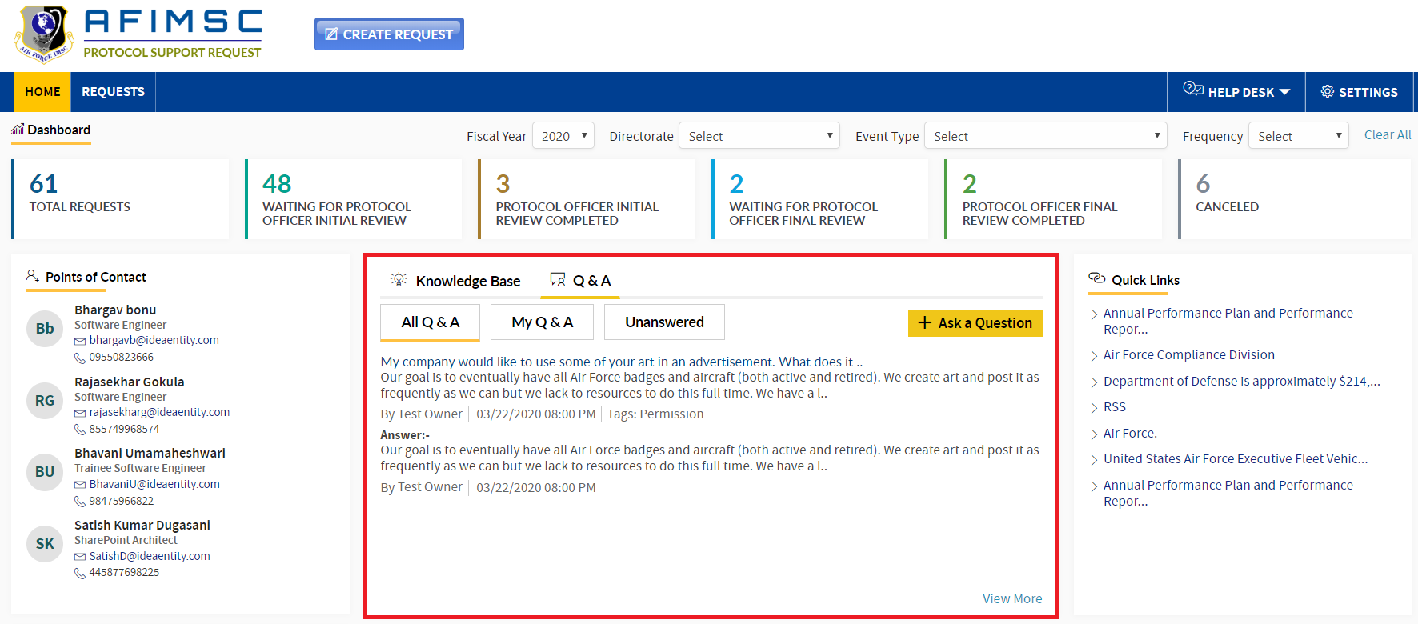

# QUICK LINKS

**Protocol Support Request Owners** and/or the **Protocol Officer** can add/edit/archive/delete the items in the list.

### ADD NEW ITEM

To add a new item in the list, follow the steps below:

1. In the **Content Management** section, click on **Quick Links**. The respective details will be visible on the right-hand side.

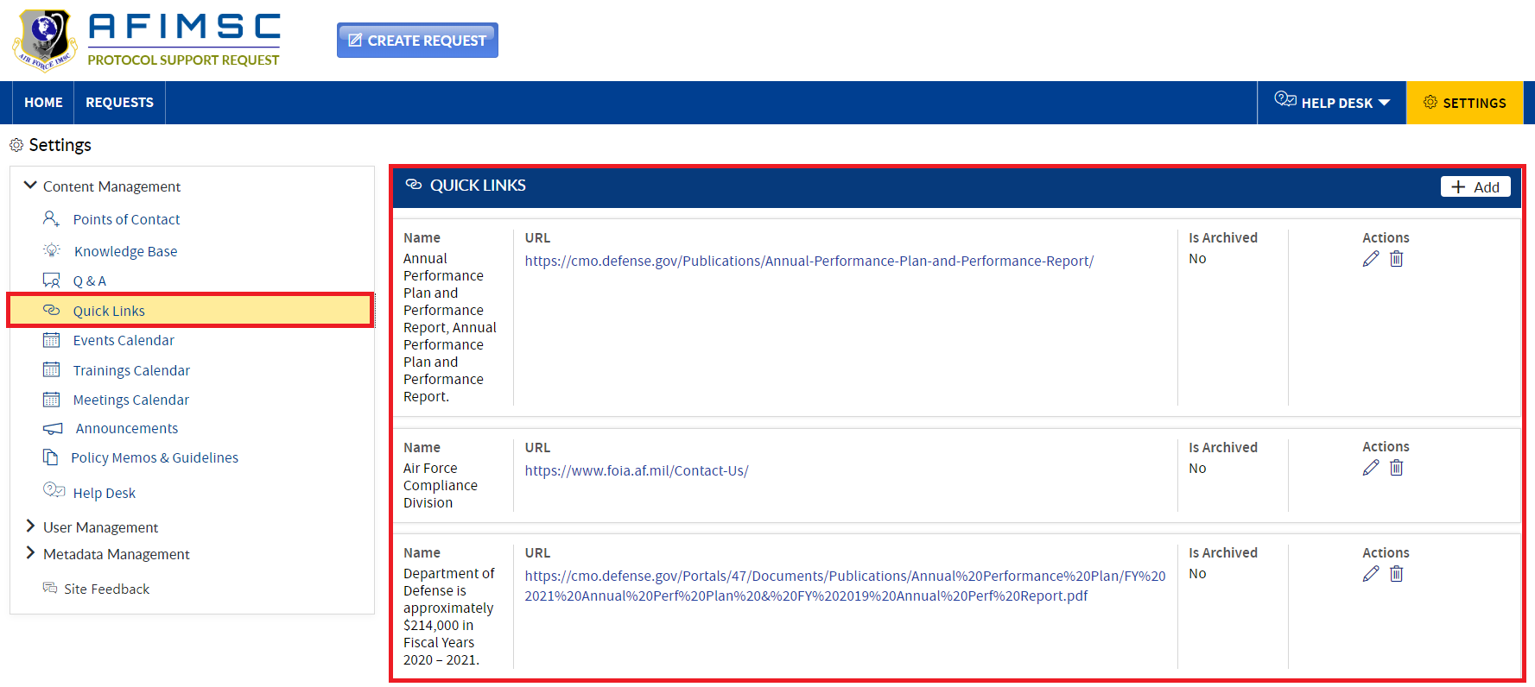

1. Click on the **Add** button in the right-side corner. The **Add** pop-up will be displayed.

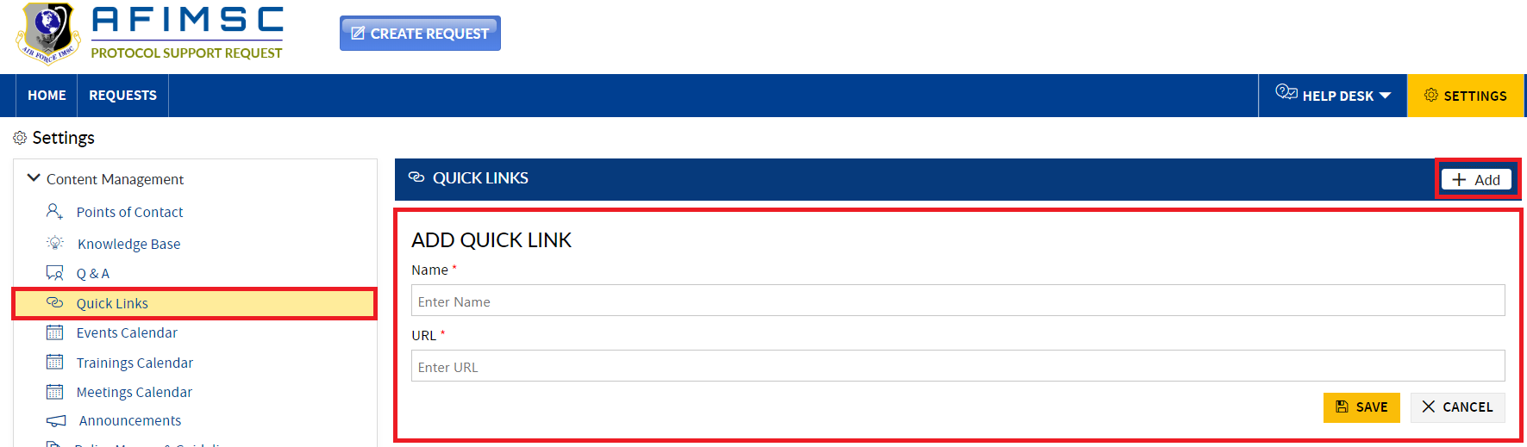

1. First, enter the URL name and then paste the URL. Then, click on the **Save** button.

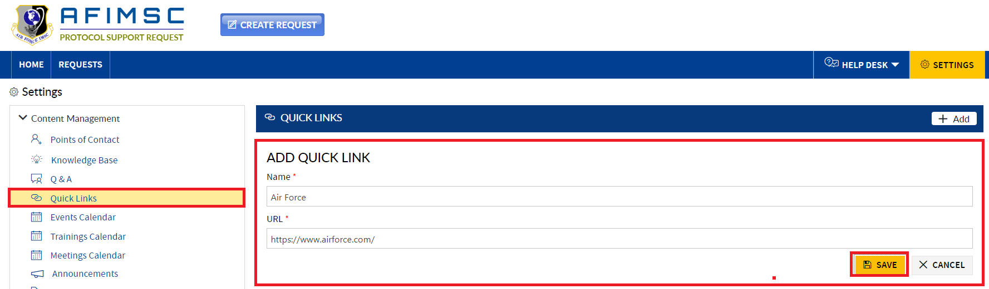

1. The item will be added and will be displayed on the **Settings** page at the top of the **Quick Links** section.

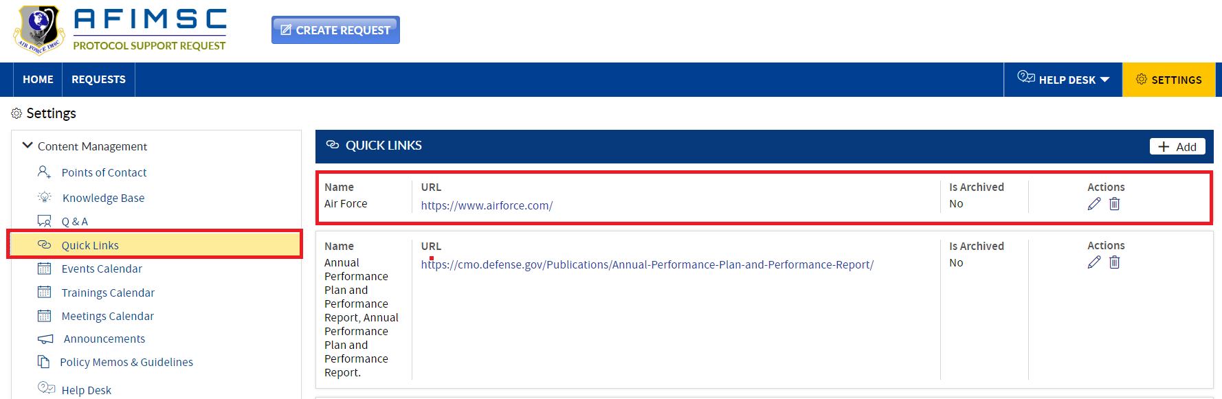

1. The added item will be displayed on the Home Page at the top of the **Quick Links** section.

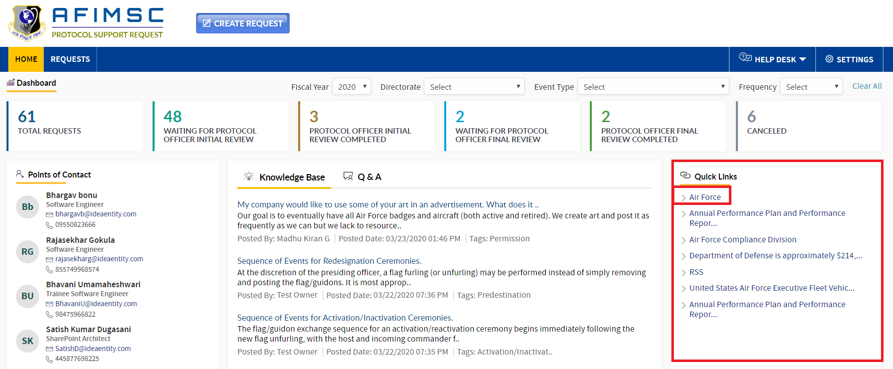

### EDIT THE ITEM

1. Choose the item, then click on the **Edit** icon.

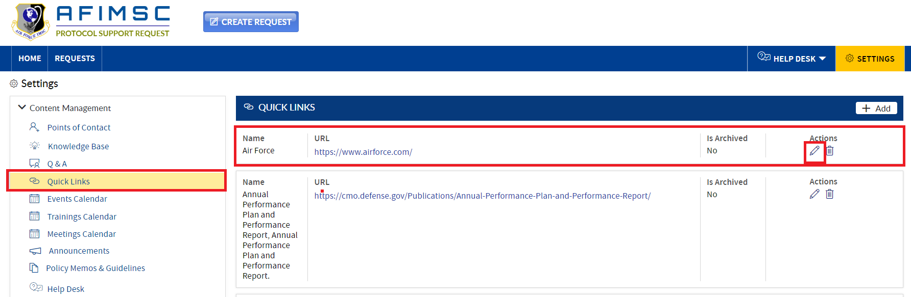

1. The **Edit** pop-up will be displayed with the **Is Archived** field and the **Update/Cancel** buttons.

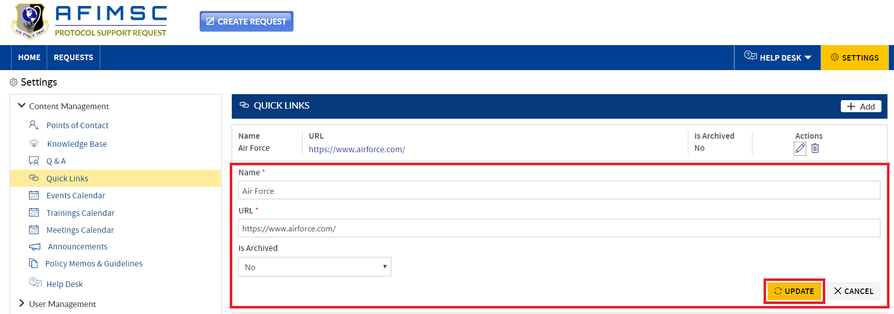

1. Edit the required field details and click on the **Update** button.



1. The updated item will be visible on top in the **Settings** page at the top of the **Quick Links** section.

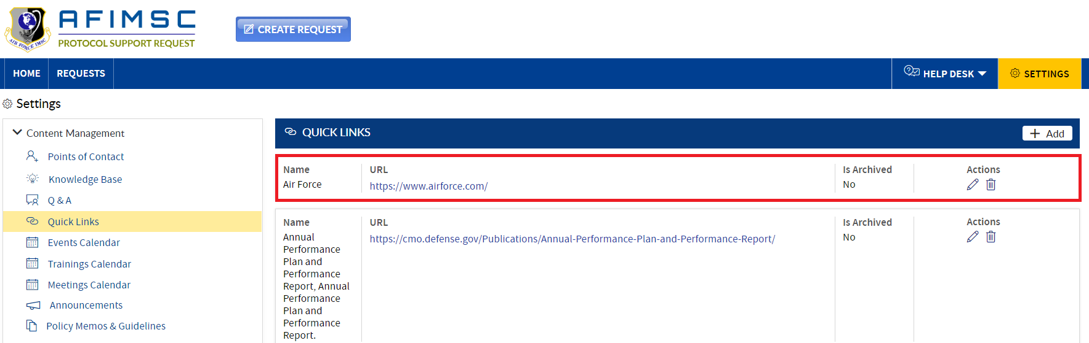

### ARCHIVE THE ITEM

To archive the item, follow the steps below:

1. Choose the item, then click on the **Edit** icon.



1. The edit pop-up will be displayed with the **Is Archived** field and the **Update/Cancel** buttons.



1. In the **Is Archived** field dropdown, select **Yes,** and then click the **Update** button.

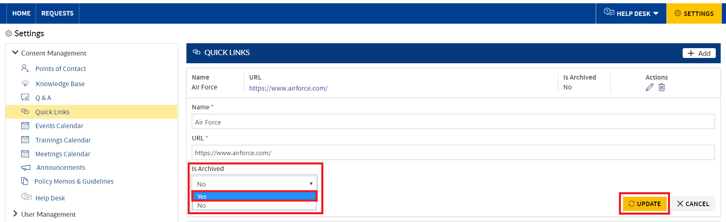

1. The item will now be archived.

Note: The archived item will not be visible on the Home Page under the **Quick Links** section.

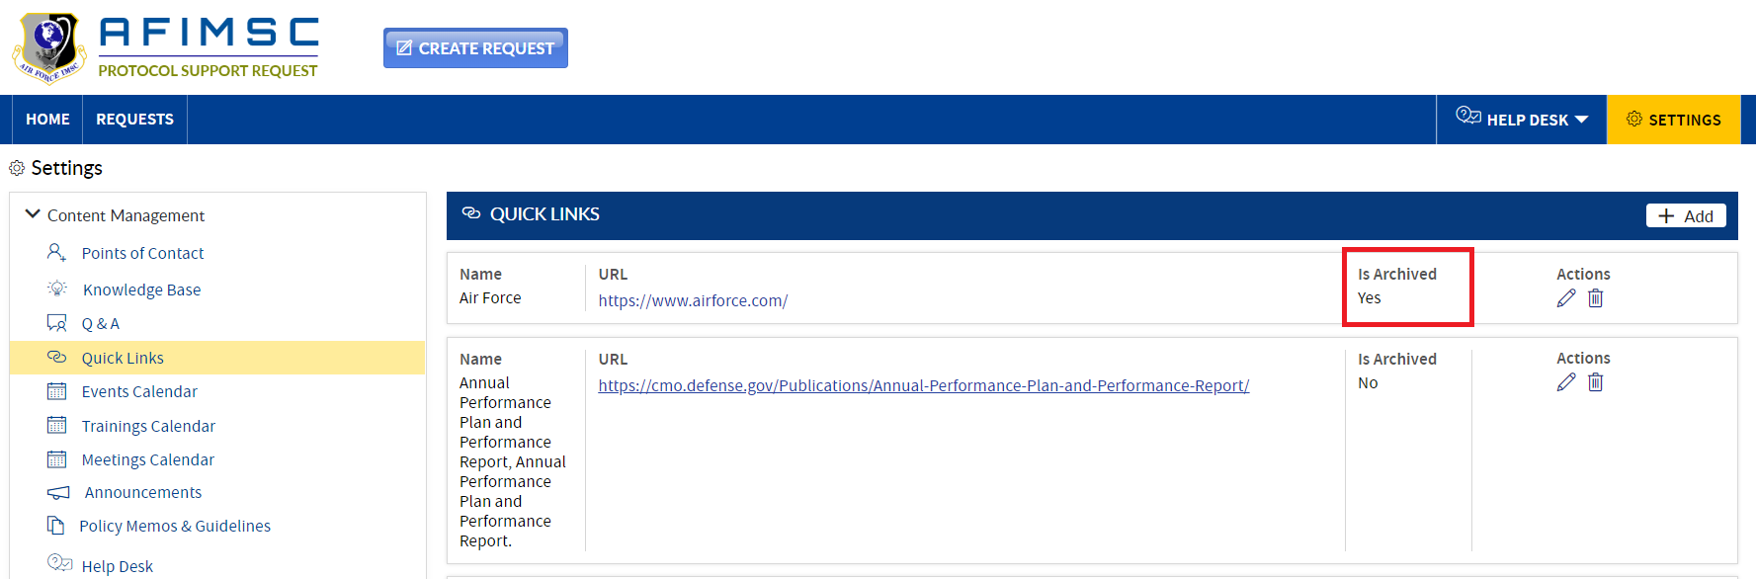

### DELETE ITEM

To delete the **Quick Links**, follow the steps below:

1. Choose the item, then click on the **Delete** icon.

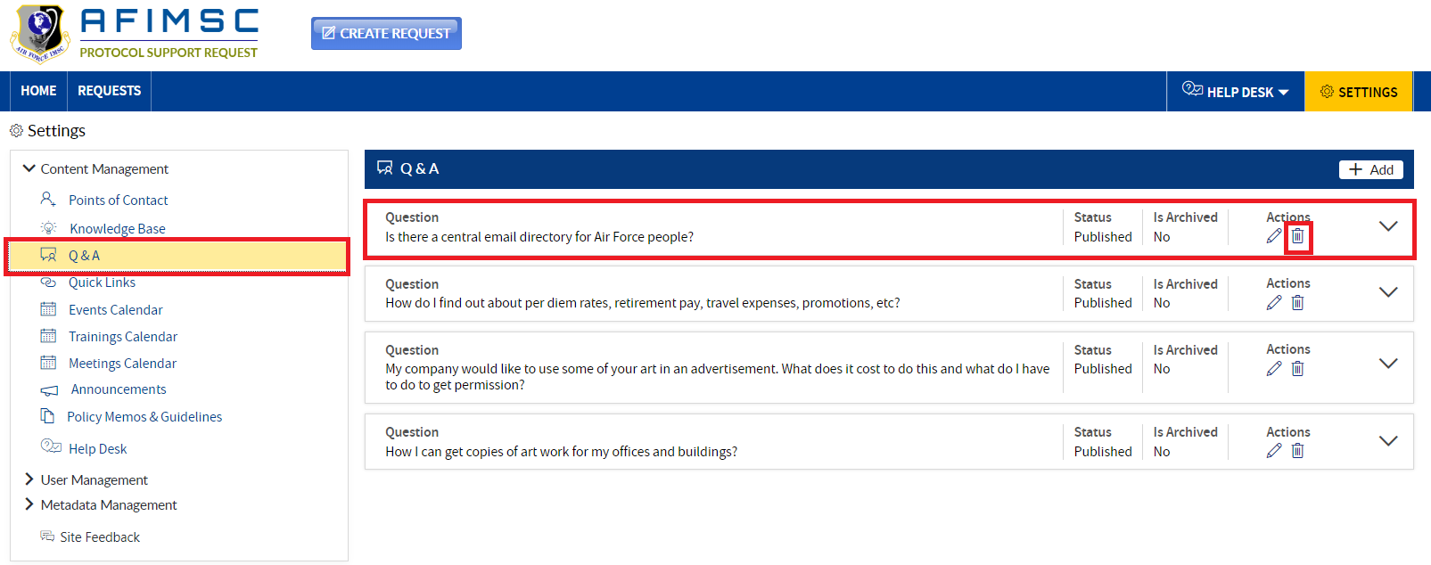

1. The confirmation pop-up will be displayed, then click on the **OK** button.



1. The item will be deleted from the list.

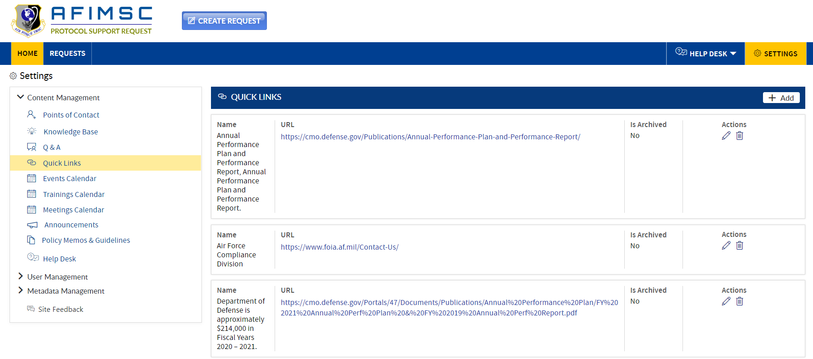

1. The deleted item will not be visible on the Home Page under the **Quick Links** section.

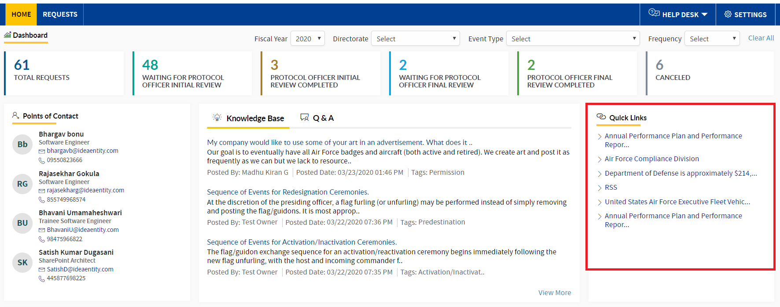

# CALENDAR

### Events/ Trainings/ Meeting Calendar

**Protocol Support Request Owners** and/or the **Protocol Officer** can add/edit/delete items from the **Calendar** lists.

### ADD NEW ITEM

To add a new **Calendar** item in the list, follow the steps below:

1. In the **Content Management** section, click on any of the **Events/ Trainings/ Meetings** found in the **Calendar**. Respective details will be visible on the right-hand side.

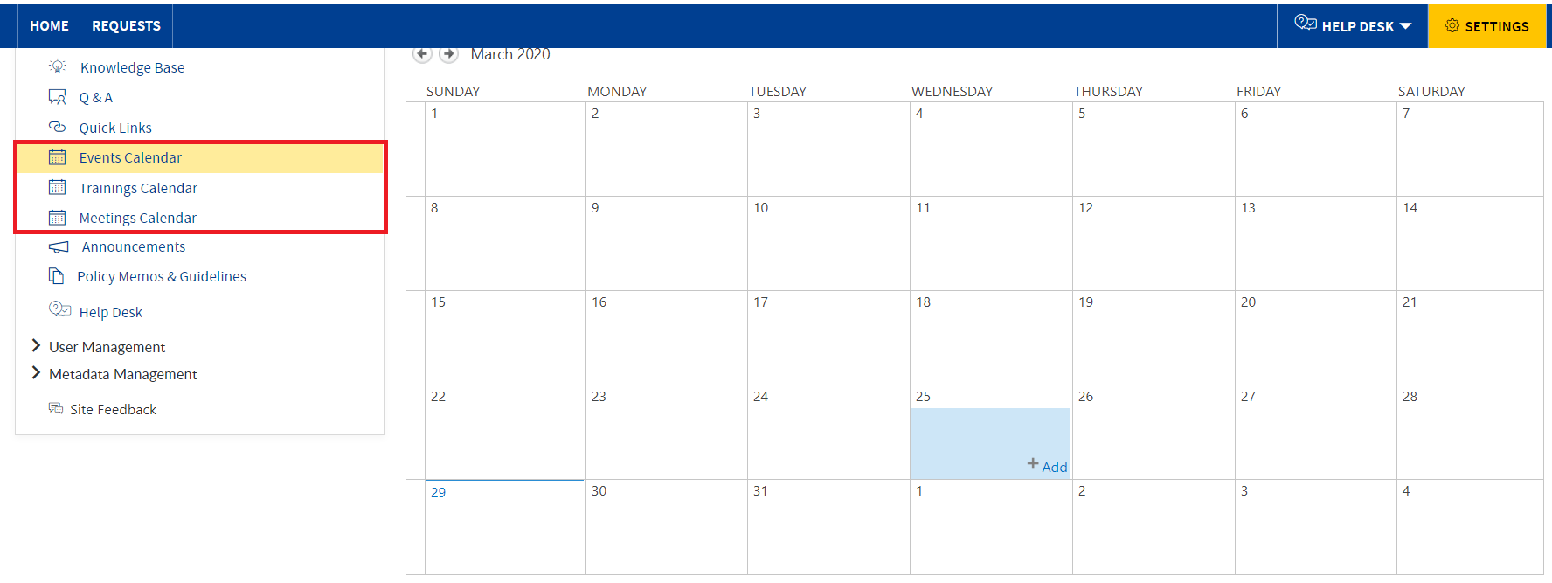

1. Select a date in the **Events/ Trainings/ Meetings** section. An **Add** button will be displayed on the date, proceed by clicking on the **Add** button.

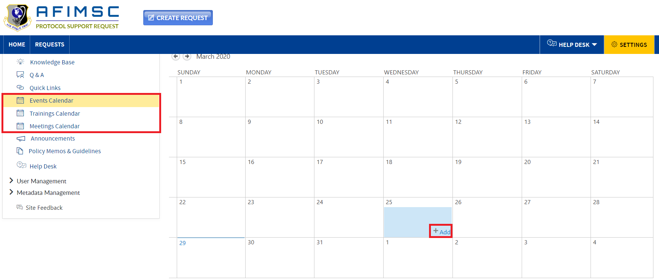

1. The **Add** pop-up will be displayed.

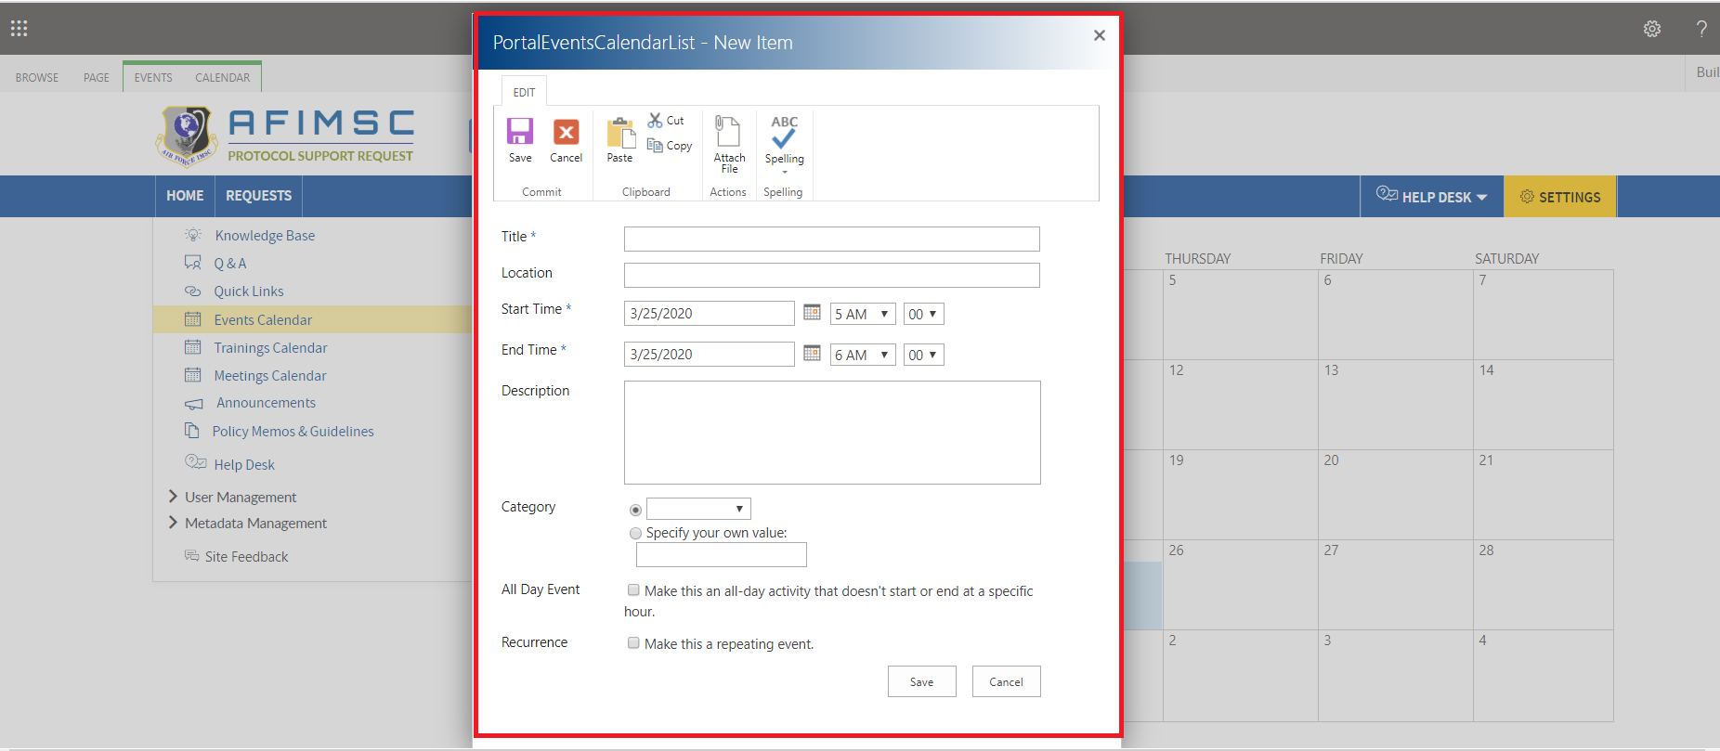

1. Enter information in all the required fields, then click the **Save** button.

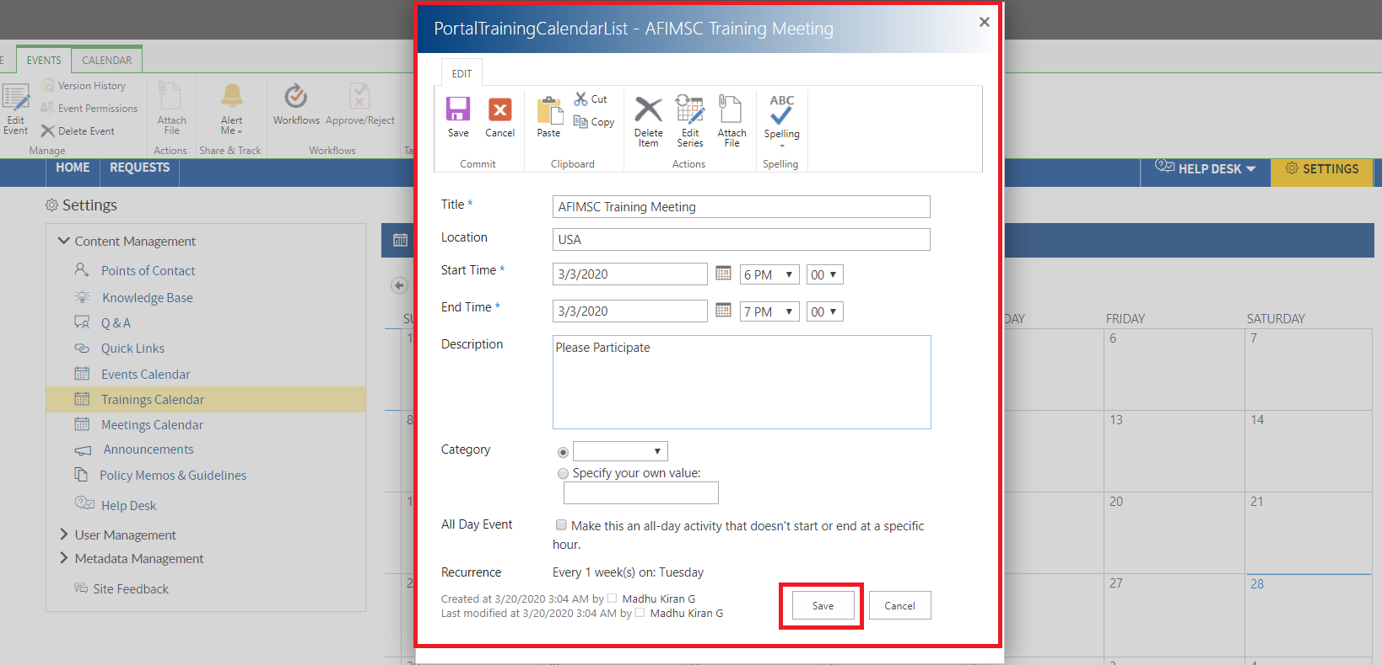

1. The added item will be displayed in the **Events/Trainings/Meetings Calendar** section.

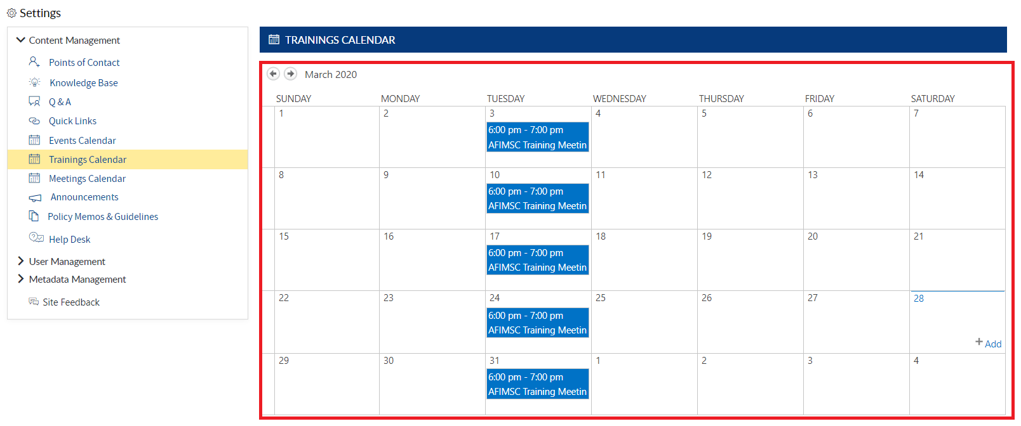

1. The added item will be displayed in the **Calendar** section.

### EDIT THE ITEM

1. Choose the item to be edited, and a pop-up will be displayed.



1. The edit pop-up will be displayed with the **Save**/**Cancel** buttons.

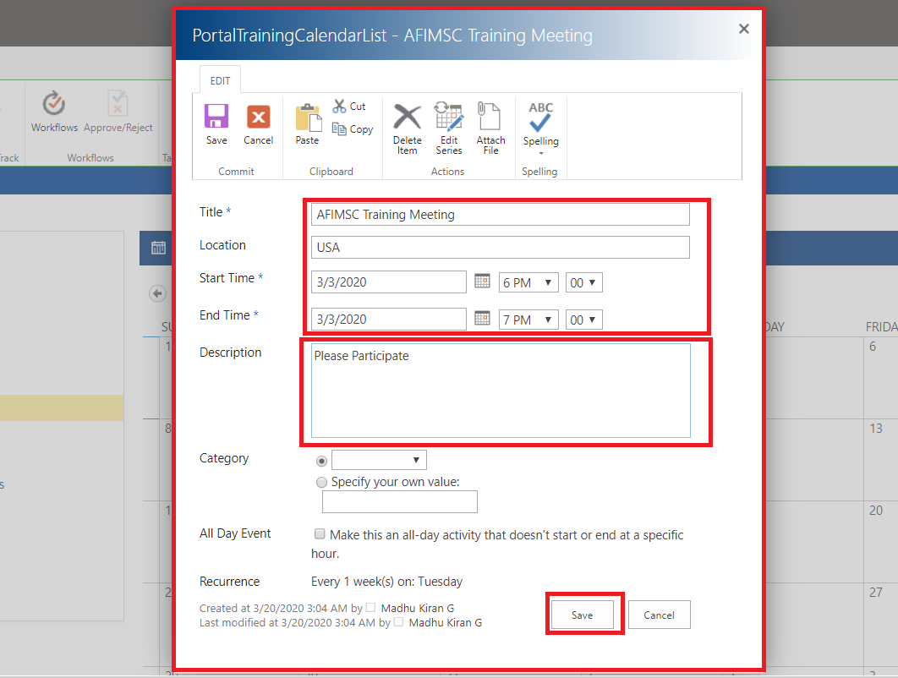

1. Edit the required field details, then click on the **Save** button.



1. The item will be updated and visible on top of the Home Page under the **Events/Trainings/Meeting Calendar** section.



### DELETE ITEM

To **Delete** an item from the **Calendar**, follow the steps below:

1. Click on the item to be deleted, and a ribbon will be displayed on the page. Then, click on the **Delete** **Event** button.

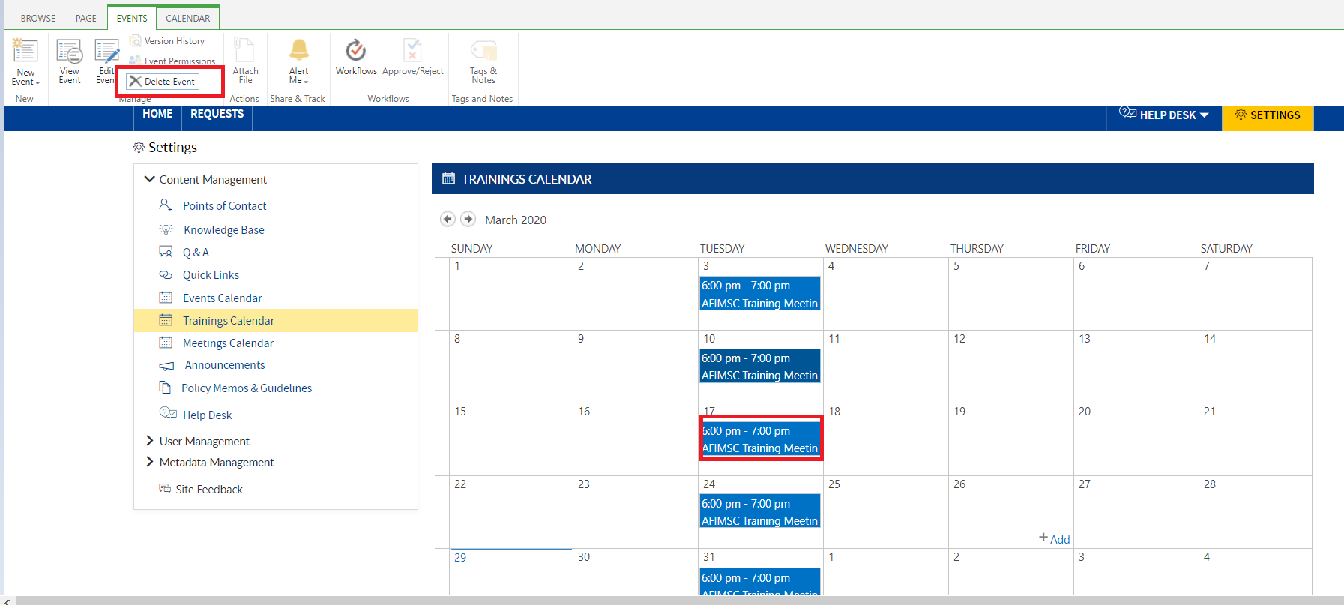

1. The confirmation pop-up will be displayed, then click on the **OK** button.



1. The item will be deleted from the list.



1. The deleted item will not be visible in the **Events/Trainings/Meeting Calendar** section.

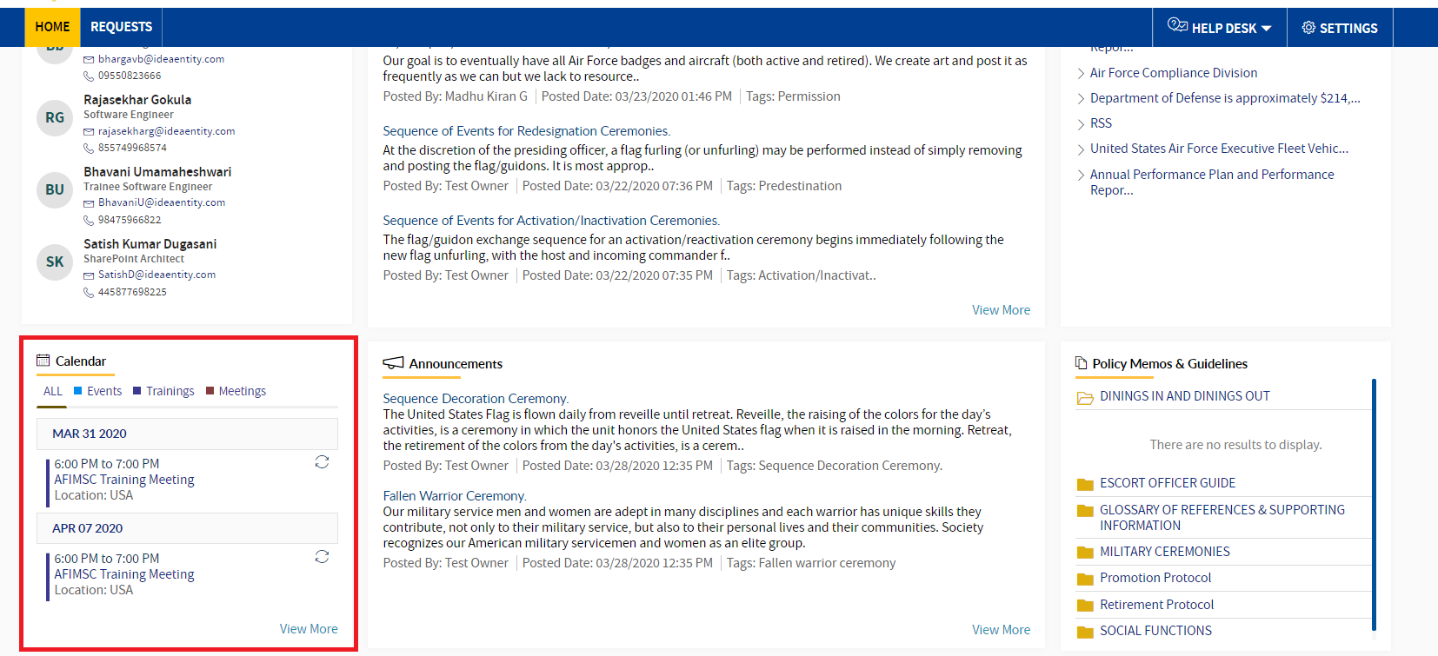

# ANNOUNCEMENTS

**Protocol Support Request Owners** and/or the **Protocol Officer** can manage add/edit/archive/delete the items in the list.

### ADD NEW ITEM

To add a new item in the list, follow the steps below:

1. In the **Content Management** section, click on the **Announcements** link. Respective details will visible on the right-hand side.

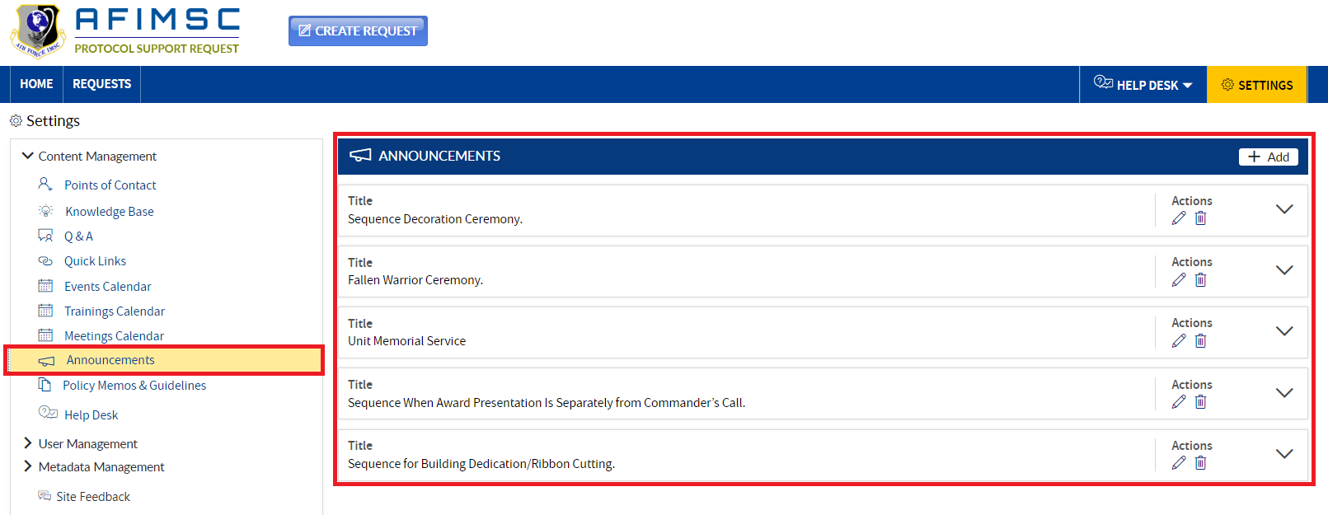

1. Click on the **Add** button in the right-side corner. An **Add** pop-up will be displayed.

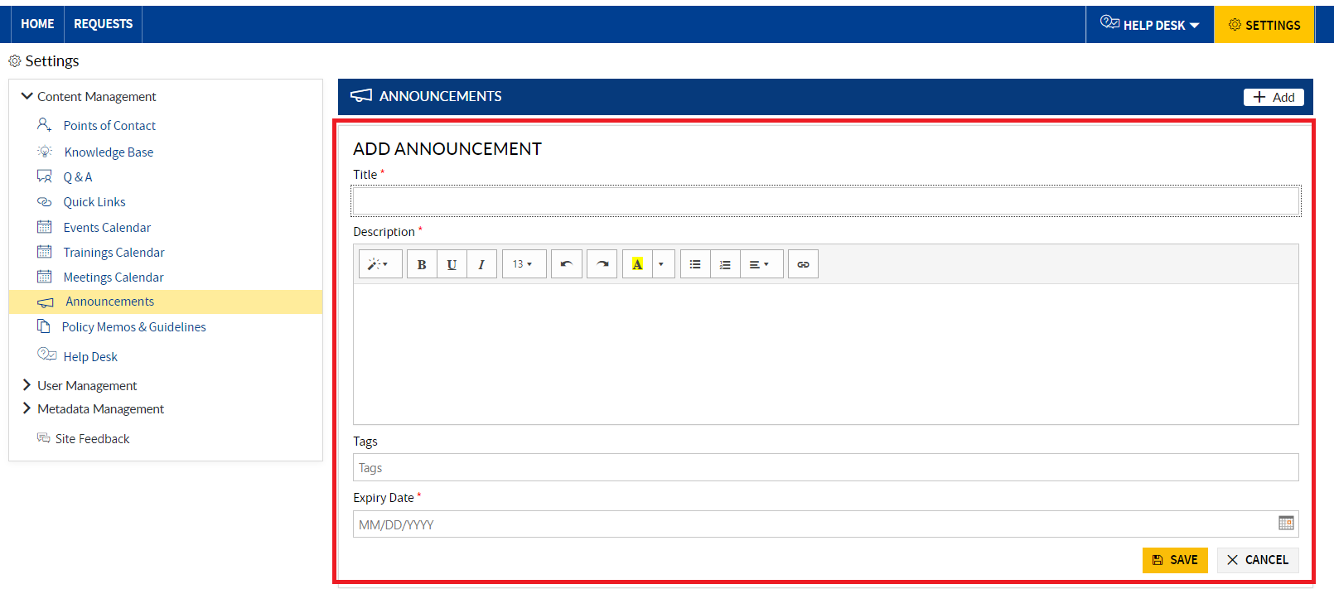

1. Enter the Title, Description, Tag and Status, then click the **Save** button.

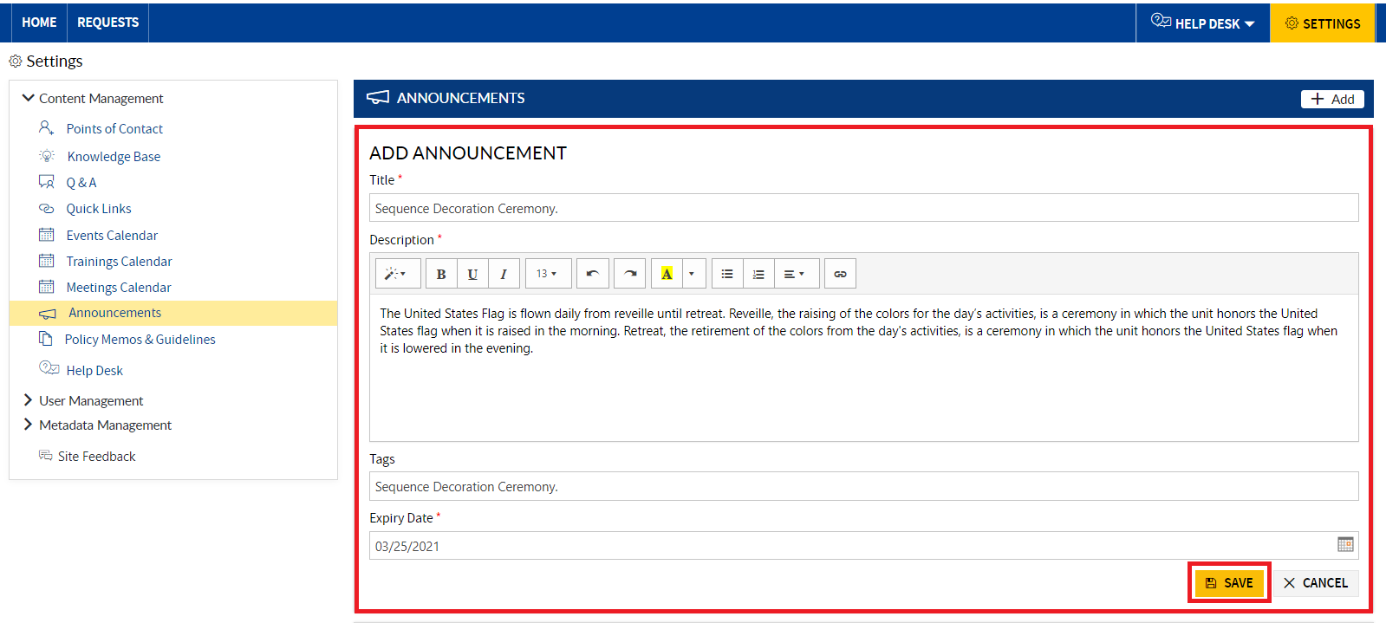

1. The item will be added and will be displayed on top in the **Settings** page under the **Announcements** section.

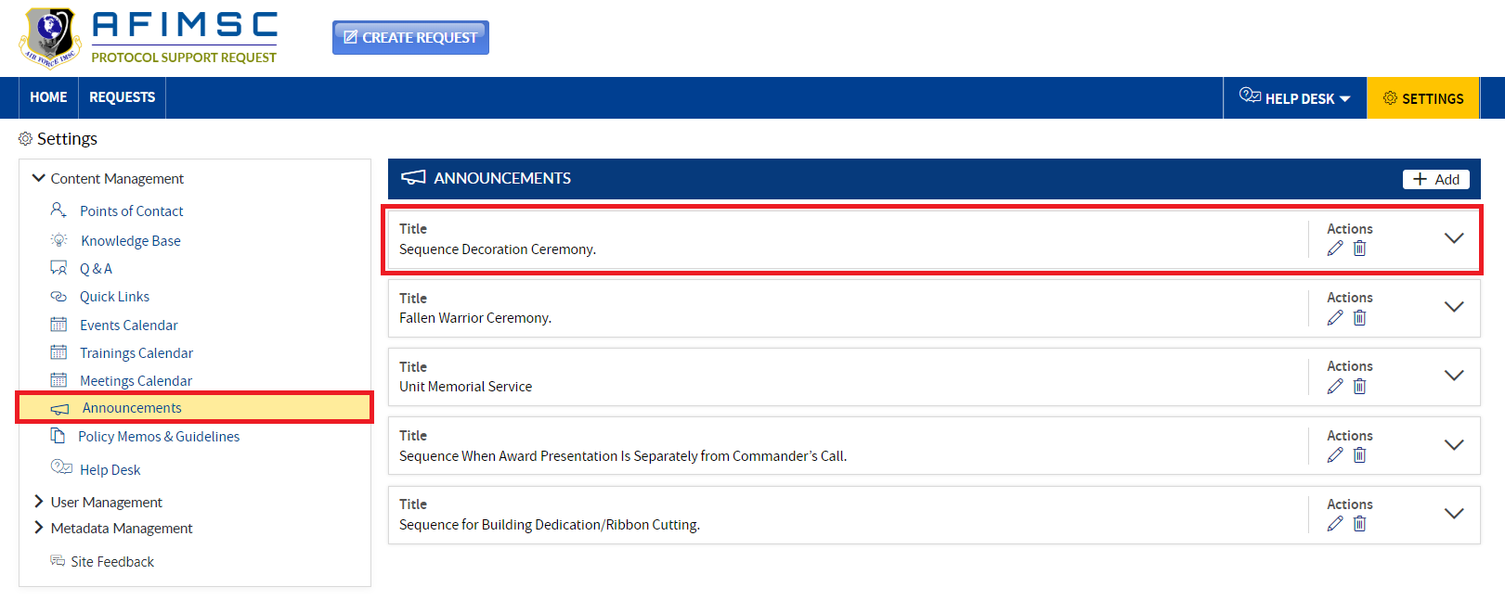

1. The added item will be displayed on the Home Page at the top of the **Announcements** section.

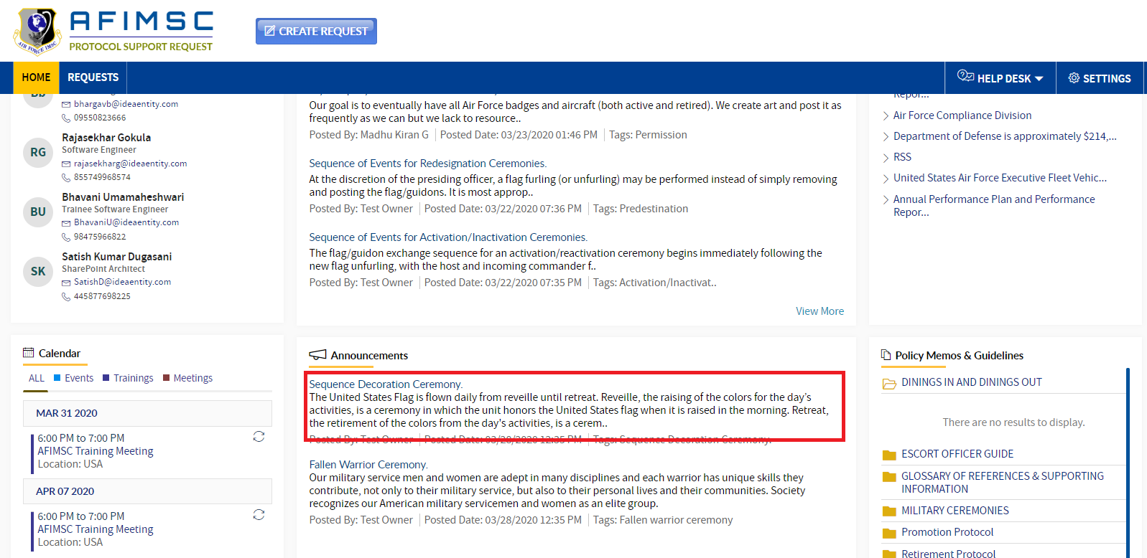

### EDIT THE ITEM

1. Choose the item, and click on the **Edit** icon.

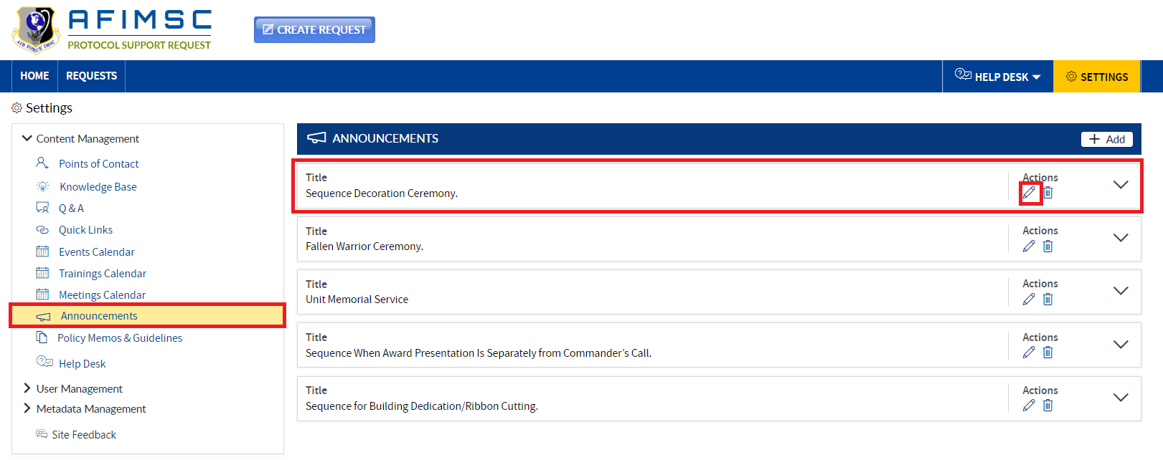

1. The **Edit** pop-up will be displayed with the **Is Archived** field and the **Update**/**Cancel** buttons.

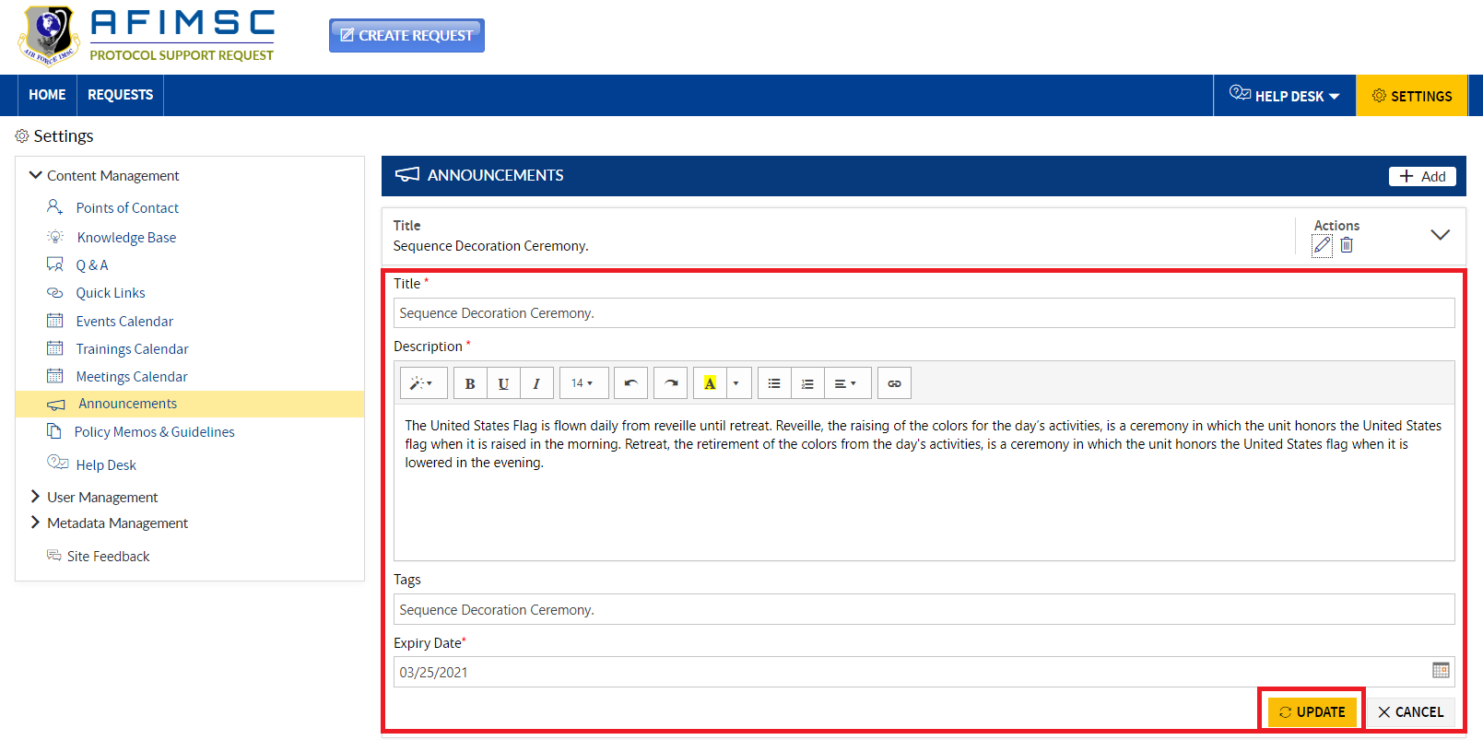

1. Edit the required field details, then click on the **Update** button.



1. The item will be updated and visible on top in the **Settings** page under the **Announcements** section.



### DELETE ITEM

To delete an **Announcement**, follow the steps below:

1. Choose the item, then click on the **Delete** icon.

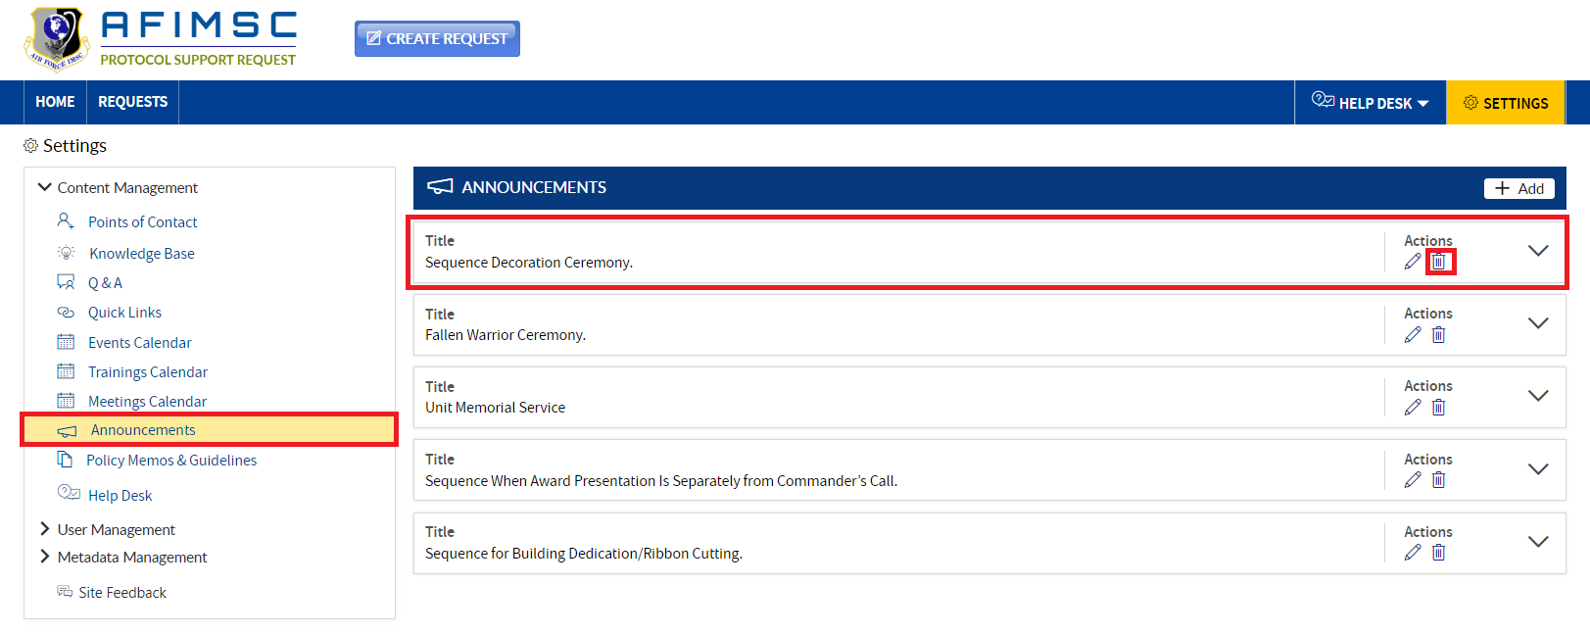

1. The confirmation pop-up will be displayed, then click on the **OK** button.



1. The item will be deleted from the list.

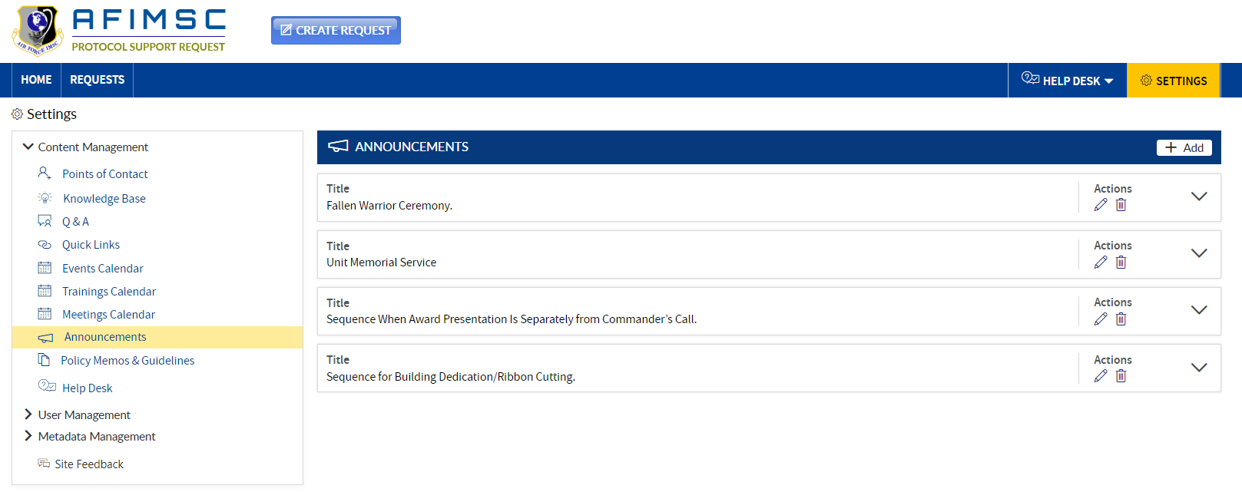

1. The deleted item will not be visible in the Home Page under the **Announcements** section.

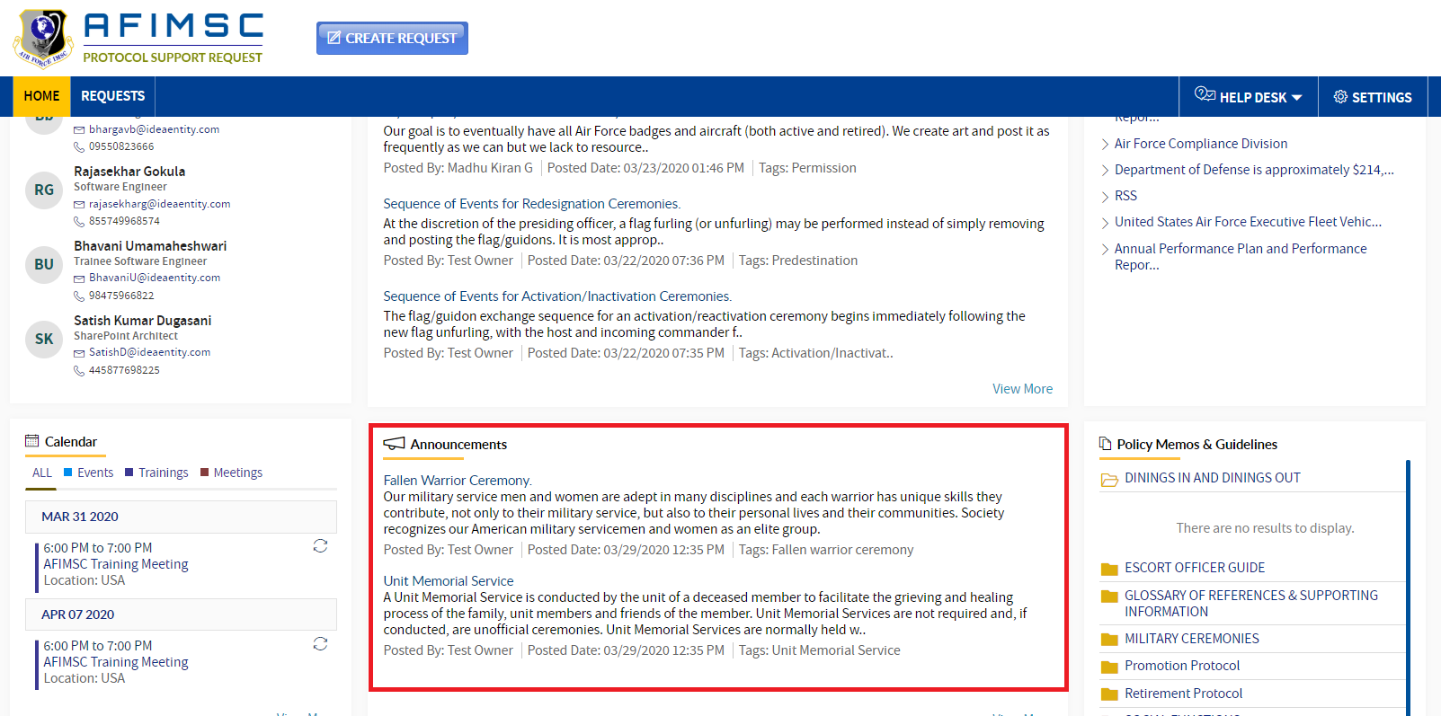

# POLICY MEMOS & GUIDELINES

**Protocol Support Request Owners** and/or the **Protocol Officer** can add/edit/archive/delete the items in the list.

1. In the **Content Management** section, click on the **Policy Memos & Guidelines** link. Respective details will be visible on the right-hand side.
2. **Add Folder**
3. **Add Document**

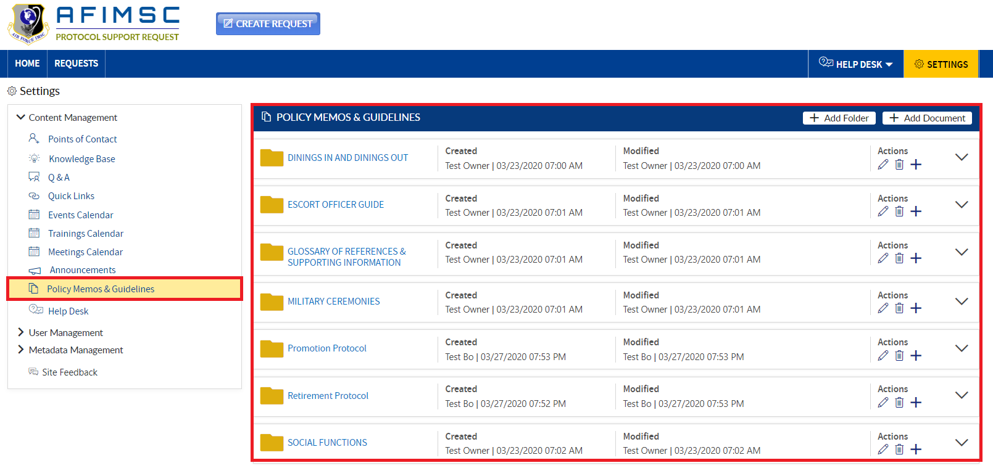

### ADD FOLDER

1. Click on the **Add Folder** button in the right-side corner. The pop-up will be displayed.

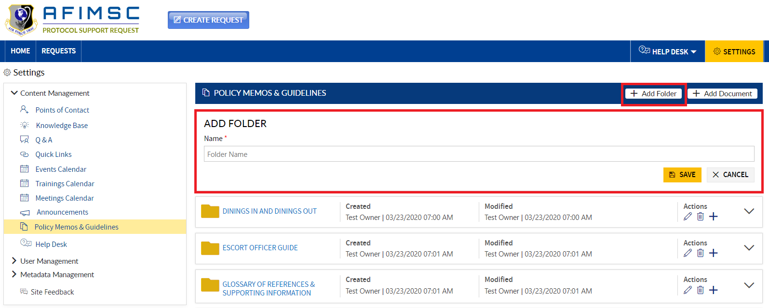

1. Enter the Folder Name and click on the **Save** button.

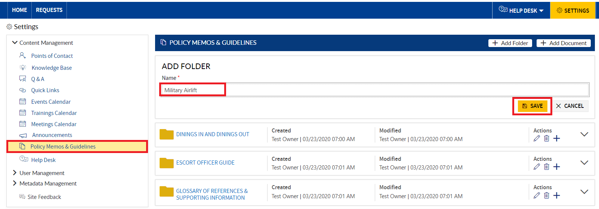

1. The added item will be displayed in the list under the **Policy Memos & Guidelines** section.

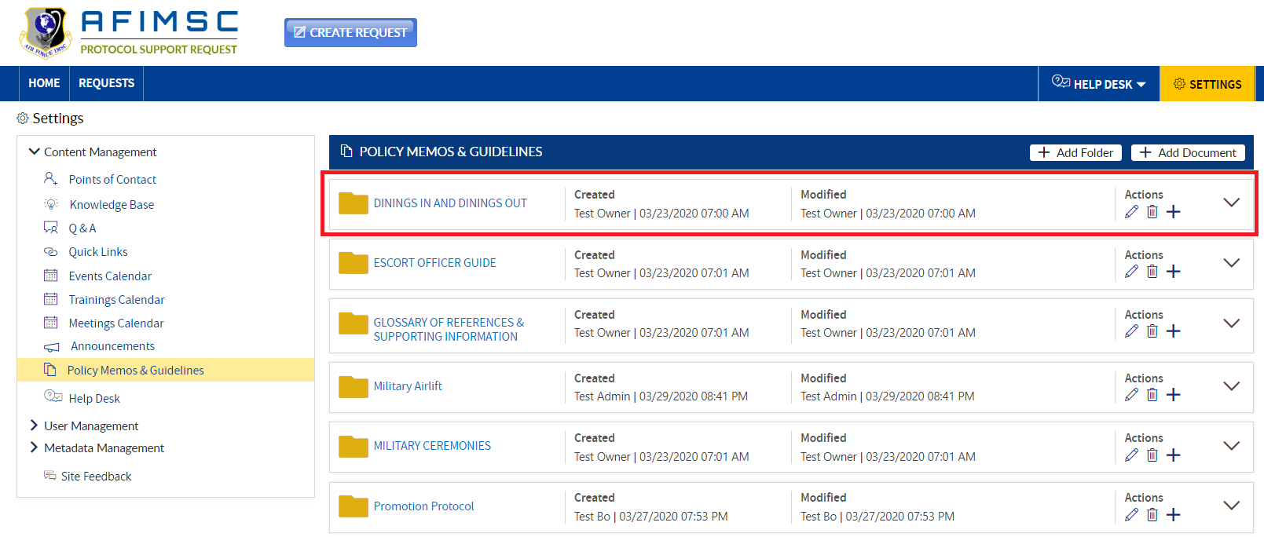

1. The added item will be displayed on top of the **Policy Memos & Guidelines** section on the Home Page.

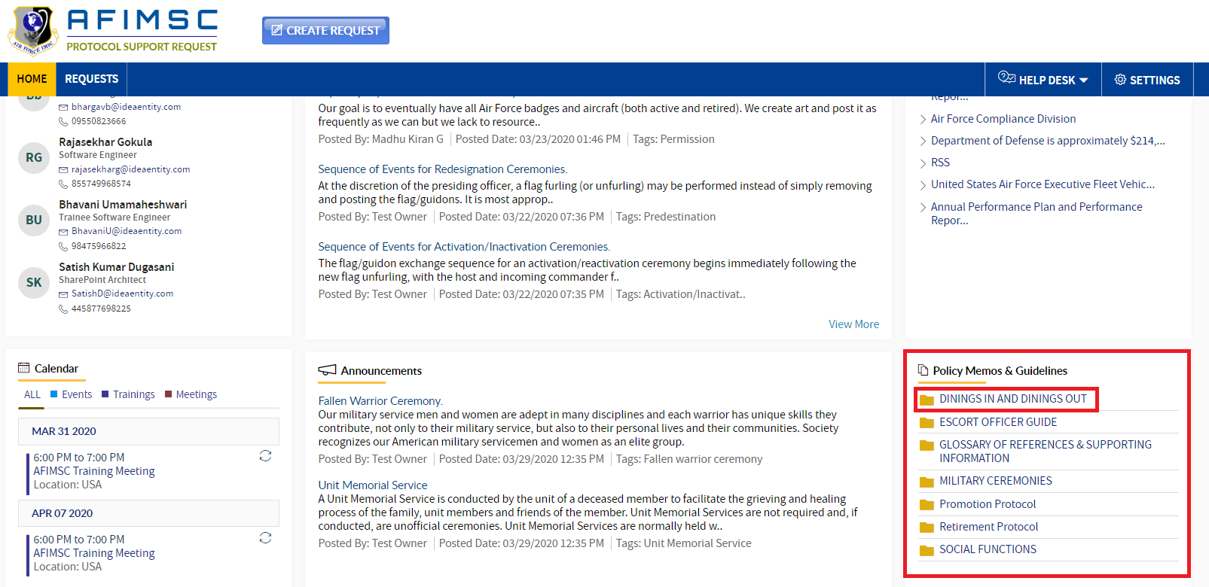

1. Click on the **Add** icon in the **Actions** column, and a pop-up will display.

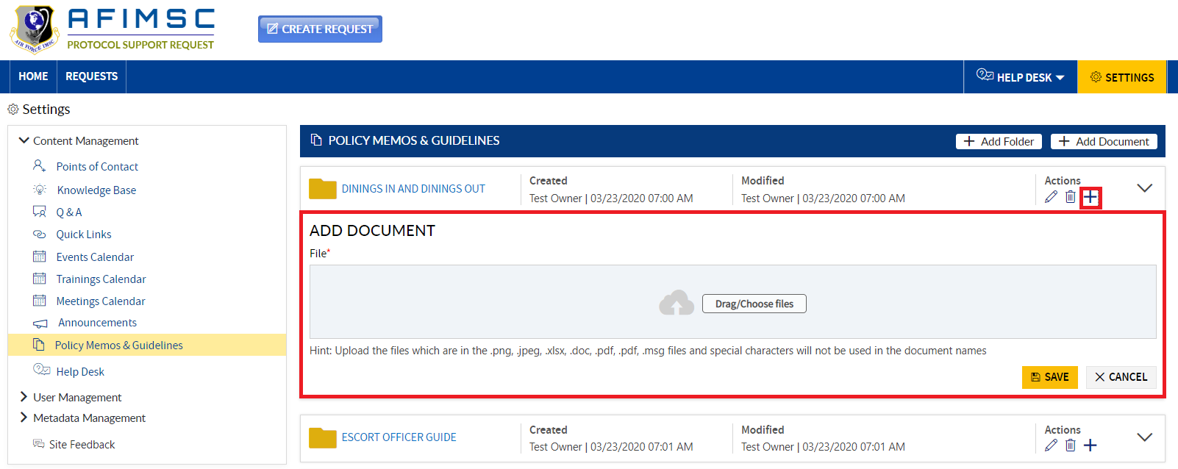

1. Click on the **Drag/Choose** files button.

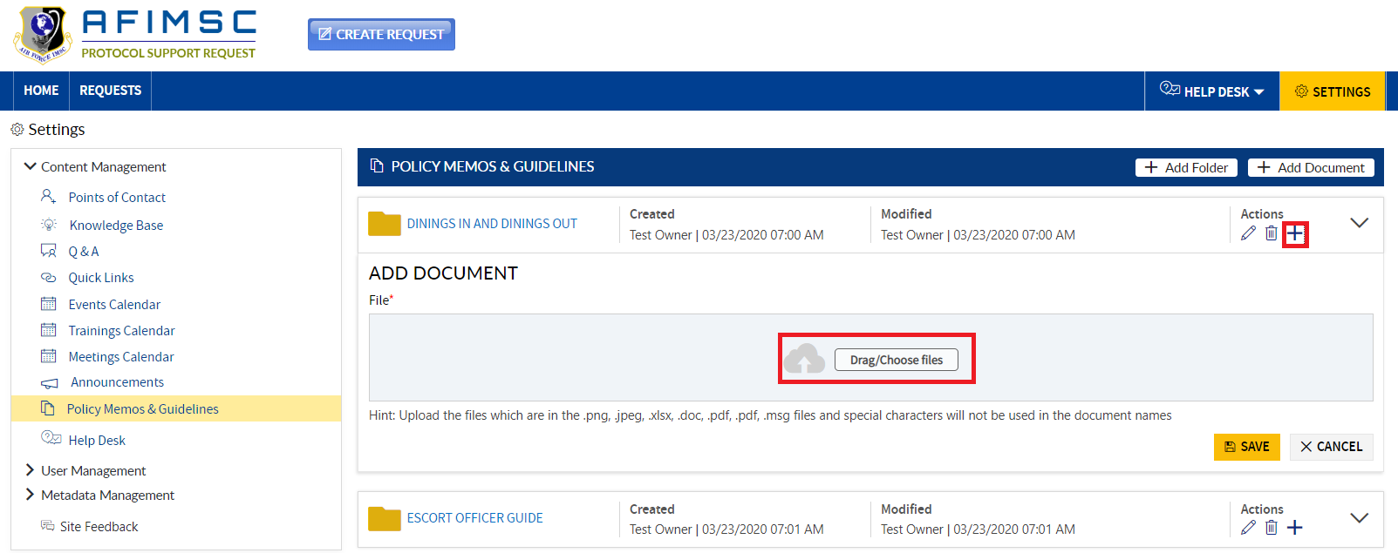

1. The local story pop-up will be displayed. From there, choose and select the files in the pop-up.

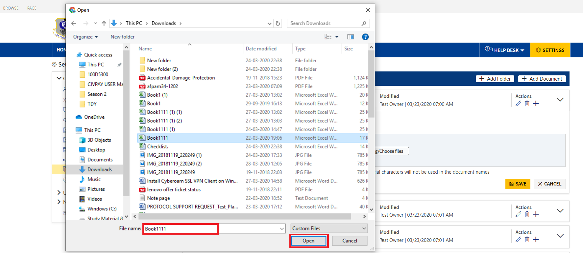

1. Click on the **Open** button in the local story pop-up.



1. The uploaded file will be displayed with the **Remove** icon then click on the **Save** button.

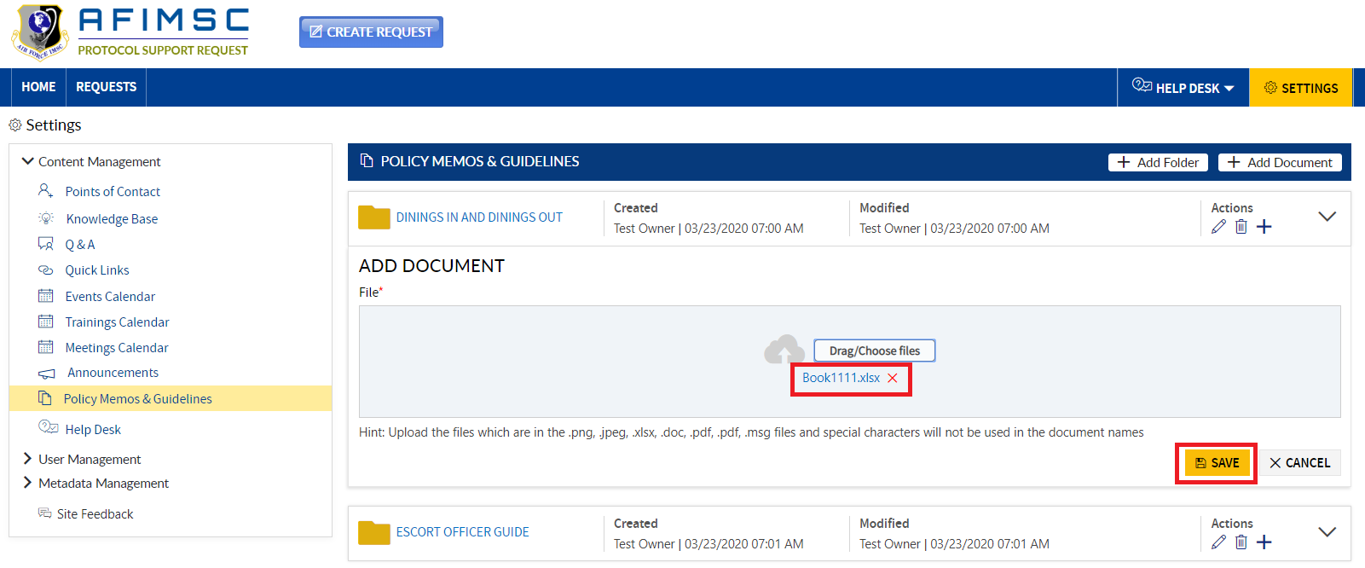

1. Click arrow to the far-right to expand the folder, and the document will be added under the respective folder.

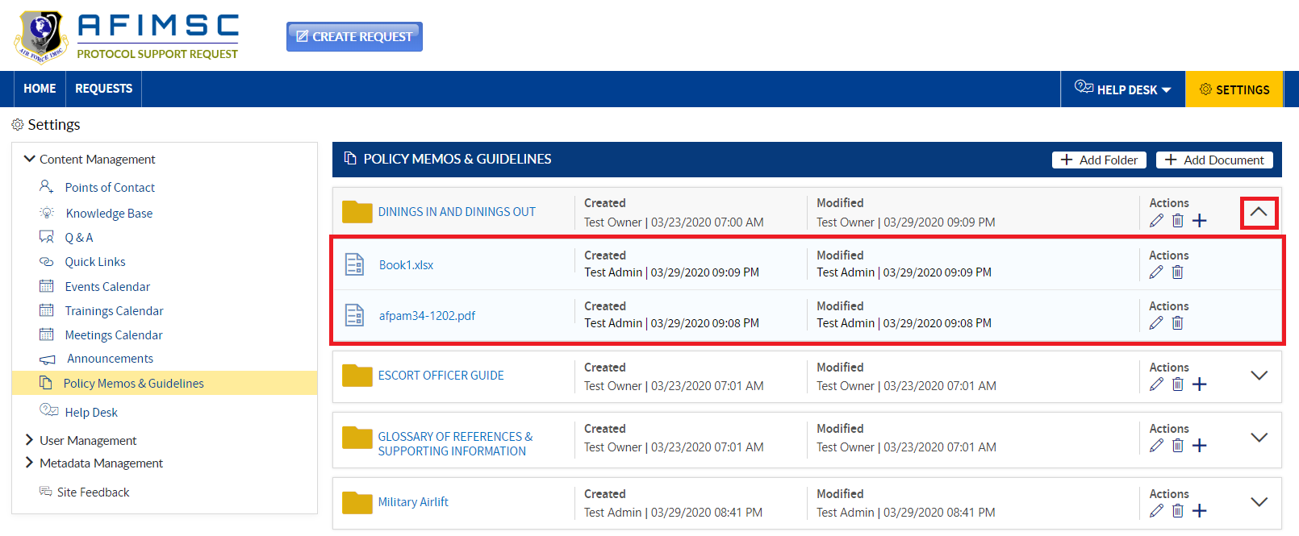

1. The added document will be visible at the top of the **Policy Memos & Guidelines** section on the Home Page.

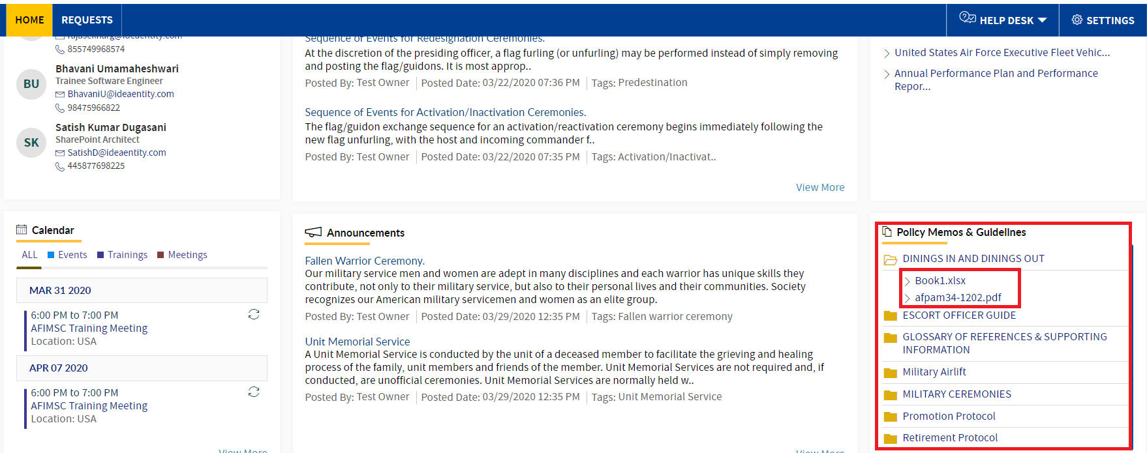

### DRAG/DROP FILES

To Add Documents by dragging & dropping the files, follow the steps below:

1. Choose the folder, click on the **Add** icon, and a pop-up will display.



1. Click on the **Drag/Choose** files button.



1. The local story pop-up will be displayed, then choose and select the files in the pop-up.

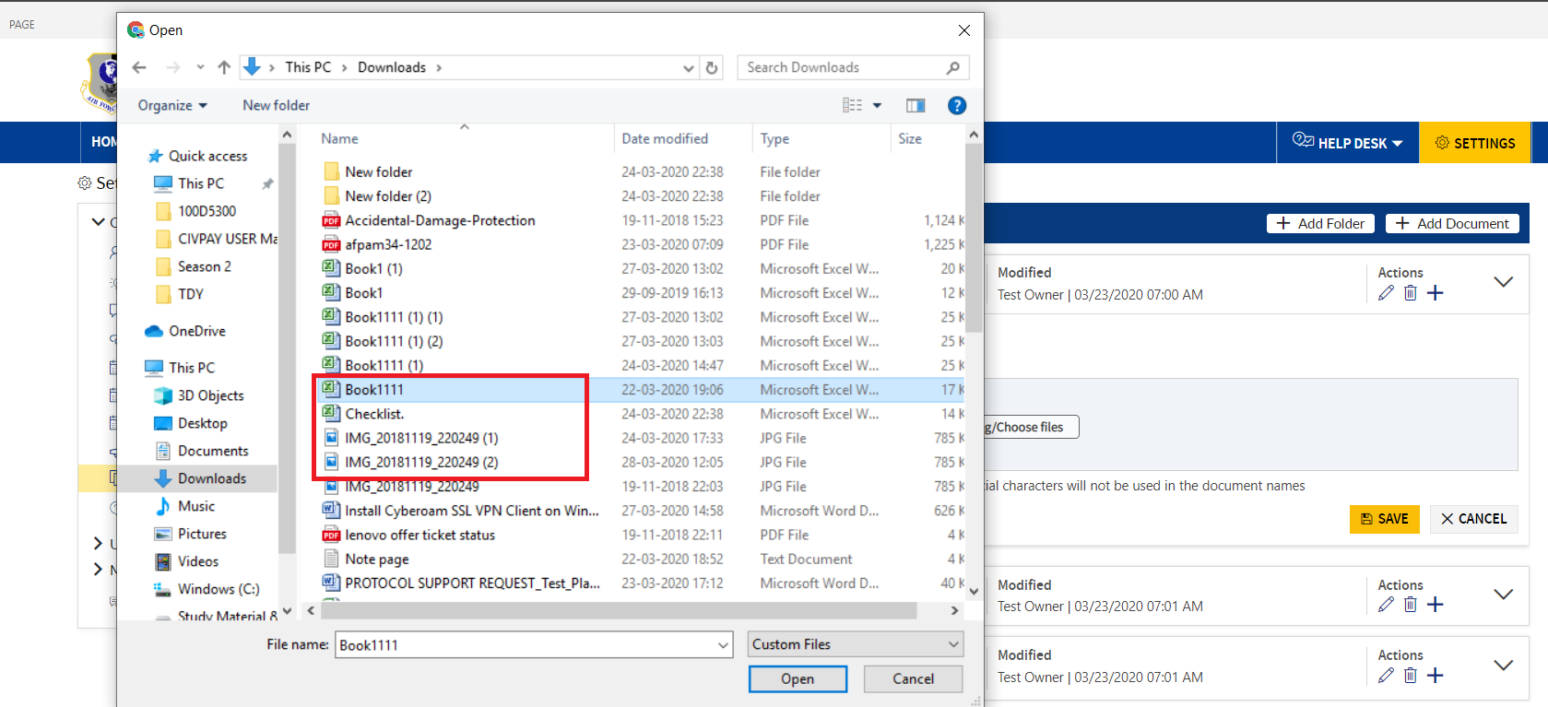

1. Drag the respective file, and drop it in the Upload file pop-up

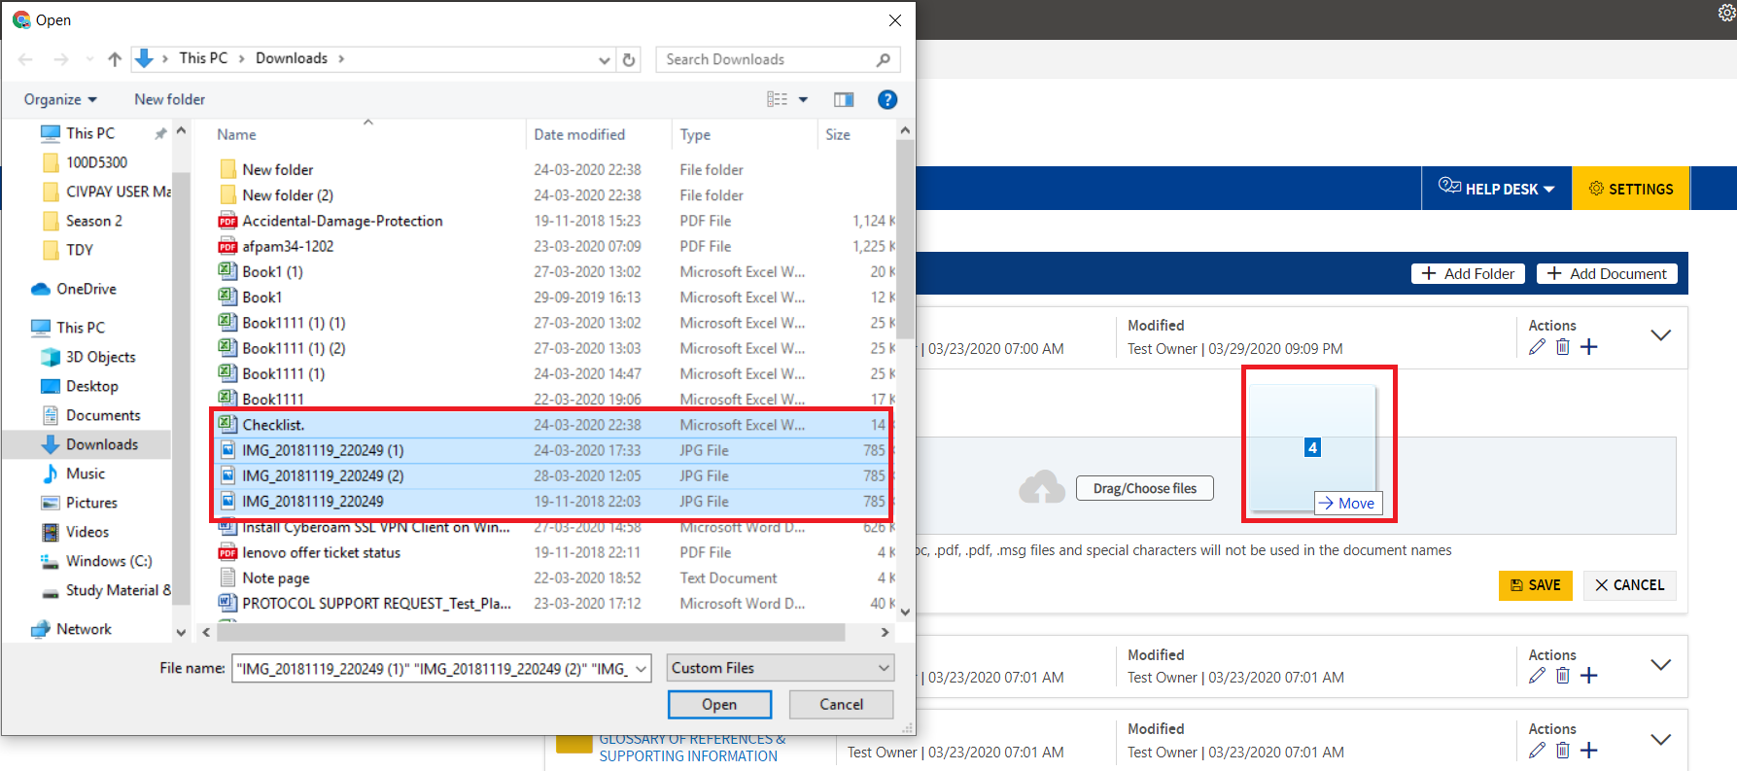

1. The uploaded file will be displayed with the **Remove** icon.

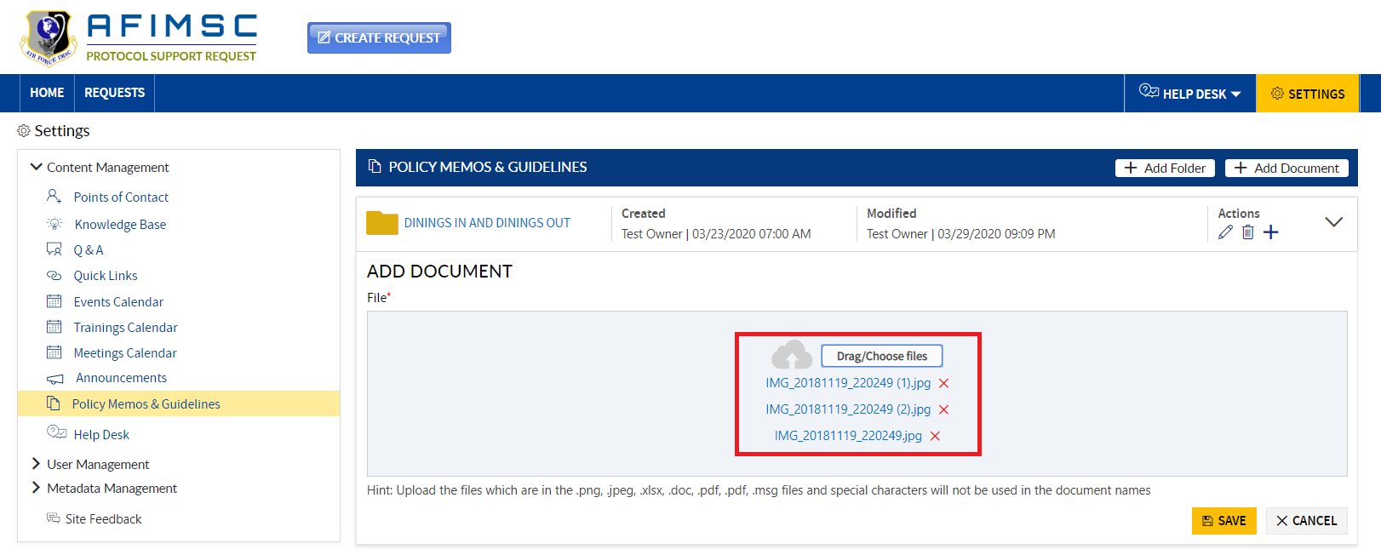

1. Click on the **Save** button.

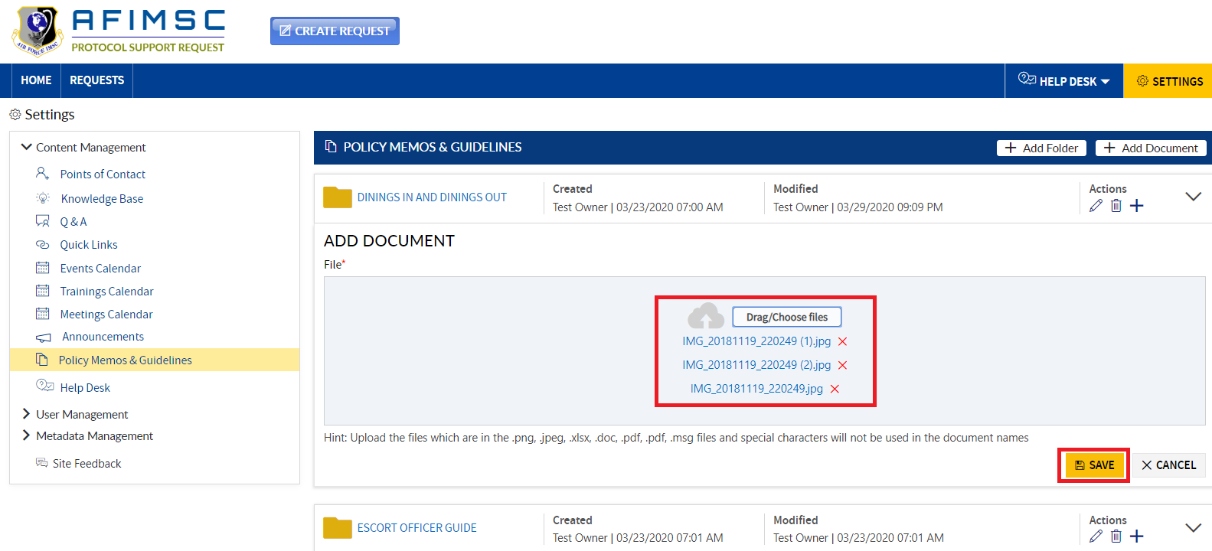

1. Expand the folder, and the added document will be visible.

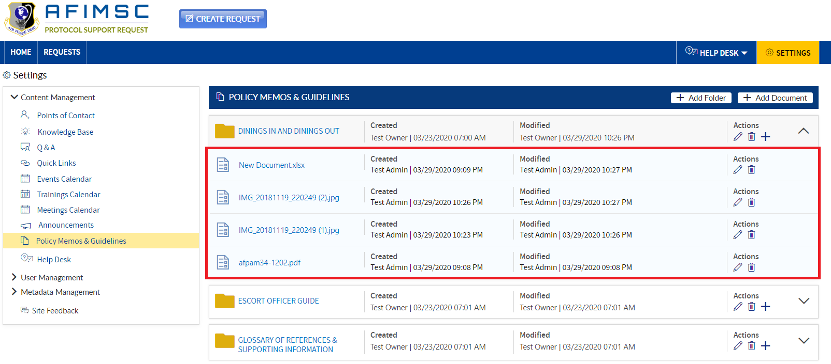

1. The added document will be visible on the Home Page under the **Policy Memos & Guidelines** section.



### EDIT THE DOCUMENT NAME

To **Edit** the document name, follow the steps below:

1. Expand the folder, choose the document, and click on the **Edit** icon.

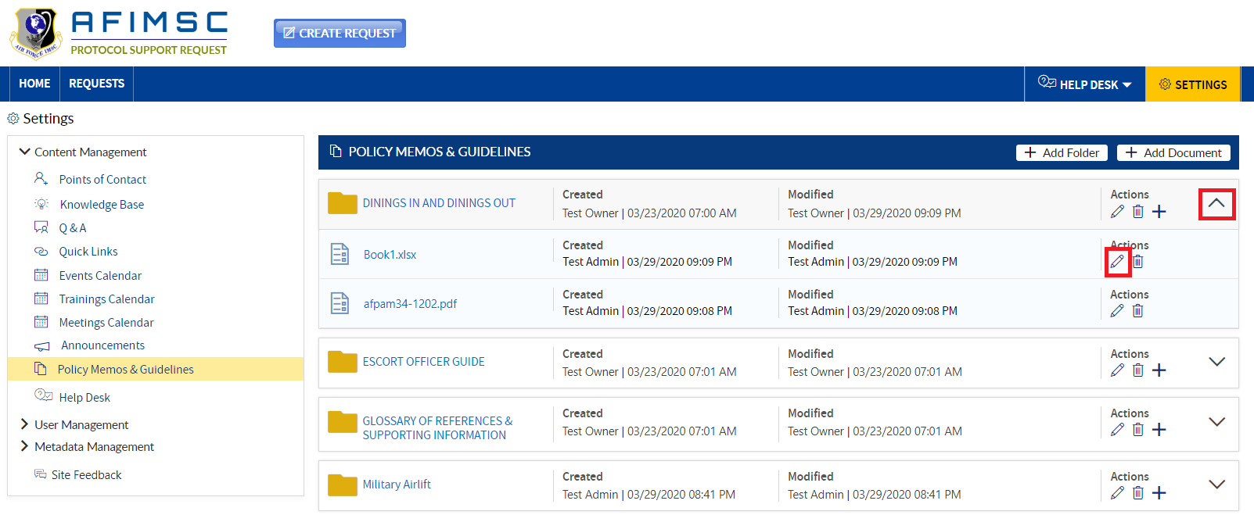

1. The **Edit** pop-up will be displayed. Edit the **Name** and click on the **Update** button.

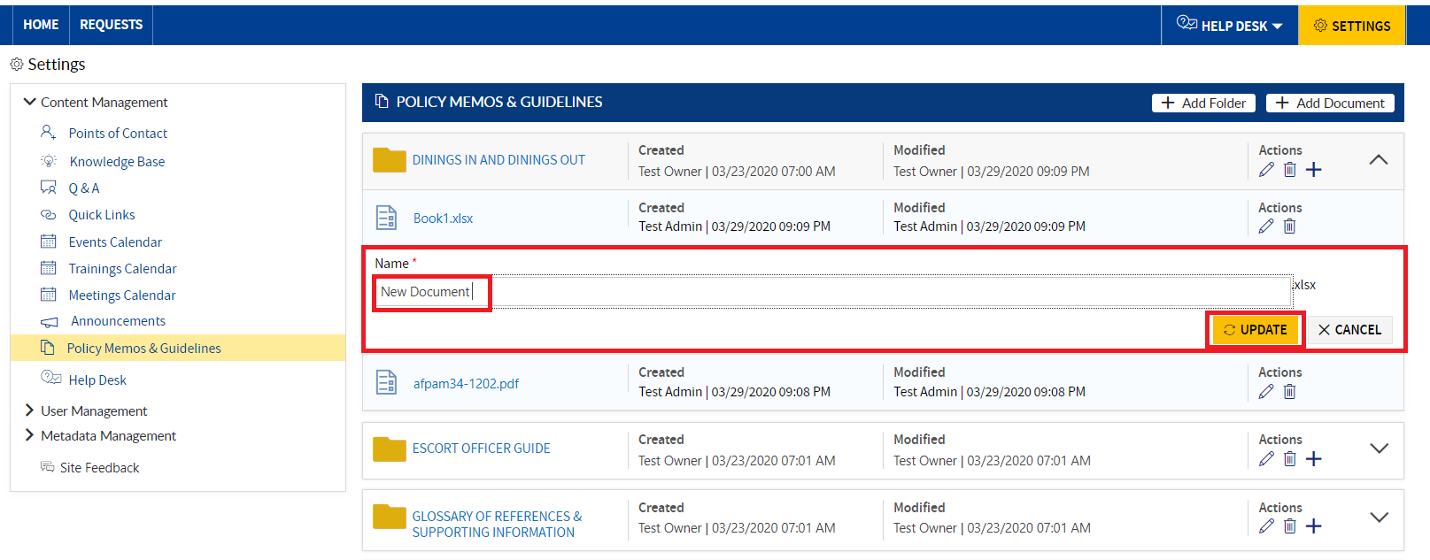

1. Expand the folder, and the updated document name will be visible.



1. The updated document name will be visible on the Home Page under the **Policy Memos & Guidelines** section.



### DELETE THE DOCUMENT

To delete the document under the folder, follow the steps below:

1. Expand the folder, choose the document, and click on the **Delete** icon.

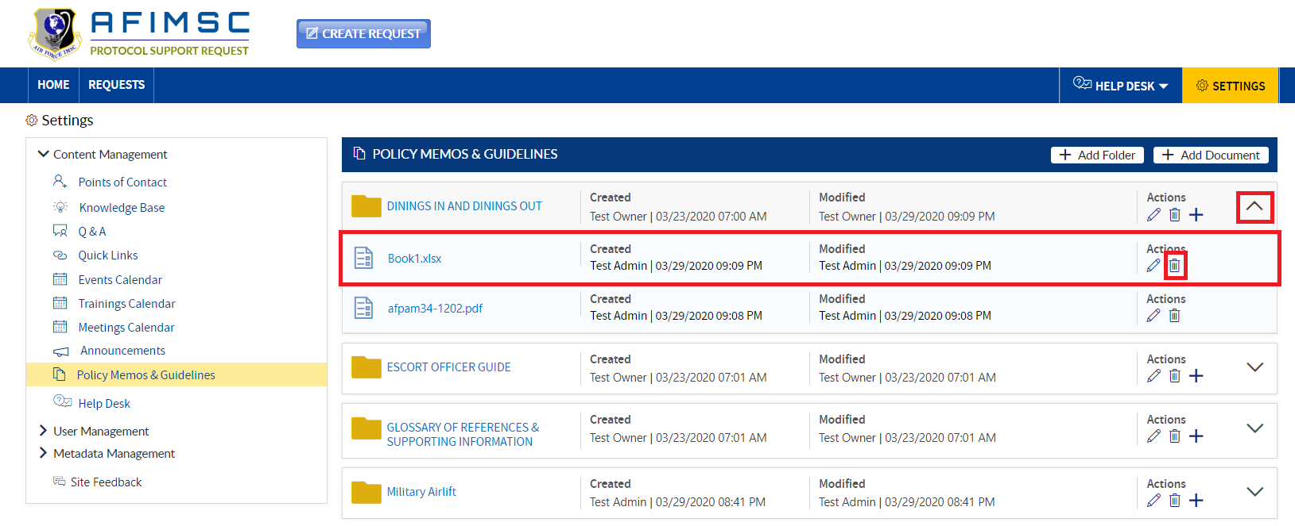

1. The confirmation pop-up will be displayed, then click on the **OK** button.



1. Expand the folder, and the deleted document will not be visible.



1. The deleted document will not be visible under the **Policy Memos & Guidelines** section on the Home Page.



Note: To add a document, follow the steps as seen above.

# HELP DESK

### EDIT THE ITEM

1. Choose the item, then click on the **Edit** icon.

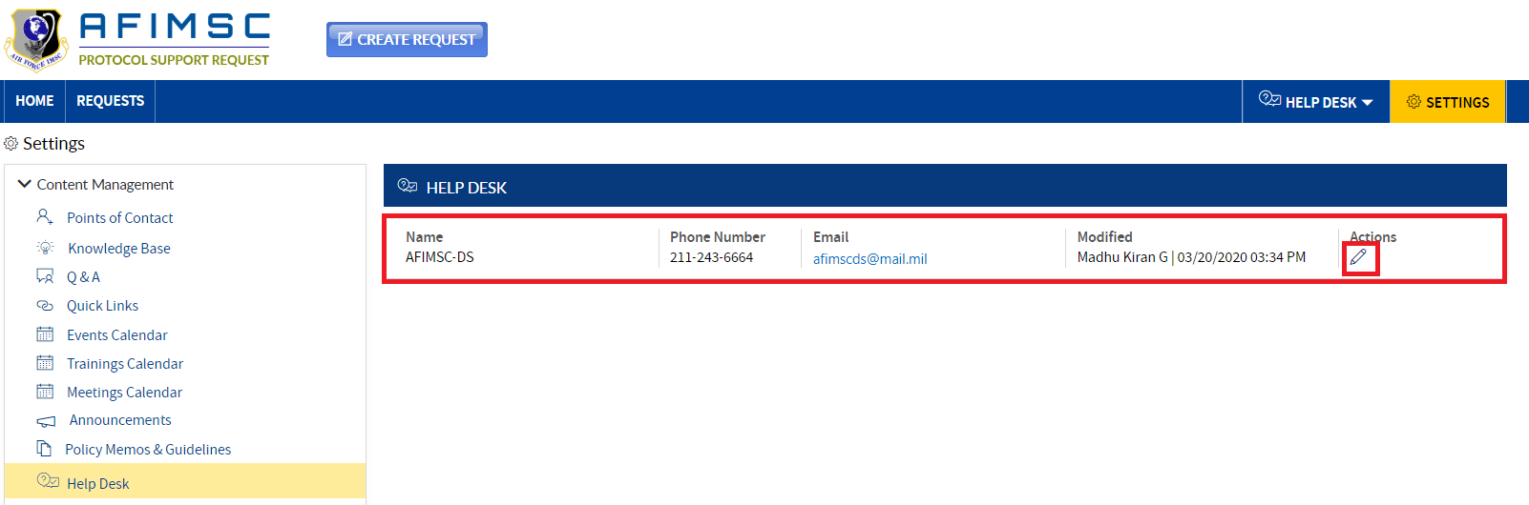

1. The edit pop-up will be displayed with the **Help Desk** details and the **Update**/**Cancel** buttons.

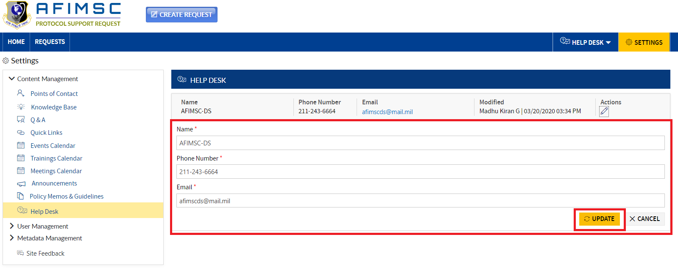

1. Edit the required field details, then click on the **Update** button.



1. The item will be updated, and then be visible at the top of the **Help Desk** section.

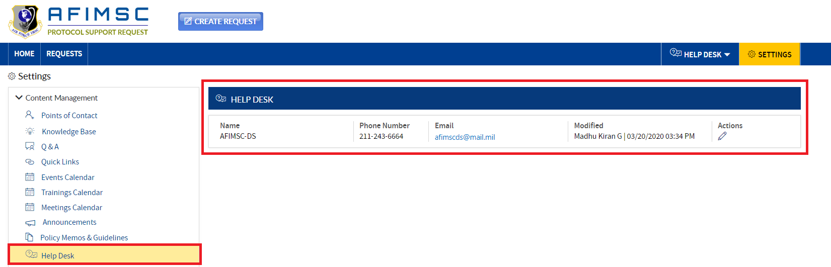

1. The item will be displayed in the **Help Desk** section.

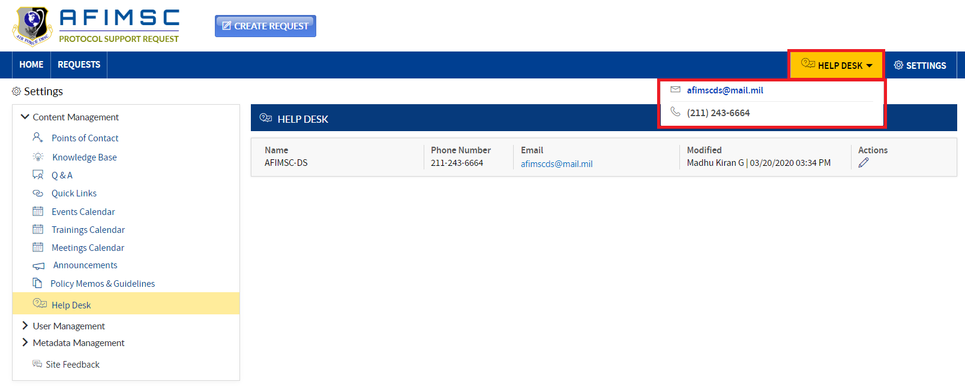

# USER MANAGEMENT SECTION

**Protocol Support Request Owners** and/or the **Protocol Officer** can manage the users by using the **Settings** page.

1. Navigate to the **Settings** page by clicking on the **Settings** tab in the menu bar.

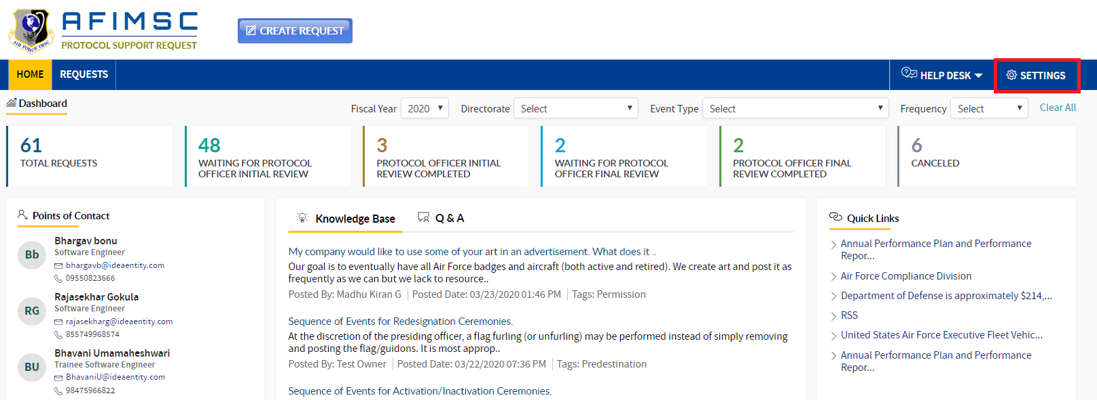

1. Click on the **User Management** section on the left-side menu. The section will expand, and the **User Groups** under **User Management** will be displayed as below:

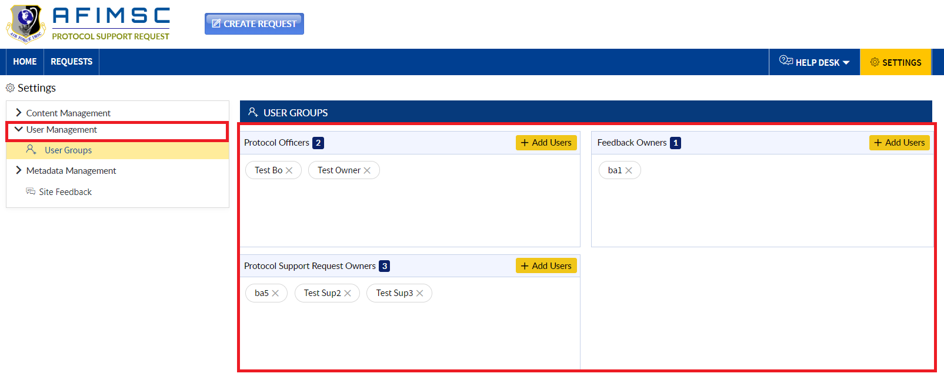

Note: For the **Protocol Officer**, all **User Groups** will be displayed except the **Feedback Owners** groups.

**Protocol Support Request Owners** will be able to see all the **User Groups** under the **User Management** section. The **Protocol Support Request Owners** are able to **Add/Remove** users from the **Protocol Officers Group** and **Feedback Owners** group.

## ADD USERS TO USER GROUPS

1. To add the users to any group, click on the **Add** button provided for the respective group.

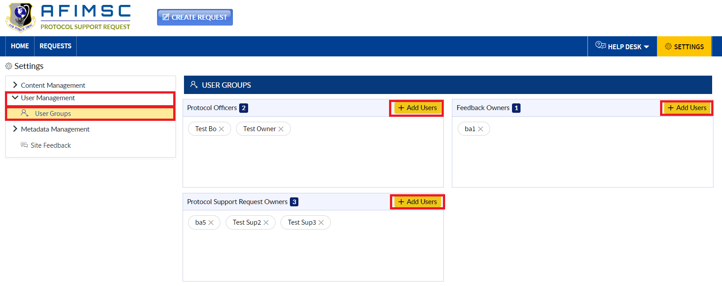

1. The **Add User** pop-up page will be displayed.

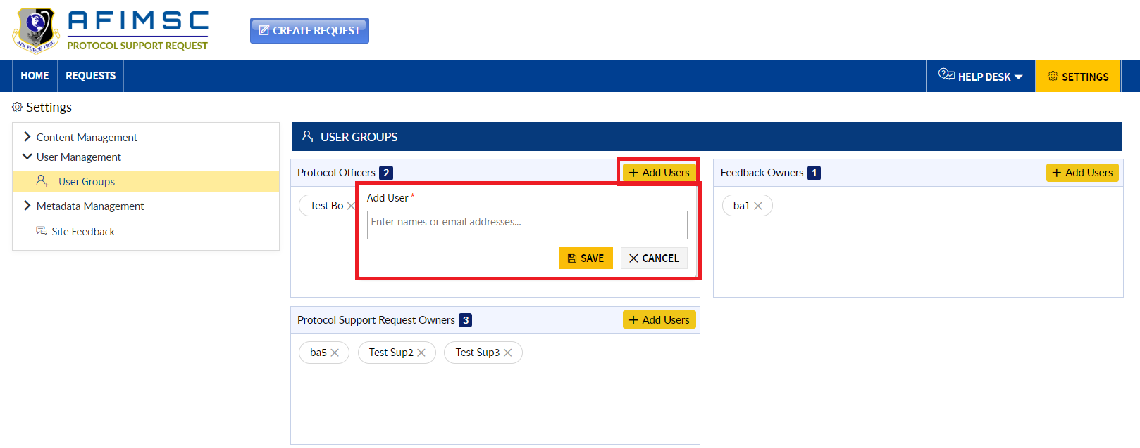

1. Add the required user(s), and click on the **Save** button.

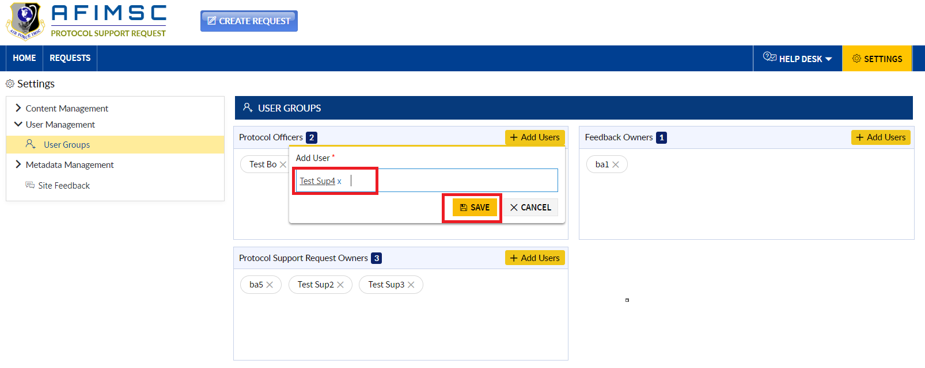

1. Added users will be displayed in the respective group.

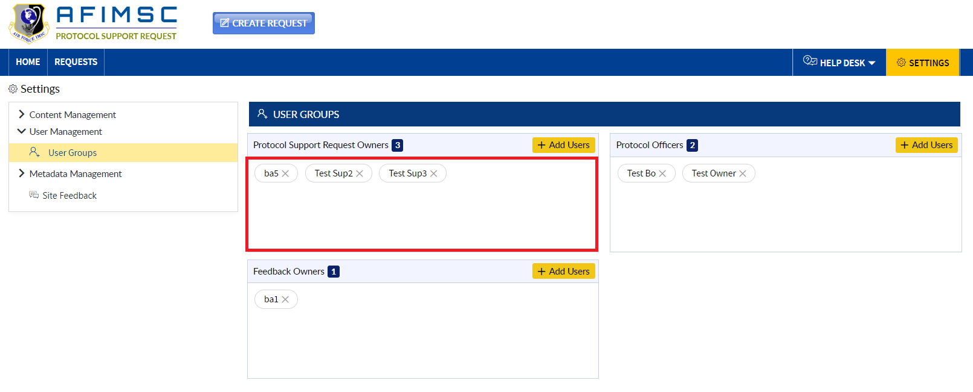

## REMOVE USERS FROM USER GROUPS

1) To remove the user from the group, click on the **Close** icon beside the user name.

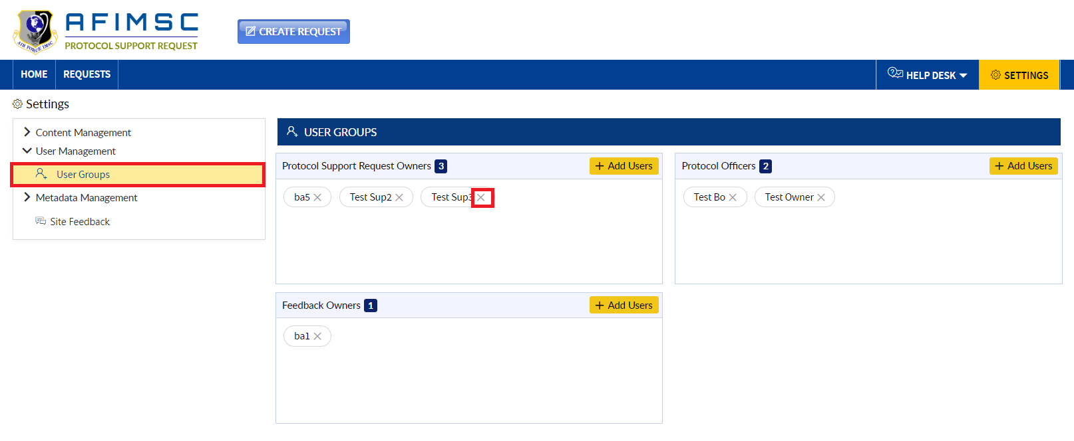

1. The confirmation pop-up comes up with **OK** and **Cancel** buttons, click on the **Cancel** button.



1. The user will be removed from the respective group, and the count will decrement.

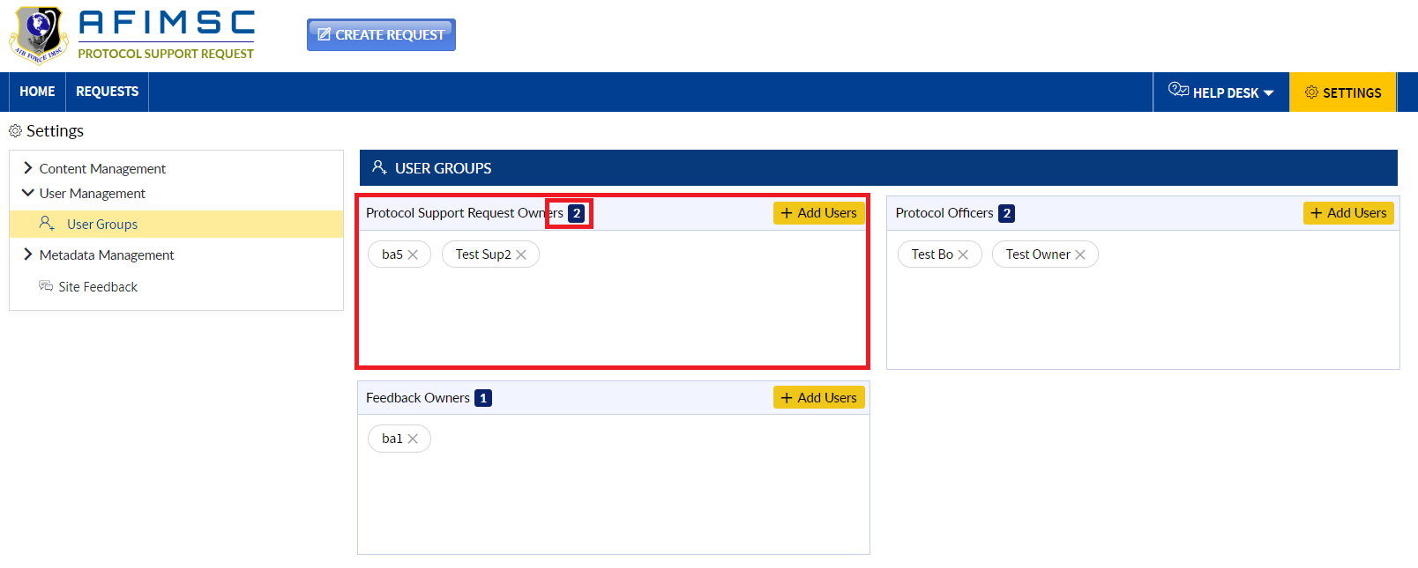

Note: Follow the similar steps to **Add/Remove** users in any group.

# METADATA MANAGEMENT

In the **Metadata Management** section below, the lists/libraries will be visible to the **Protocol Support Request Owners** and/or the **Protocol Officer** for management.

1. Navigate to the **Settings** page by clicking on **Settings** tab in the menu bar.



1. The user will be navigated to the **Settings** page, click on the **Metadata Management** section on the left-side menu. The menu will expand to show all lists.

Note: By default, Rank Metadata will be displayed to the user under the **Metadata Management** section.

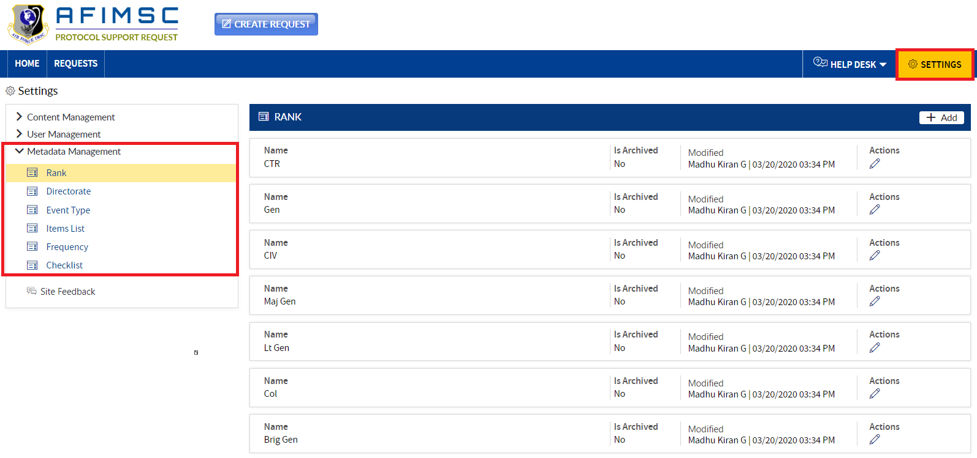

## ADD RANK

1. Click on the **Add** button, and a pop-up will be displayed.

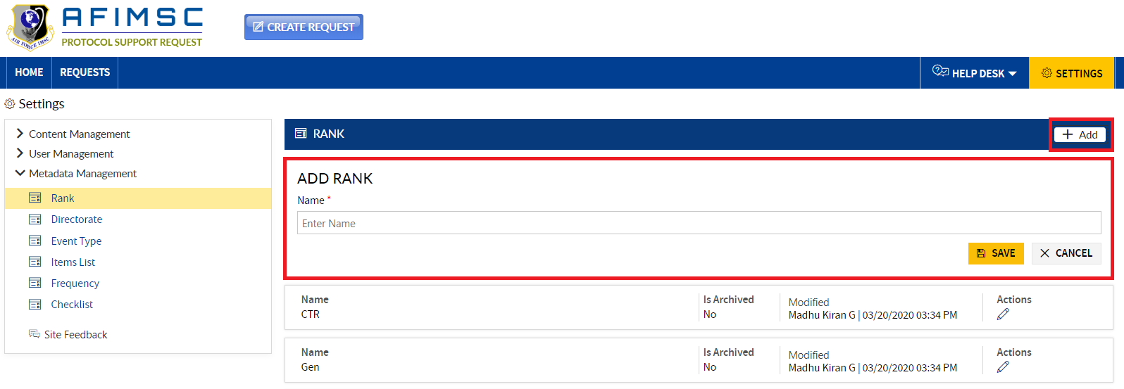

1. Enter the **Name**, and click the **Save** button.

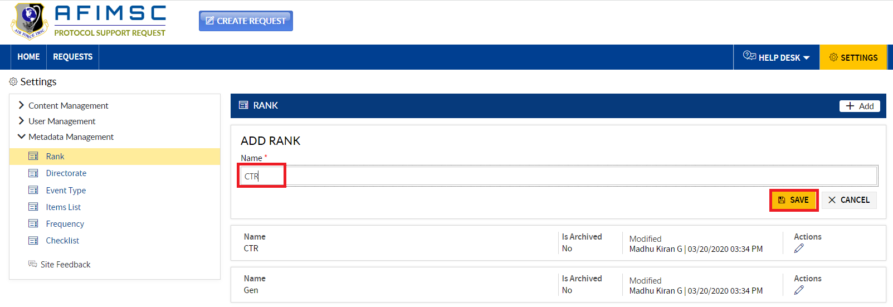

1. The added **Rank** will be displayed in the **Rank** section.

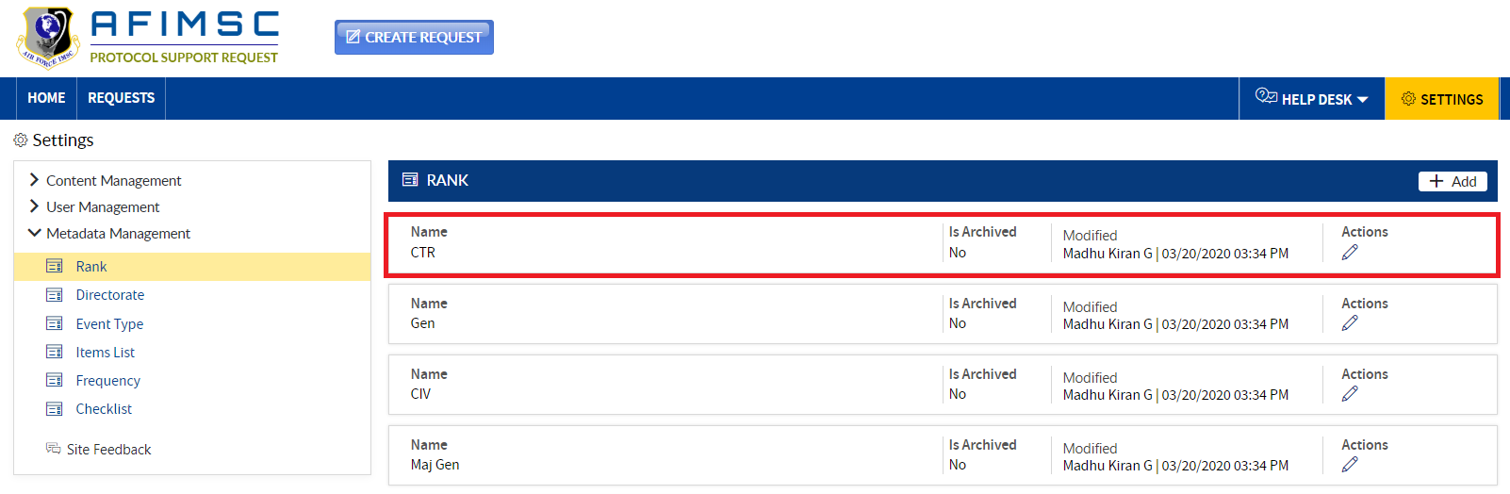

### EDIT THE ITEM

1. Choose the item, and click on the **Edit** icon.

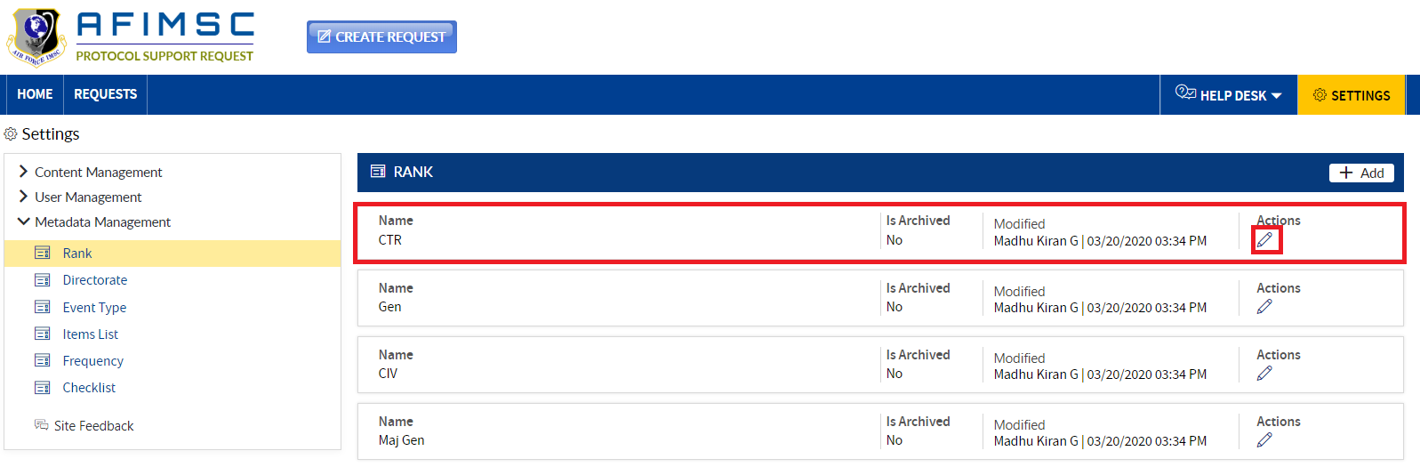

1. The **Edit** pop-up will be displayed with the **Is Archived** field and the **Update**/**Cancel** buttons.

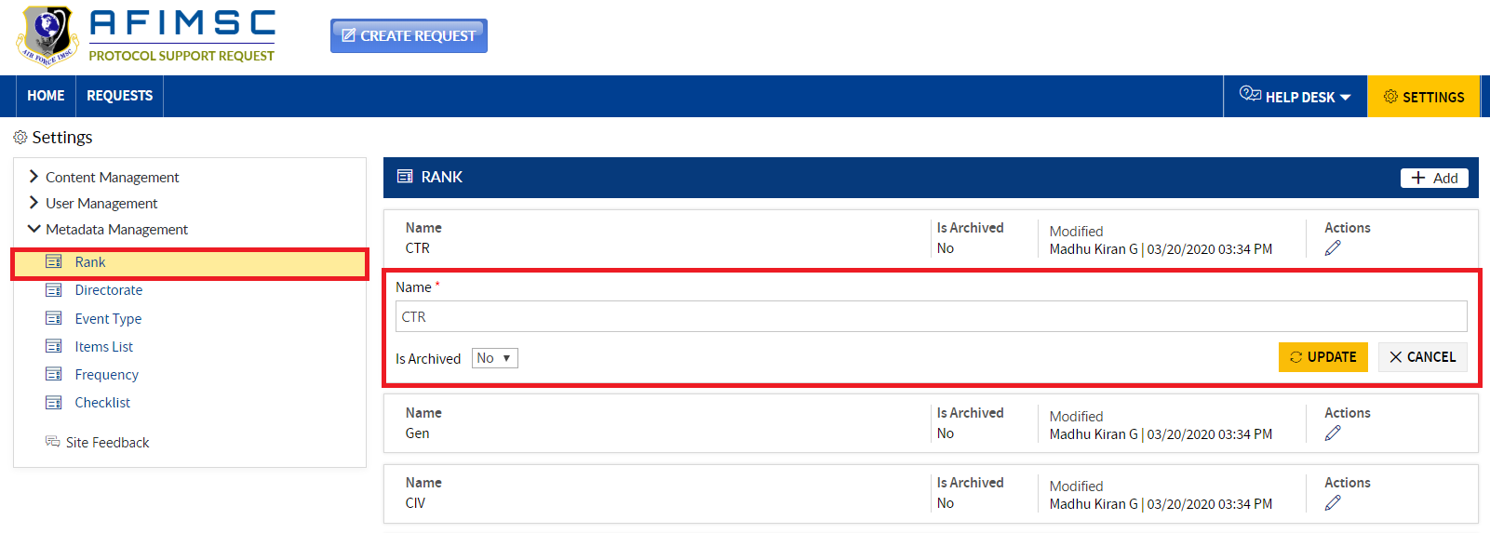

1. Edit the required field details, and click on the **Update** button.

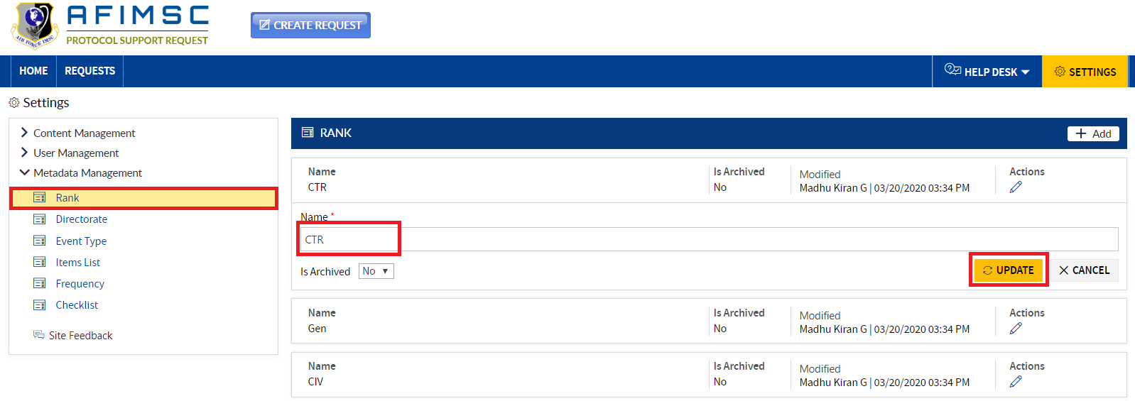

### ARCHIVE THE ITEM

To archive the item, follow the steps below:

1. Choose the item, then click on the **Edit** icon.



1. The **Edit** pop-up will be displayed with the **Is Archived** field and the **Update/Cancel** buttons.



1. In the **Is Archived** field dropdown, select **Yes,** and click on the **Update** button.

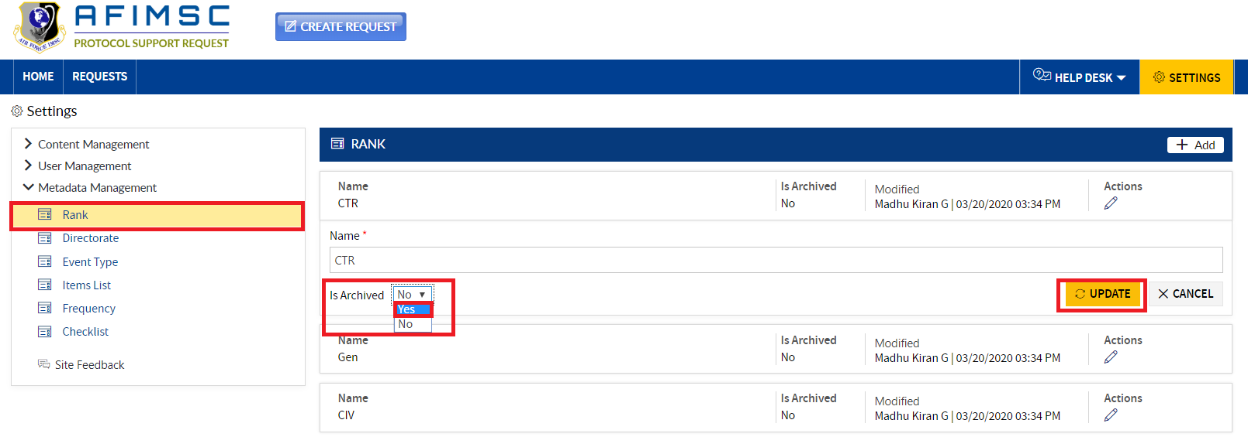

1. The item will now be archived.

Note: The archived item will not be visible in the Home/Requests/Form pages.

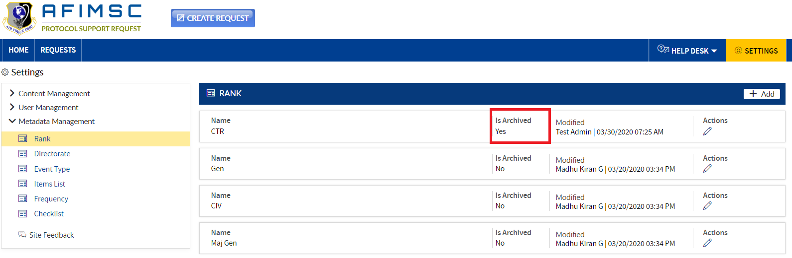

## ADD DIRECTORATE

1. Click on the **Add** button, and a pop-up will be displayed.

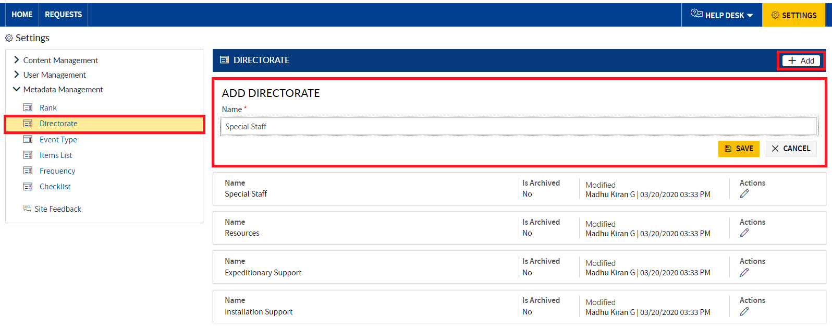

1. Enter the **Name**, and click the **Save** button.

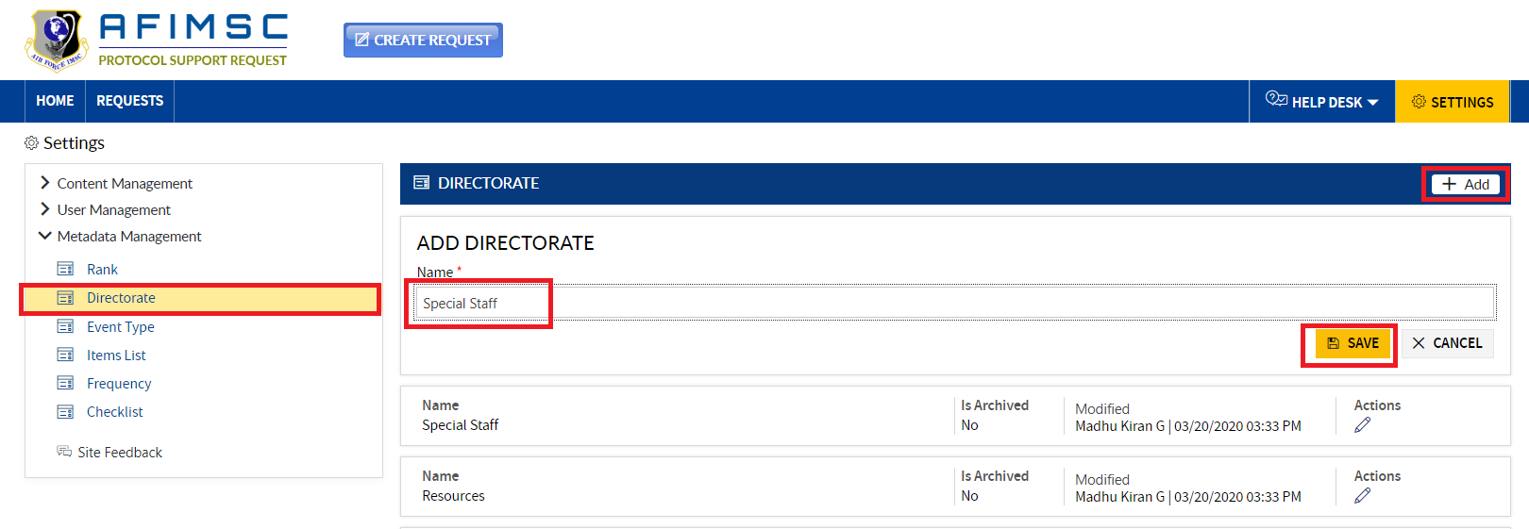

1. The added **Directorate** will be displayed in the **Directorate** section.

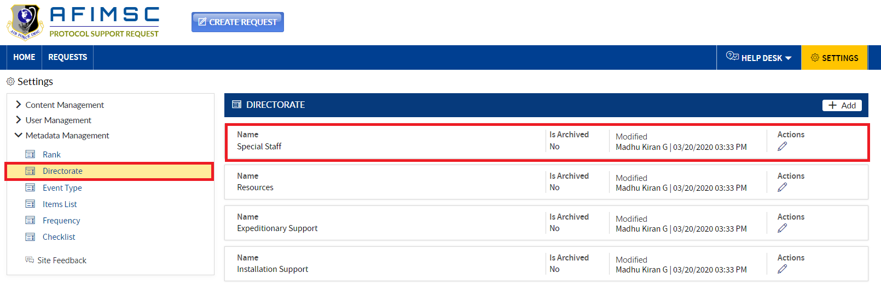

### EDIT THE ITEM

1. Choose the item, and click on the **Edit** icon.

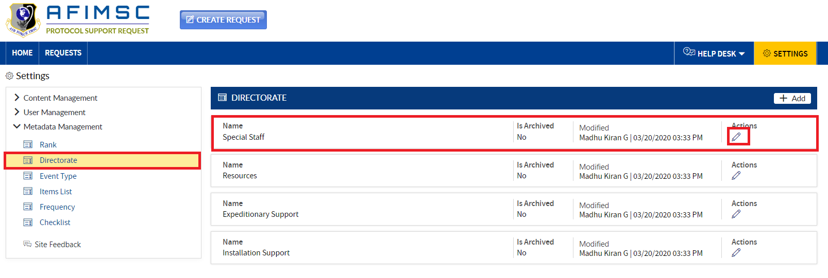

1. The **Edit** pop-up will be displayed with the **Is Archived** field and the **Update/Cancel** buttons.

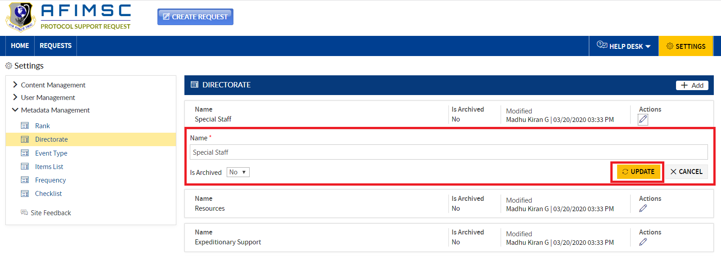

1. **Edit** the required field details, and click on the **Update** button.

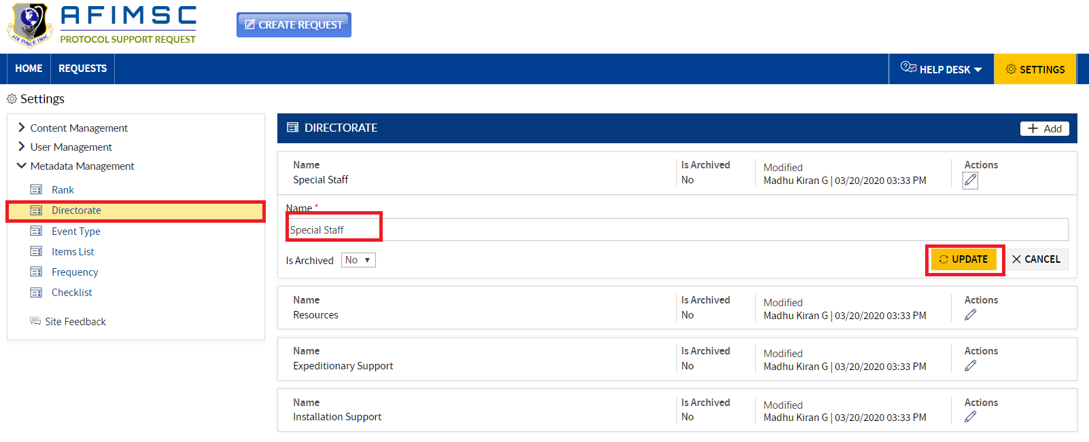

### ARCHIVE THE ITEM

To archive the item, follow the steps below:

1. Choose the item, and click on the **Edit** icon.



1. The **Edit** pop-up will be displayed with the **Is Archived** field and the **Update/Cancel** buttons.



1. In the **Is Archived** field dropdown, select **Yes**, and click on the **Update** button.

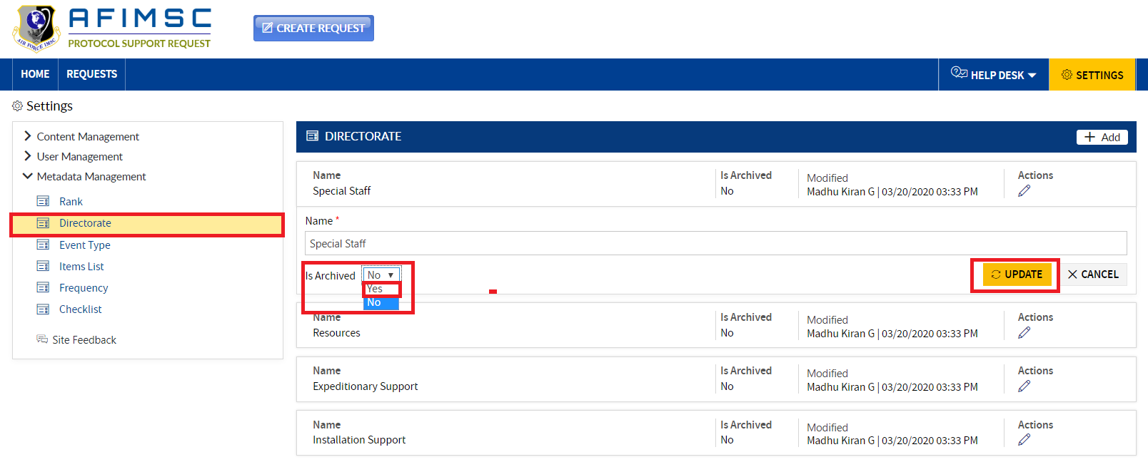

1. The item will now be archived.

Note: The archived item will not be visible in the Home/Requests/Form pages.

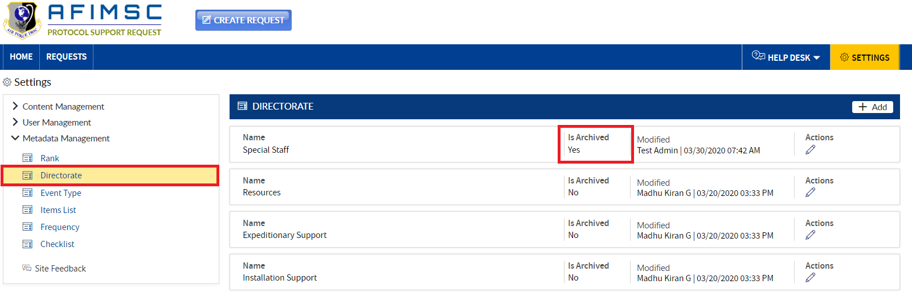

## ADD EVENT TYPE

1. Click on the **Add** button, and a pop-up will be displayed.

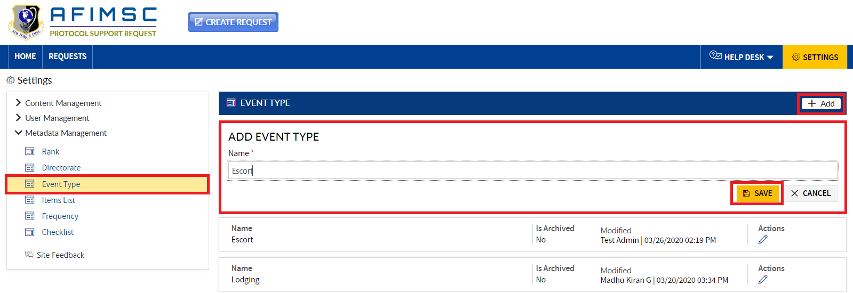

1. Enter the **Name**, and click the **Save** button.

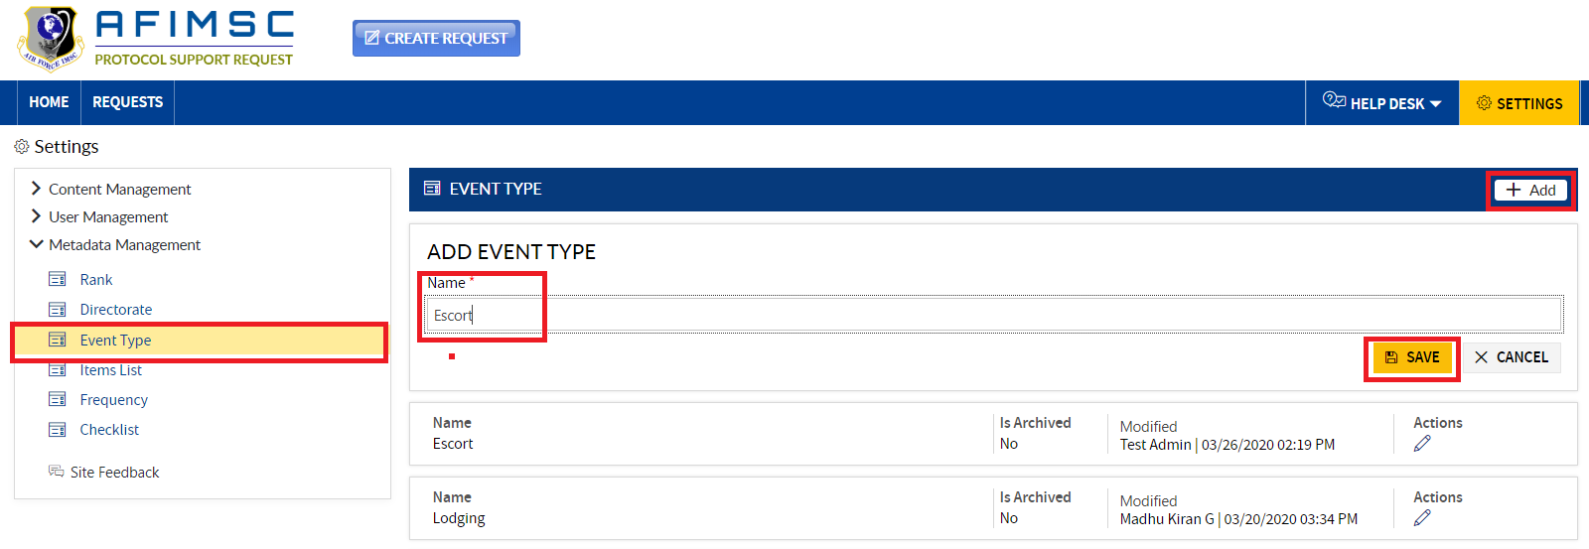

1. The added **Directorate** will be displayed in the **Directorate** section.

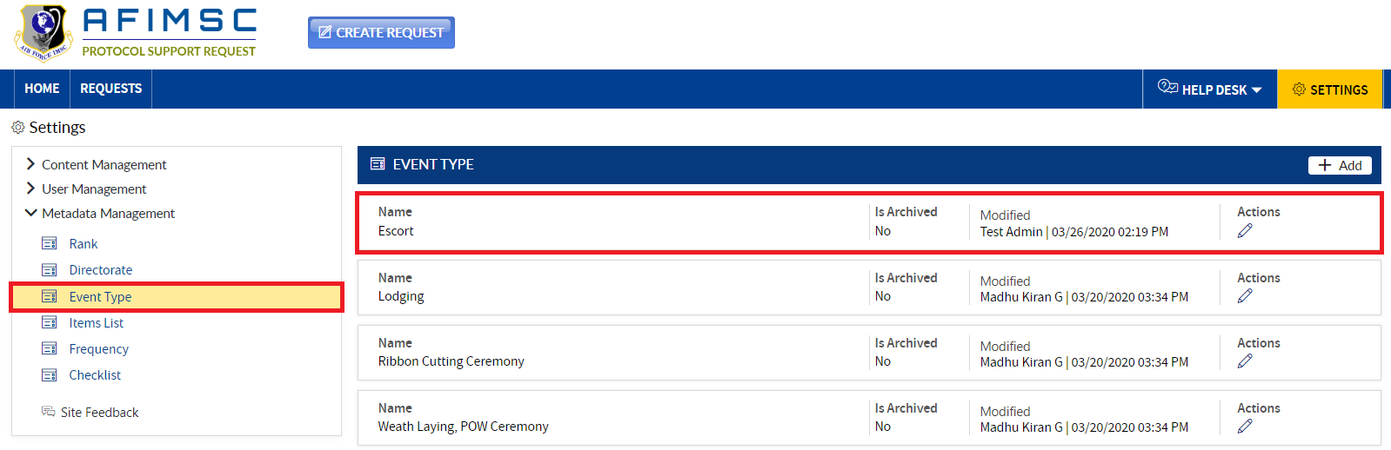

### EDIT THE ITEM

1. Choose the item, and click on the **Edit** icon.

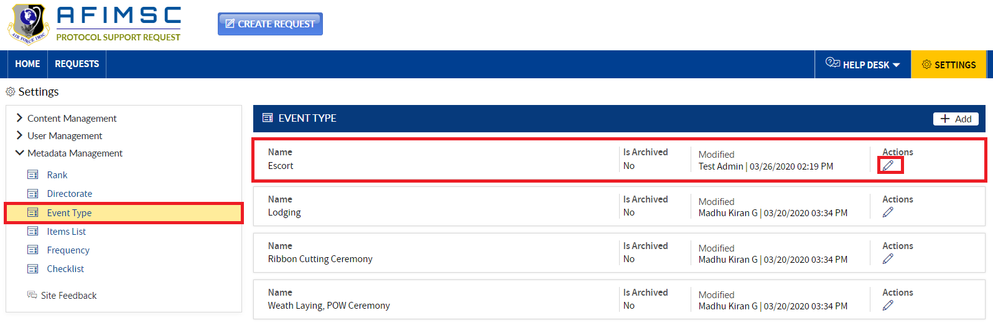

1. The **Edit** pop-up will be displayed with the **Is Archived** field and the **Update/Cancel** buttons.

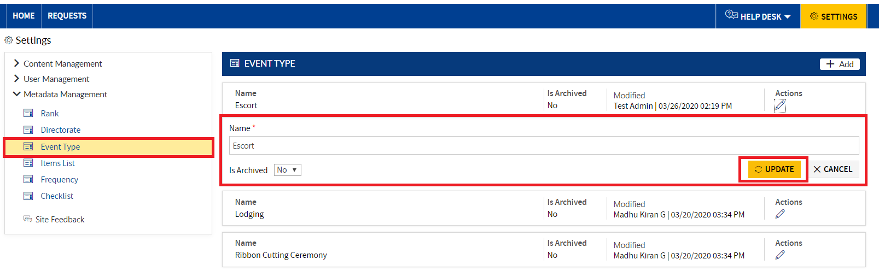

1. **Edit** the required field details, and click on the **Update** button.

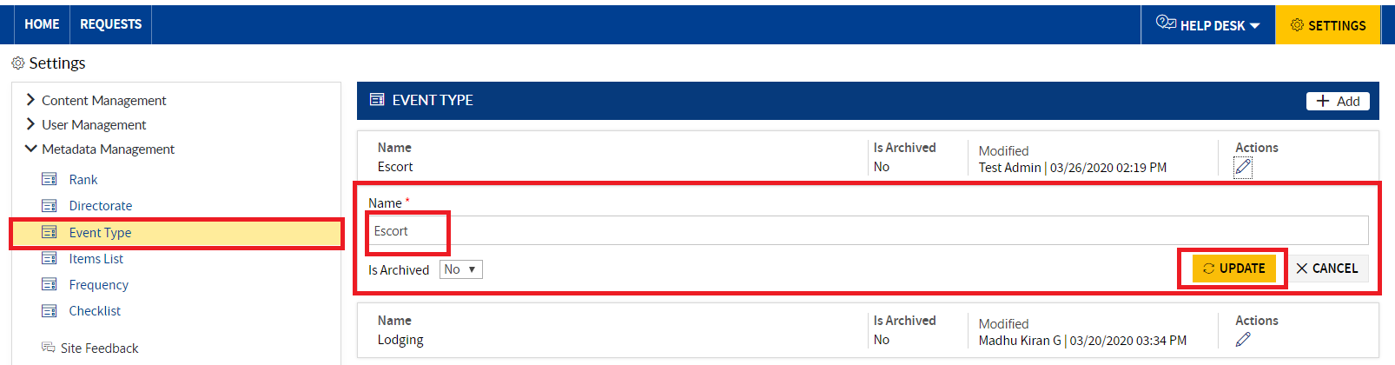

### ARCHIVE THE ITEM

To archive the item, follow the steps below:

1. Choose the item, and click on the **Edit** icon.



1. The **Edit** pop-up will be displayed with the **Is Archived** field and the **Update/Cancel** buttons.



1. In the **Is Archived** field dropdown, select **Yes,** and click the **Update** button.

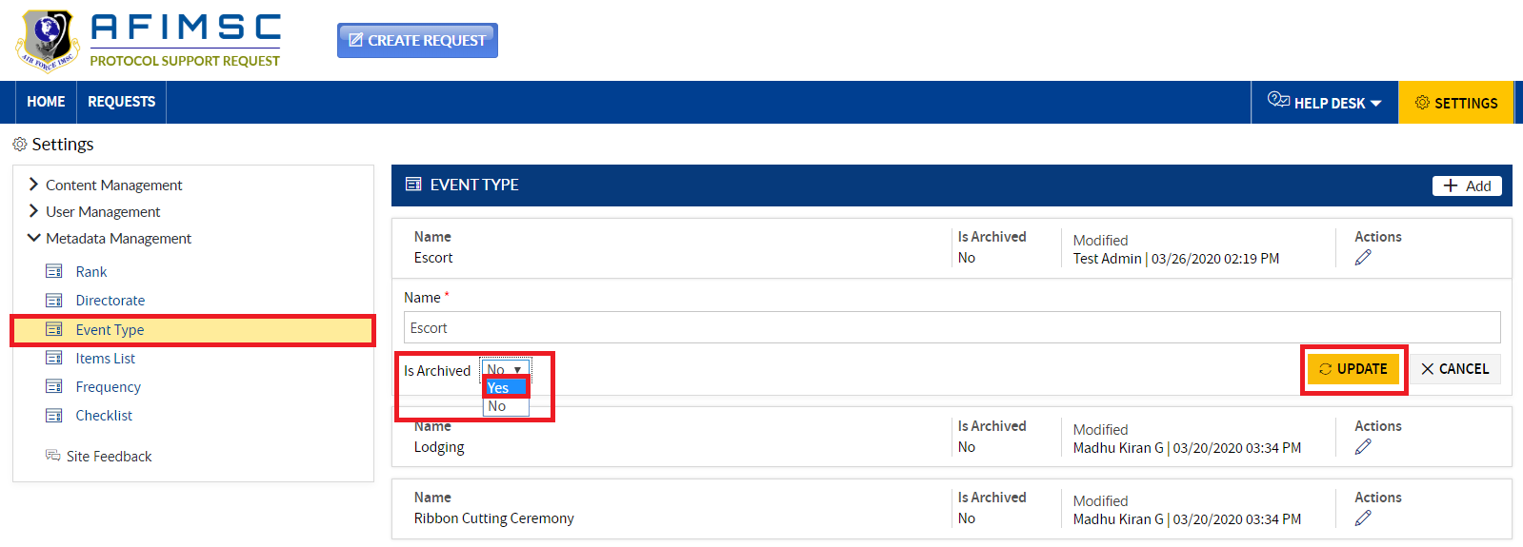

1. The item will be archived.

Note: The archived item will not be visible in the Home/Requests/Form pages.

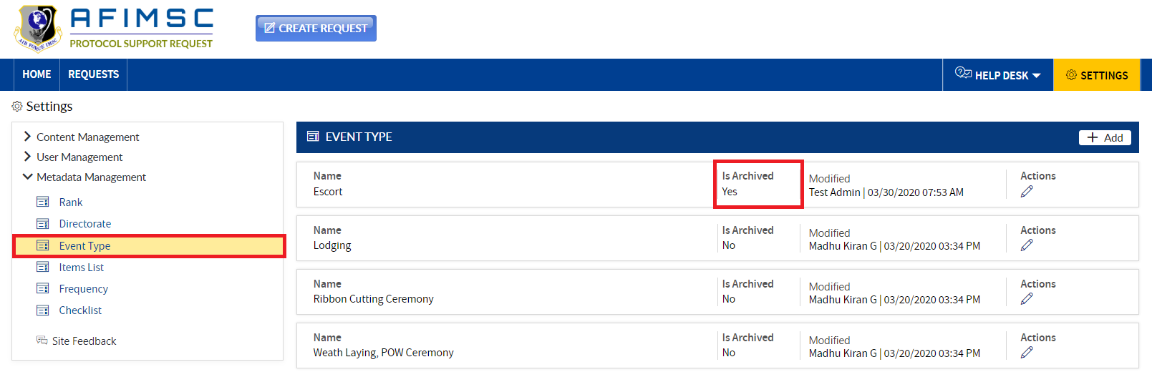

## ADD ITEMS LIST

1. Click on the **Add** button, and a pop-up will be displayed.

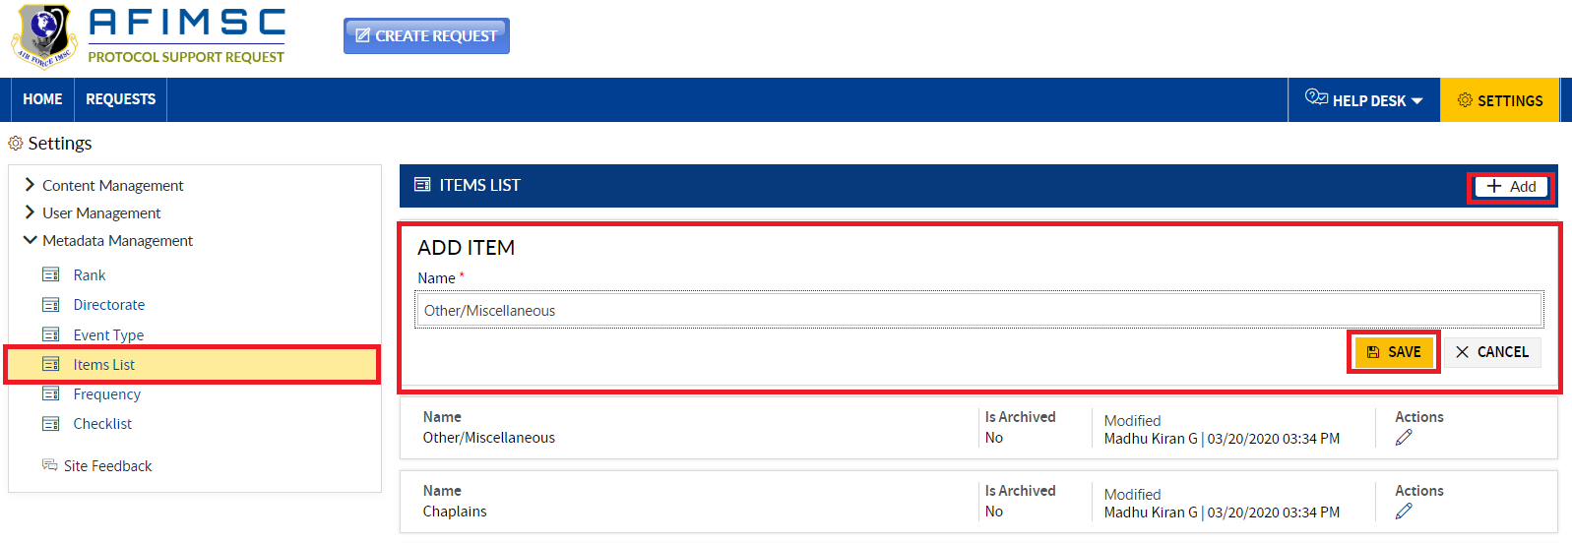

1. Enter the **Name** and click the **Save** button.

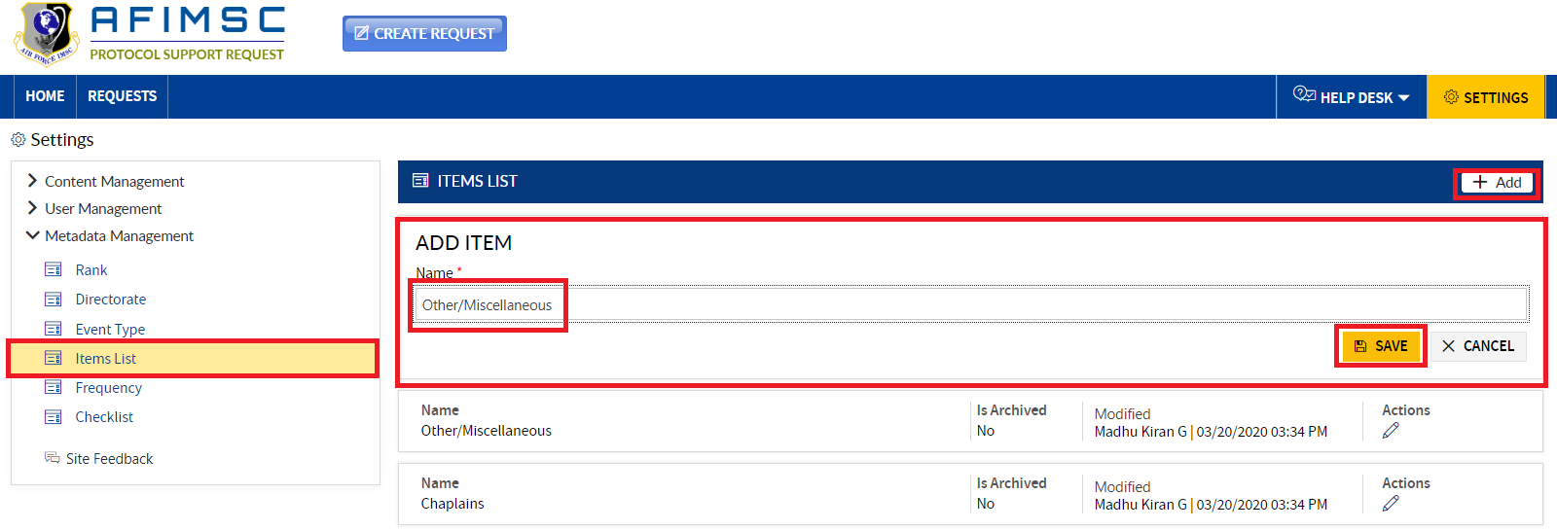

1. The added item will be displayed in the **Items List** section.

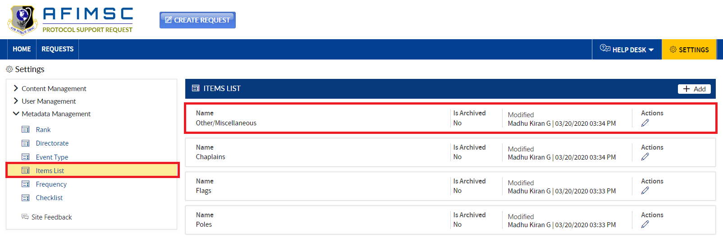

### EDIT THE ITEM

1. Choose the item, and click on the **Edit** icon.

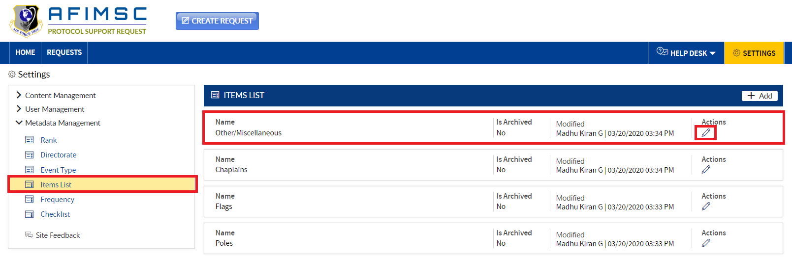

1. The **Edit** pop-up will be displayed with the **Is Archived** field and the **Update/Cancel** buttons.



1. **Edit** required field details and click on the **Update** button.

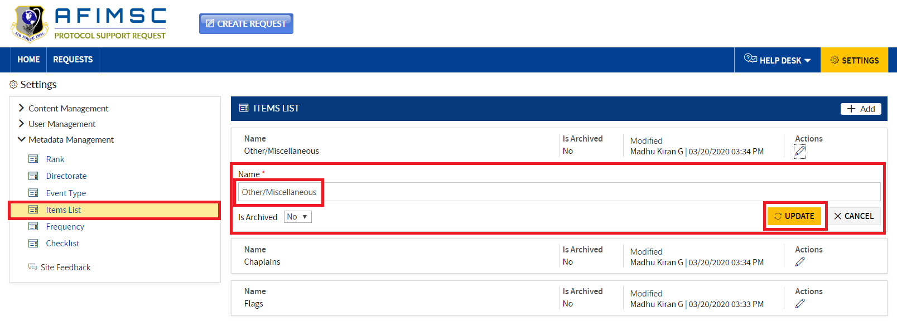

### ARCHIVE THE ITEM

To archive the item, follow the steps below:

1. Choose the item, and click on the **Edit** icon.



1. The **Edit** pop-up will be displayed with the **Is Archived** field and the **Update/Cancel** buttons.



1. In the **Is Archived** field dropdown, select **Yes**, and click the **Update** button.

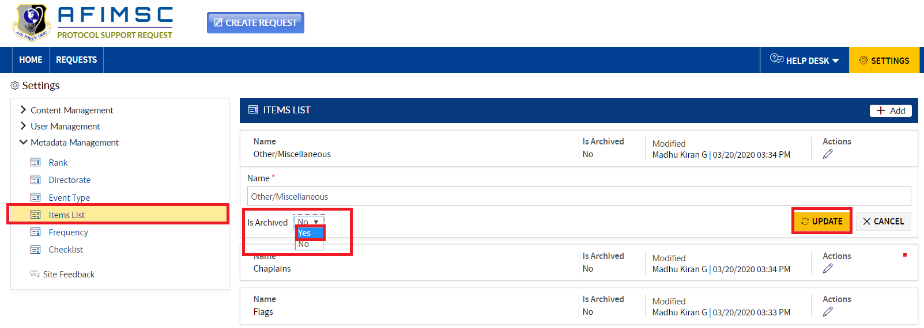

1. The item will be archived.

Note: The archived item will not be visible in the Home/Requests/Form pages.

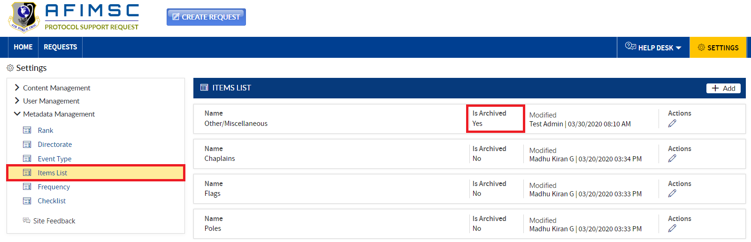

## ADD FREQUENCY

1. Click on the **Add** **Frequency** button, and a pop-up will be displayed.

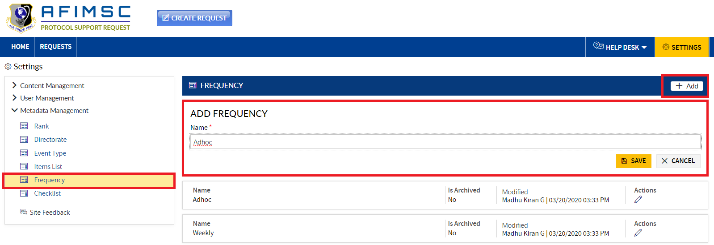

1. Enter the **Name** and click the **Save** button.

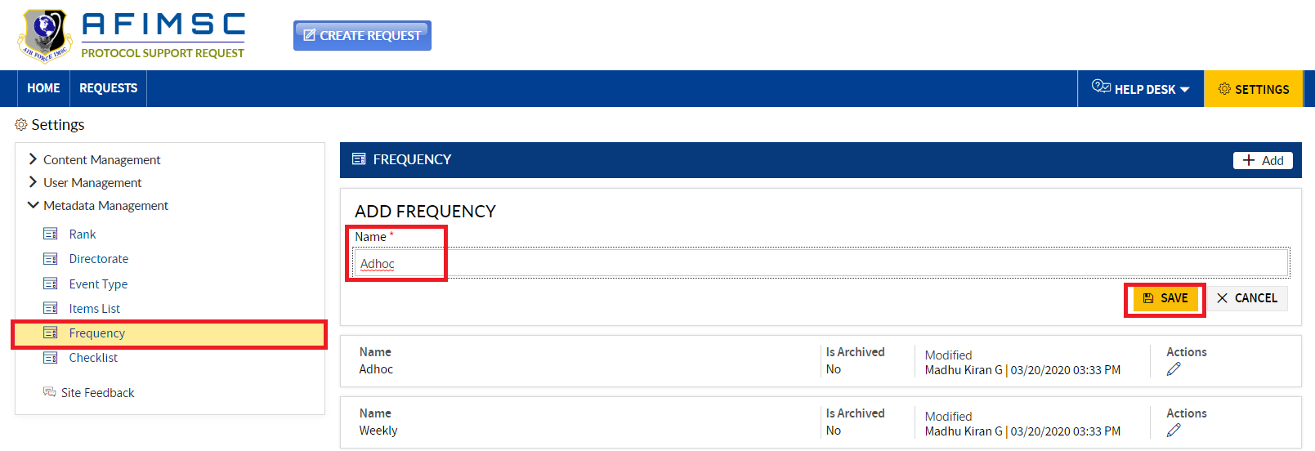

1. The added item will be displayed in the **Frequency** section.

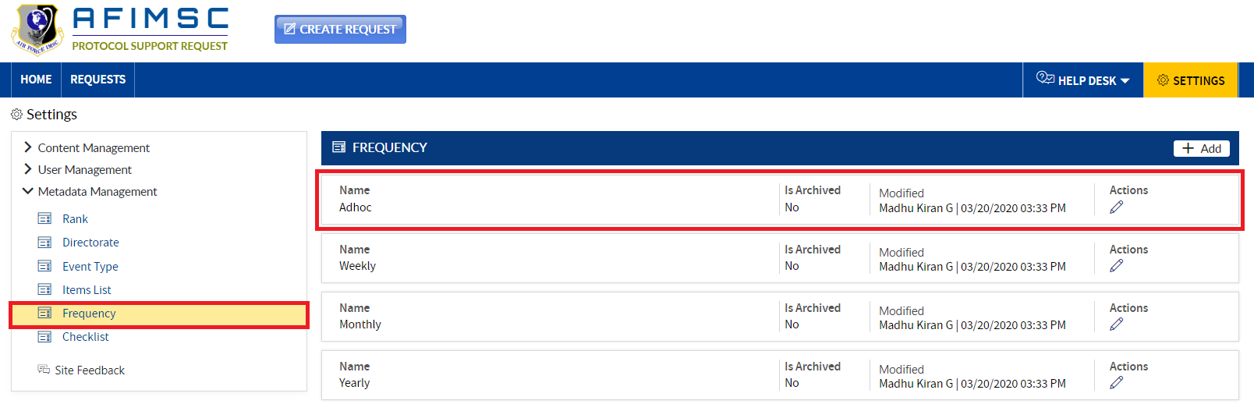

### EDIT THE ITEM

1. Choose the item, and click on the **Edit** icon

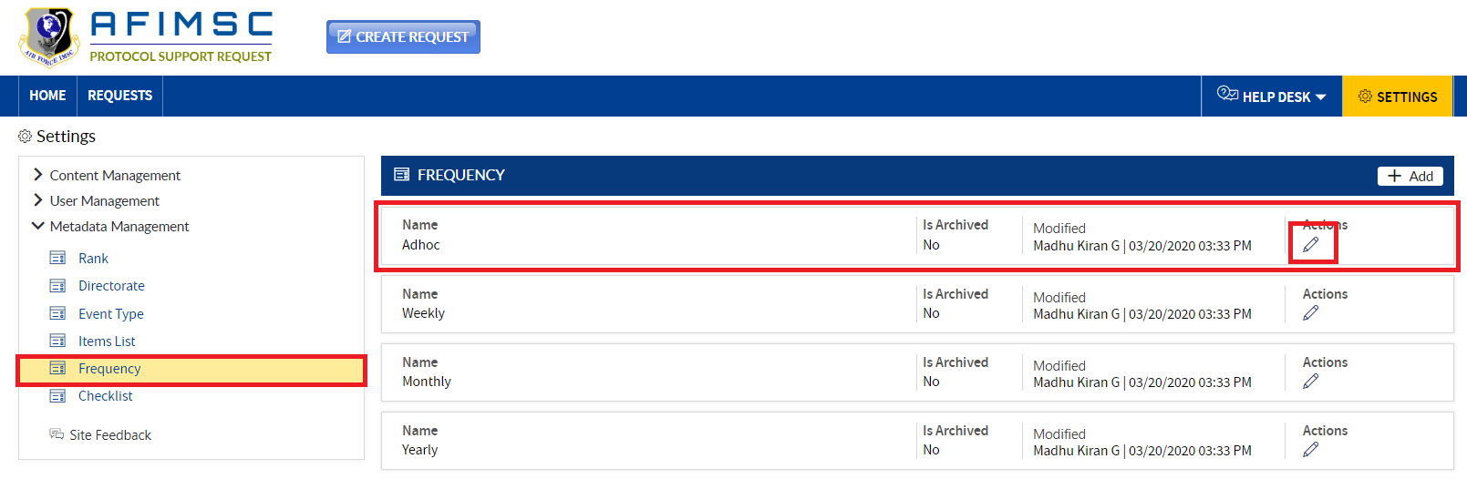

1. The **Edit** pop-up will be displayed with the **Is Archived** field and the **Update/Cancel** buttons.

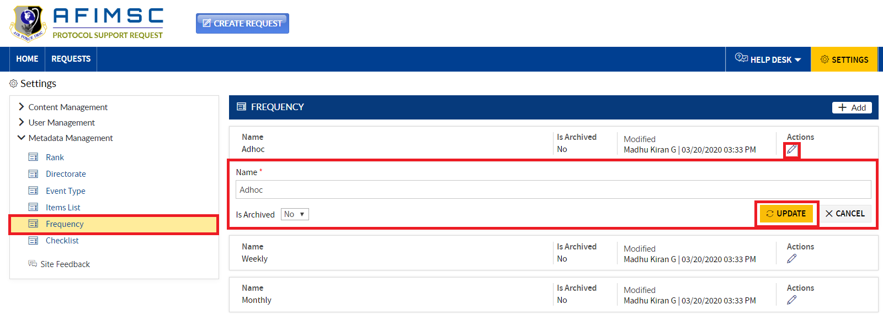

1. **Edit** required field details and click on the **Update** button.

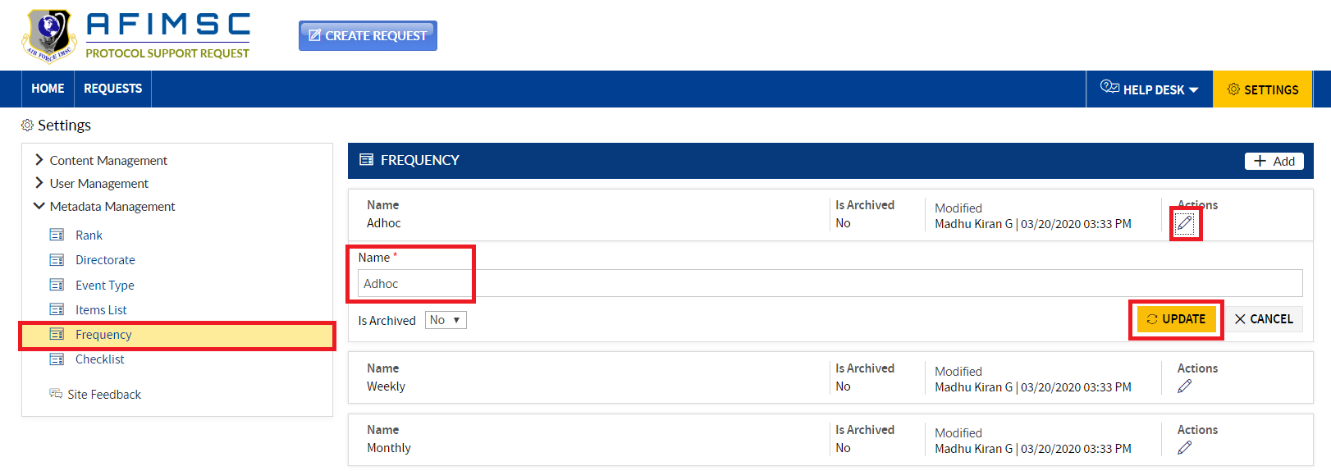

### ARCHIVE THE ITEM

To archive the item, follow the steps below:

1. Choose the item, and click on the **Edit** icon.



1. The **Edit** pop-up will be displayed with the **Is Archived** field and the **Update/Cancel** buttons.



1. In the **Is Archived** field dropdown, select **Yes**, and click the **Update** button.

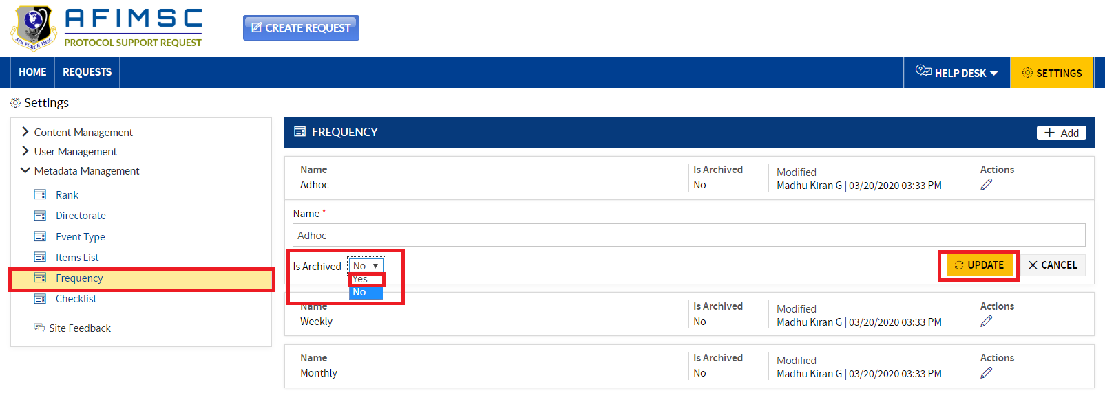

1. The item will be archived.

Note: The archived item will not be visible in the Home/Requests/Form pages.

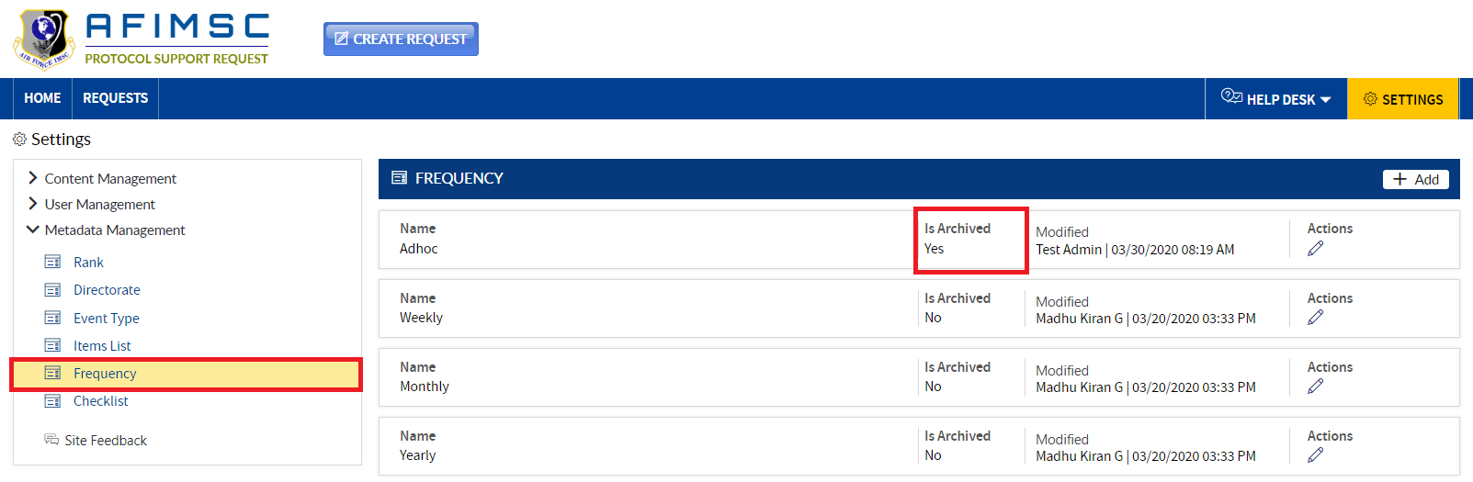

## ADD CHECKLIST

1. Click on the **Add** button, and a pop-up will be displayed.

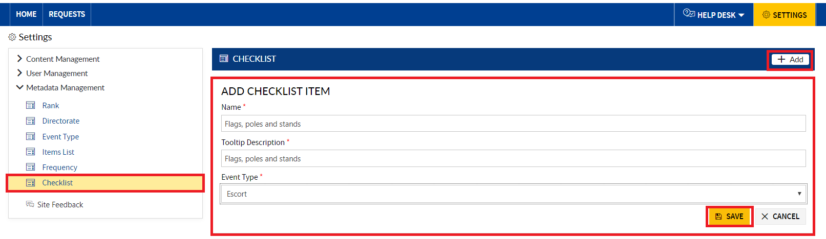

1. Enter the **Name**, **Tooltip Description** and **Event Type**, then click the **Save** button.

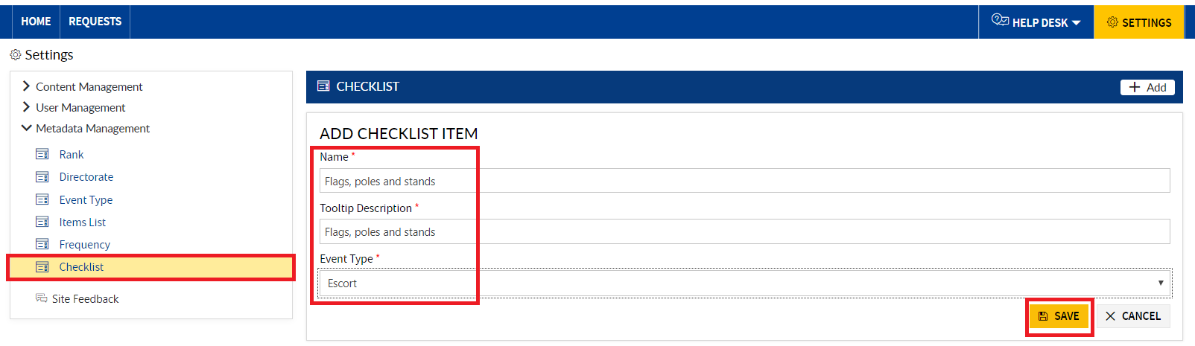

1. The added item will be displayed in the **Checklist** section.

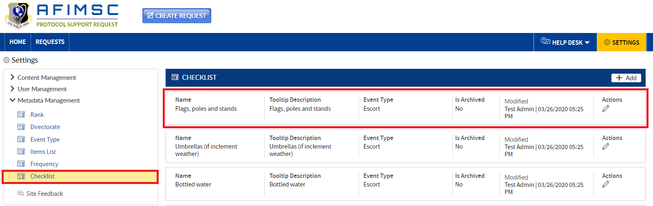

### EDIT THE ITEM

1. Choose the item, and click on the **Edit** icon.

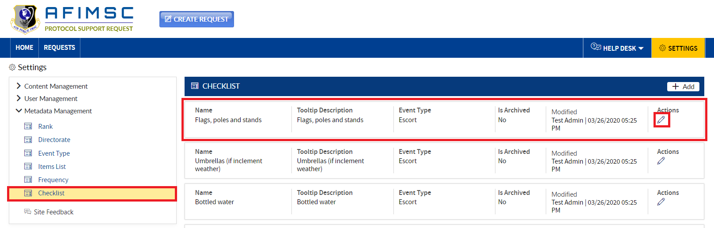

1. The **Edit** pop-up will be displayed with the **Is Archived** field and the **Update/Cancel** buttons.

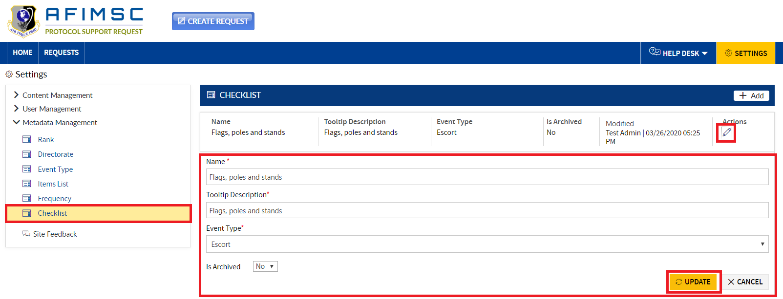

1. **Edit** required field details and click on the **Update** button.

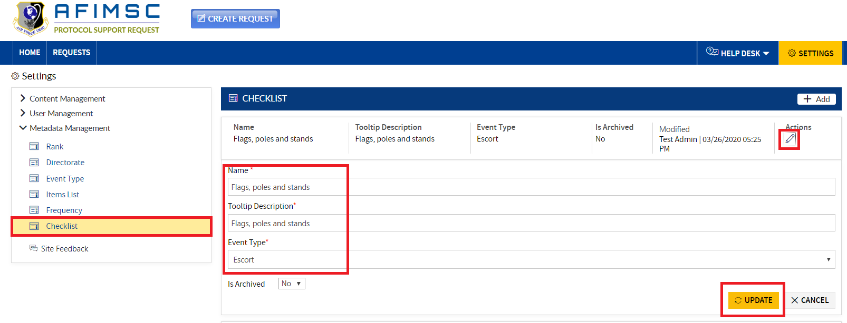

### IS ARCHIVE THE ITEM

To archive the item, follow the steps below:

1. Choose the item, and click on the **Edit** icon.



1. The **Edit** pop-up will be displayed with the **Is Archived** field and the **Update/Cancel** buttons.



1. In the **Is Archived** field dropdown, select Yes, and click the **Update** button.

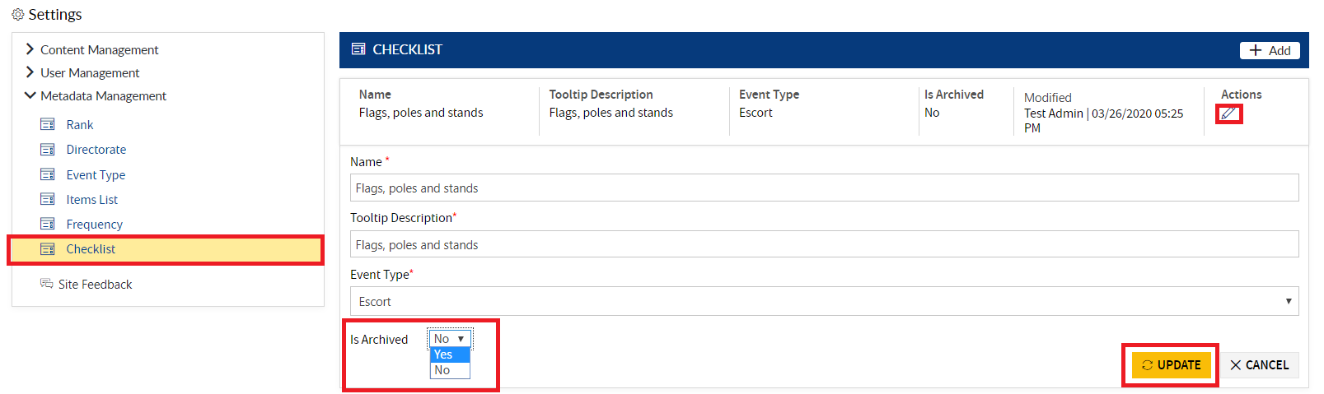

1. The item will be archived.

Note: The archived item will not be visible in the Home/Requests/Form pages.

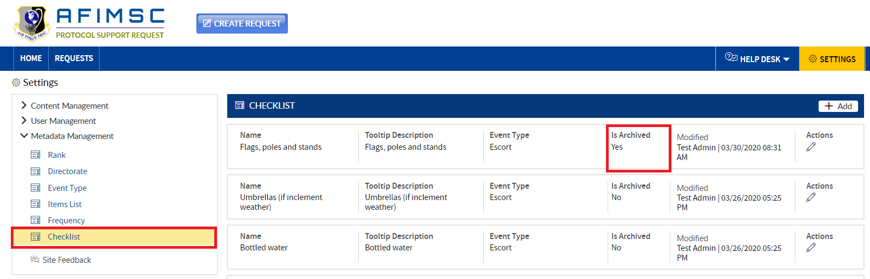

# SITE FEEDBACK

**Protocol Support Request Owners** and/or the **Protocol Officer** can manage the **Feedback** by using the **Settings** page. They can track the **User Feedback** from the respective list.

1. Click on the **Feedback** in the left-side menu, and the **Feedback** details will be displayed on the right-hand side of the page.

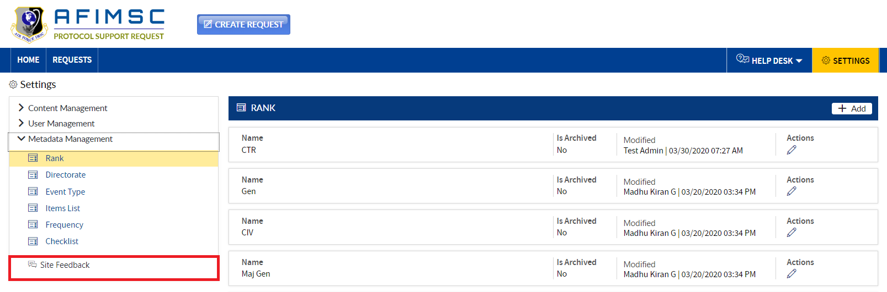

1. The **Protocol Support Request Owners** and/or the **Protocol Officer** can export the list of feedback submitted by the users. Click on the **Export to Excel** button to export the list of feedback.

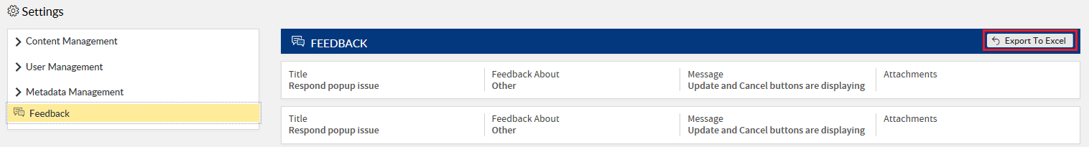

1. The Excel File will be downloaded. Click on the downloaded excel file to view the details.

